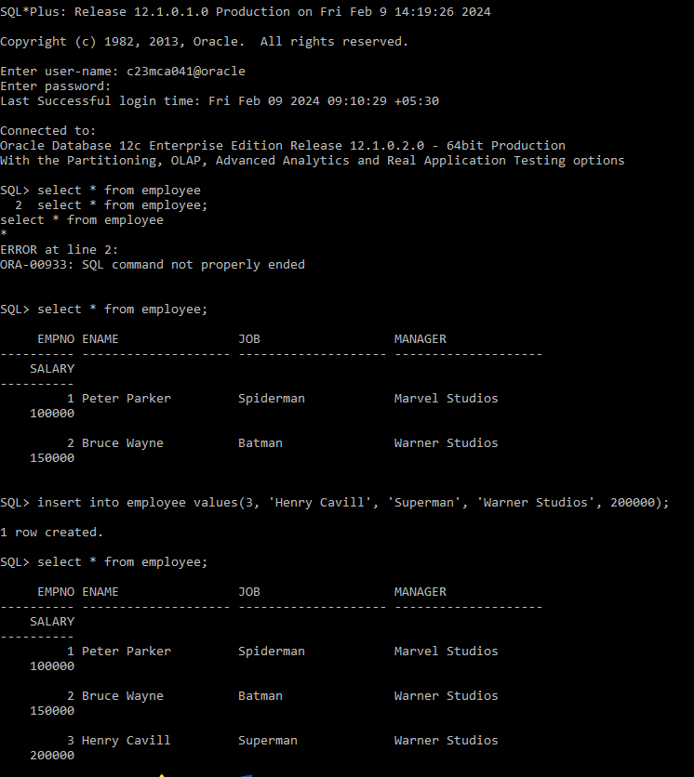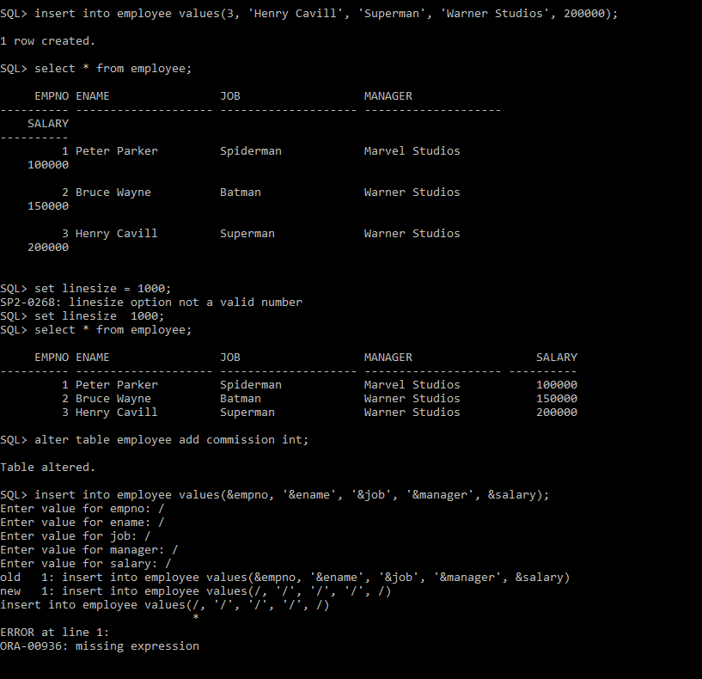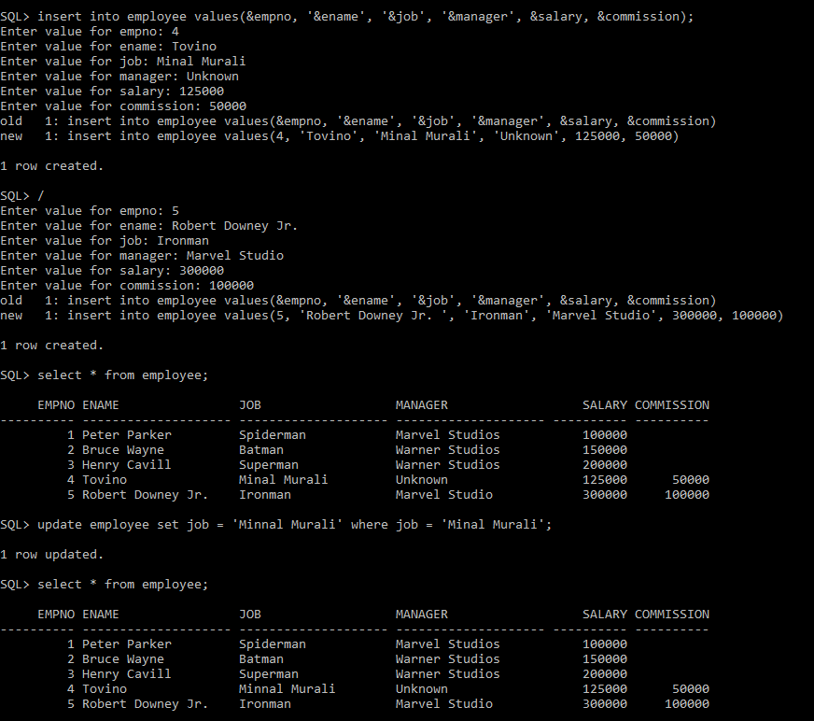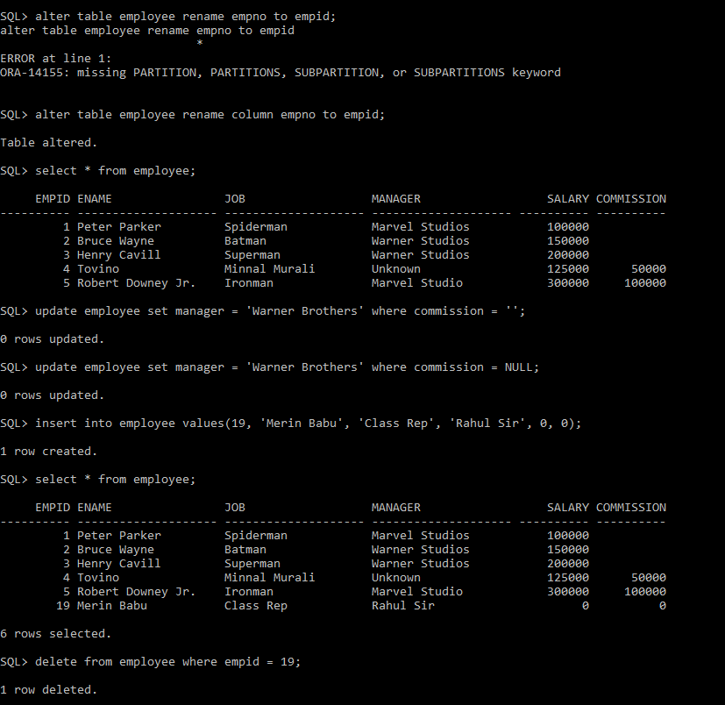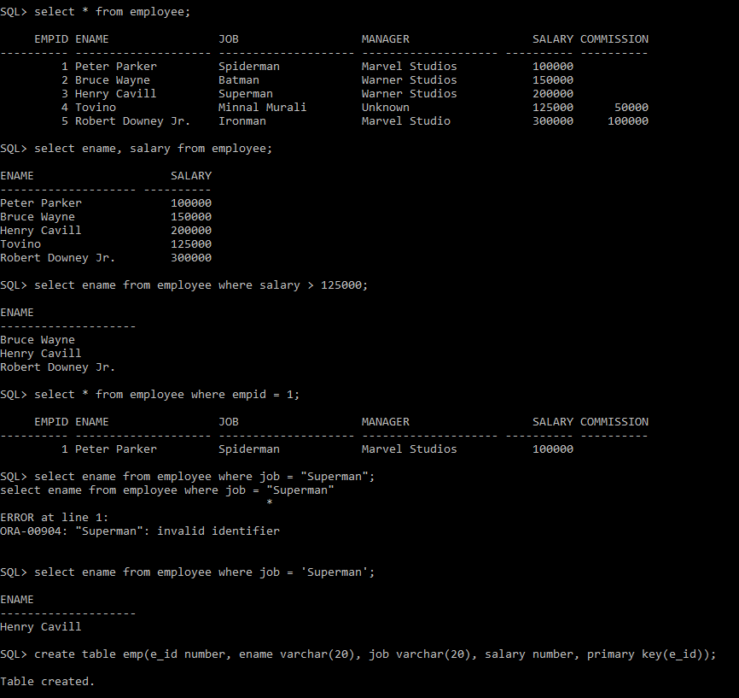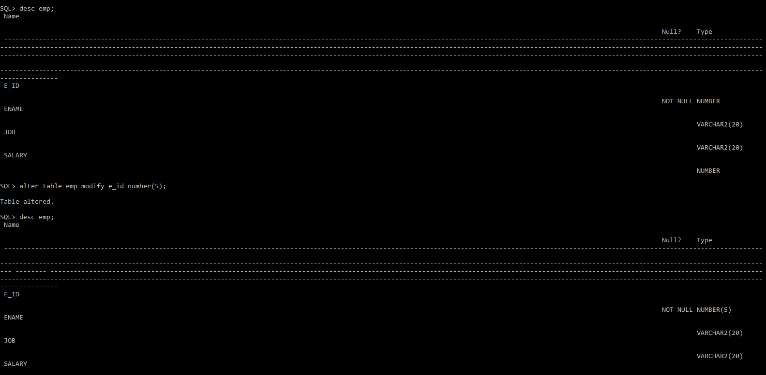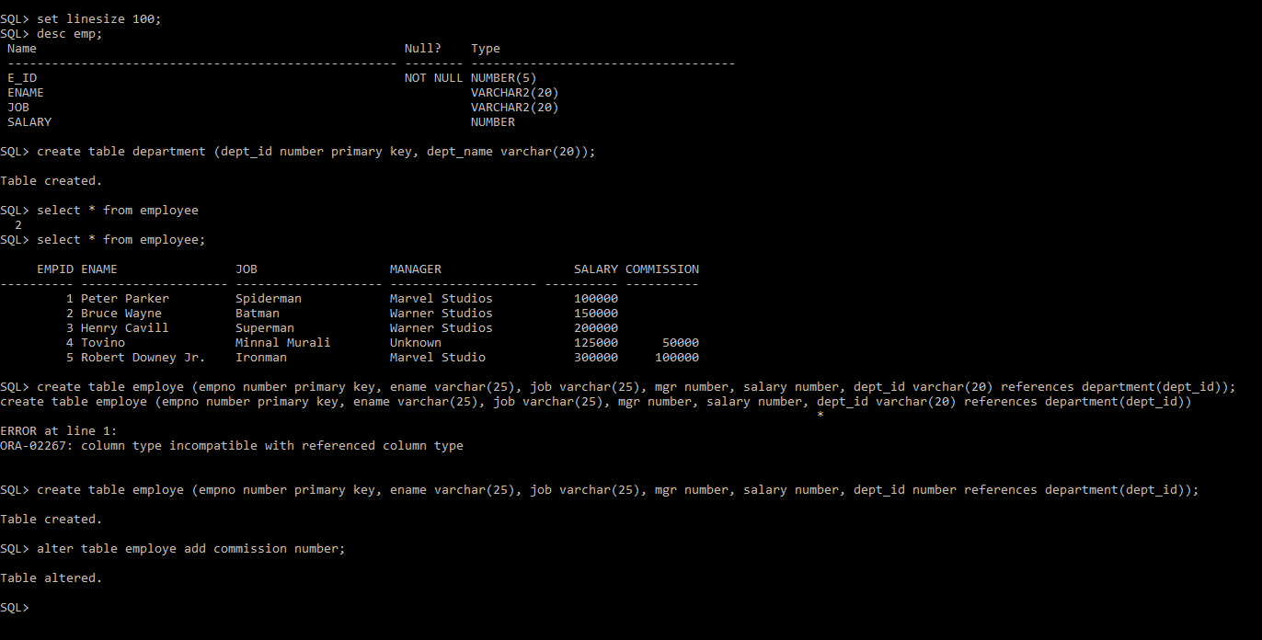

SQL*Plus: Release 12.1.0.1.0 Production on Fri Feb 9 14:19:26 2024

Copyright (c) 1982, 2013, Oracle. All rights reserved.

Enter user-name: c23mca041@oracle

Enter password:

Last Successful login time: Fri Feb 09 2024 09:10:29 +05:30

Connected to:

Oracle Database 12c Enterprise Edition Release 12.1.0.2.0 - 64bit Production

With the Partitioning, OLAP, Advanced Analytics and Real Application Testing options

SQL> select * from employee

2 select * from employee;

select * from employee

*

ERROR at line 2:

ORA-00933: SQL command not properly ended

SQL> select * from employee;

EMPNO ENAME JOB MANAGER

---------- -------------------- -------------------- --------------------

SALARY

----------

1 Peter Parker Spiderman Marvel Studios

100000

2 Bruce Wayne Batman Warner Studios

150000

SQL> insert into employee values(3, 'Henry Cavill', 'Superman', 'Warner Studios', 200000);

1 row created.

SQL> select * from employee;

EMPNO ENAME JOB MANAGER

---------- -------------------- -------------------- --------------------

SALARY

----------

1 Peter Parker Spiderman Marvel Studios

100000

2 Bruce Wayne Batman Warner Studios

150000

3 Henry Cavill Superman Warner Studios

200000

SQL> set linesize = 1000;

SP2-0268: linesize option not a valid number

SQL> set linesize 1000;

SQL> select * from employee;

EMPNO ENAME JOB MANAGER SALARY

---------- -------------------- -------------------- -------------------- ----------

1 Peter Parker Spiderman Marvel Studios 100000

2 Bruce Wayne Batman Warner Studios 150000

3 Henry Cavill Superman Warner Studios 200000

SQL> alter table employee add commission int;

Table altered.

SQL> insert into employee values(&empno, '&ename', '&job', '&manager', &salary);

Enter value for empno: /

Enter value for ename: /

Enter value for job: /

Enter value for manager: /

Enter value for salary: /

old 1: insert into employee values(&empno, '&ename', '&job', '&manager', &salary)

new 1: insert into employee values(/, '/', '/', '/', /)

insert into employee values(/, '/', '/', '/', /)

*

ERROR at line 1:

ORA-00936: missing expression

SQL> insert into employee values(&empno, '&ename', '&job', '&manager', &salary, &commission);

Enter value for empno: 4

Enter value for ename: Tovino

Enter value for job: Minal Murali

Enter value for manager: Unknown

Enter value for salary: 125000

Enter value for commission: 50000

old 1: insert into employee values(&empno, '&ename', '&job', '&manager', &salary, &commission)

new 1: insert into employee values(4, 'Tovino', 'Minal Murali', 'Unknown', 125000, 50000)

1 row created.

SQL> /

Enter value for empno: 5

Enter value for ename: Robert Downey Jr.

Enter value for job: Ironman

Enter value for manager: Marvel Studio

Enter value for salary: 300000

Enter value for commission: 100000

old 1: insert into employee values(&empno, '&ename', '&job', '&manager', &salary, &commission)

new 1: insert into employee values(5, 'Robert Downey Jr. ', 'Ironman', 'Marvel Studio', 300000, 100000)

1 row created.

SQL> select * from employee;

EMPNO ENAME JOB MANAGER SALARY COMMISSION

---------- -------------------- -------------------- -------------------- ---------- ----------

1 Peter Parker Spiderman Marvel Studios 100000

2 Bruce Wayne Batman Warner Studios 150000

3 Henry Cavill Superman Warner Studios 200000

4 Tovino Minal Murali Unknown 125000 50000

5 Robert Downey Jr. Ironman Marvel Studio 300000 100000

SQL> update employee set job = 'Minnal Murali' where job = 'Minal Murali';

1 row updated.

SQL> select * from employee;

EMPNO ENAME JOB MANAGER SALARY COMMISSION

---------- -------------------- -------------------- -------------------- ---------- ----------

1 Peter Parker Spiderman Marvel Studios 100000

2 Bruce Wayne Batman Warner Studios 150000

3 Henry Cavill Superman Warner Studios 200000

4 Tovino Minnal Murali Unknown 125000 50000

5 Robert Downey Jr. Ironman Marvel Studio 300000 100000

SQL> alter table employee rename empno to empid;

alter table employee rename empno to empid

*

ERROR at line 1:

ORA-14155: missing PARTITION, PARTITIONS, SUBPARTITION, or SUBPARTITIONS keyword

SQL> alter table employee rename column empno to empid;

Table altered.

SQL> select * from employee;

EMPID ENAME JOB MANAGER SALARY COMMISSION

---------- -------------------- -------------------- -------------------- ---------- ----------

1 Peter Parker Spiderman Marvel Studios 100000

2 Bruce Wayne Batman Warner Studios 150000

3 Henry Cavill Superman Warner Studios 200000

4 Tovino Minnal Murali Unknown 125000 50000

5 Robert Downey Jr. Ironman Marvel Studio 300000 100000

SQL> update employee set manager = 'Warner Brothers' where commission = '';

0 rows updated.

SQL> update employee set manager = 'Warner Brothers' where commission = NULL;

0 rows updated.

SQL> insert into employee values(19, 'Merin Babu', 'Class Rep', 'Rahul Sir', 0, 0);

1 row created.

SQL> select * from employee;

EMPID ENAME JOB MANAGER SALARY COMMISSION

---------- -------------------- -------------------- -------------------- ---------- ----------

1 Peter Parker Spiderman Marvel Studios 100000

2 Bruce Wayne Batman Warner Studios 150000

3 Henry Cavill Superman Warner Studios 200000

4 Tovino Minnal Murali Unknown 125000 50000

5 Robert Downey Jr. Ironman Marvel Studio 300000 100000

19 Merin Babu Class Rep Rahul Sir 0 0

6 rows selected.

SQL> delete from employee where empid = 19;

1 row deleted.

SQL> select * from employee;

EMPID ENAME JOB MANAGER SALARY COMMISSION

---------- -------------------- -------------------- -------------------- ---------- ----------

1 Peter Parker Spiderman Marvel Studios 100000

2 Bruce Wayne Batman Warner Studios 150000

3 Henry Cavill Superman Warner Studios 200000

4 Tovino Minnal Murali Unknown 125000 50000

5 Robert Downey Jr. Ironman Marvel Studio 300000 100000

SQL> select ename, salary from employee;

ENAME SALARY

-------------------- ----------

Peter Parker 100000

Bruce Wayne 150000

Henry Cavill 200000

Tovino 125000

Robert Downey Jr. 300000

SQL> select ename from employee where salary > 125000;

ENAME

--------------------

Bruce Wayne

Henry Cavill

Robert Downey Jr.

SQL> select * from employee where empid = 1;

EMPID ENAME JOB MANAGER SALARY COMMISSION

---------- -------------------- -------------------- -------------------- ---------- ----------

1 Peter Parker Spiderman Marvel Studios 100000

SQL> select ename from employee where job = "Superman";

select ename from employee where job = "Superman"

*

ERROR at line 1:

ORA-00904: "Superman": invalid identifier

SQL> select ename from employee where job = 'Superman';

ENAME

--------------------

Henry Cavill

SQL> create table emp(e_id number, ename varchar(20), job varchar(20), salary number, primary key(e_id));

Table created.

SQL> desc emp;

Name

Null? Type

----------------------------------------------------------------------------------------------------------------------------------------------------------------------------------------------------------------------------------------------------------------------------------------------------------------------------------------------------------------------------------------------------------------------------------------------------------------------------------------------------------------------------------------------------------------------------------------------------------------- -------- ------------------------------------------------------------------------------------------------------------------------------------------------------------------------------------------------------------------------------------------------------------------------------------------------------------------------------------------------------------------------------------------------------------

E_ID

NOT NULL NUMBER

ENAME

VARCHAR2(20)

JOB

VARCHAR2(20)

SALARY

NUMBER

SQL> alter table emp modify e_id number(5);

Table altered.

SQL> desc emp;

Name

Null? Type

----------------------------------------------------------------------------------------------------------------------------------------------------------------------------------------------------------------------------------------------------------------------------------------------------------------------------------------------------------------------------------------------------------------------------------------------------------------------------------------------------------------------------------------------------------------------------------------------------------------- -------- ------------------------------------------------------------------------------------------------------------------------------------------------------------------------------------------------------------------------------------------------------------------------------------------------------------------------------------------------------------------------------------------------------------

E_ID

NOT NULL NUMBER(5)

ENAME

VARCHAR2(20)

JOB

VARCHAR2(20)

SALARY

NUMBER

SQL> set linesize 100;

SQL> desc emp;

Name Null? Type

----------------------------------------------------- -------- ------------------------------------

E_ID NOT NULL NUMBER(5)

ENAME VARCHAR2(20)

JOB VARCHAR2(20)

SALARY NUMBER

SQL> create table department (dept_id number primary key, dept_name varchar(20));

Table created.

SQL> select * from employee

2

SQL> select * from employee;

EMPID ENAME JOB MANAGER SALARY COMMISSION

---------- -------------------- -------------------- -------------------- ---------- ----------

1 Peter Parker Spiderman Marvel Studios 100000

2 Bruce Wayne Batman Warner Studios 150000

3 Henry Cavill Superman Warner Studios 200000

4 Tovino Minnal Murali Unknown 125000 50000

5 Robert Downey Jr. Ironman Marvel Studio 300000 100000

SQL> create table employe (empno number primary key, ename varchar(25), job varchar(25), mgr number, salary number, dept_id varchar(20) references department(dept_id));

create table employe (empno number primary key, ename varchar(25), job varchar(25), mgr number, salary number, dept_id varchar(20) references department(dept_id))

*

ERROR at line 1:

ORA-02267: column type incompatible with referenced column type

SQL> create table employe (empno number primary key, ename varchar(25), job varchar(25), mgr number, salary number, dept_id number references department(dept_id));

Table created.

SQL> alter table employe add commission number;

Table altered.

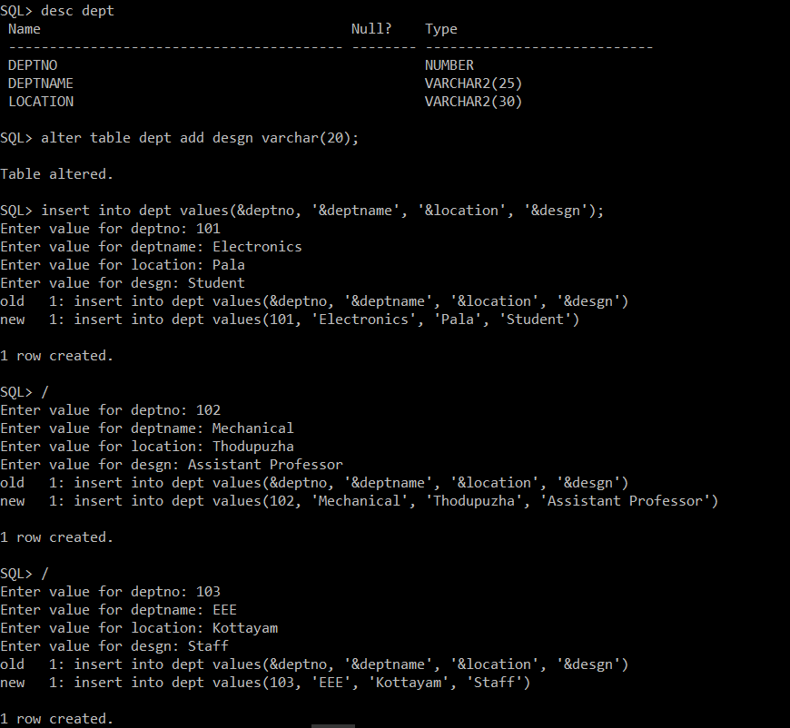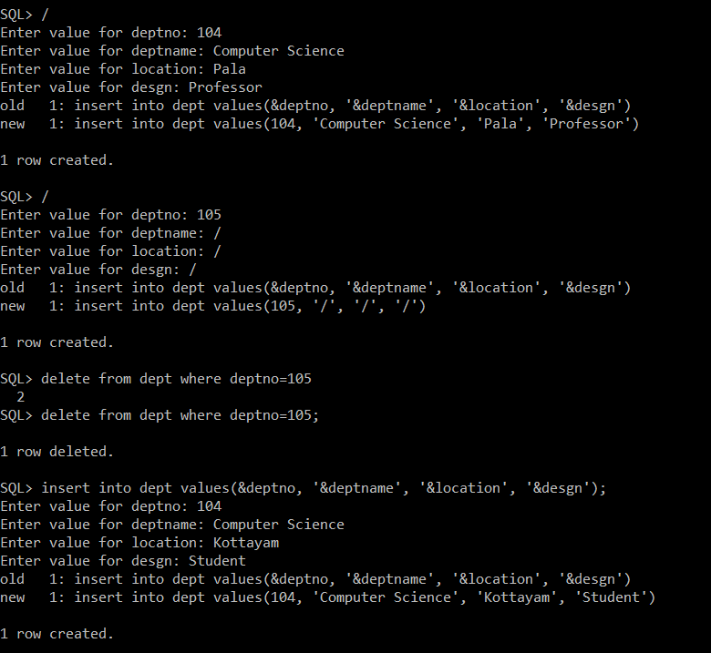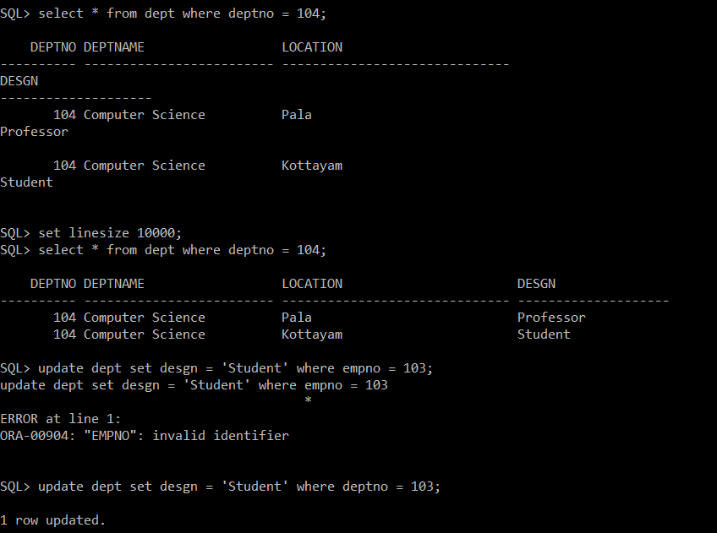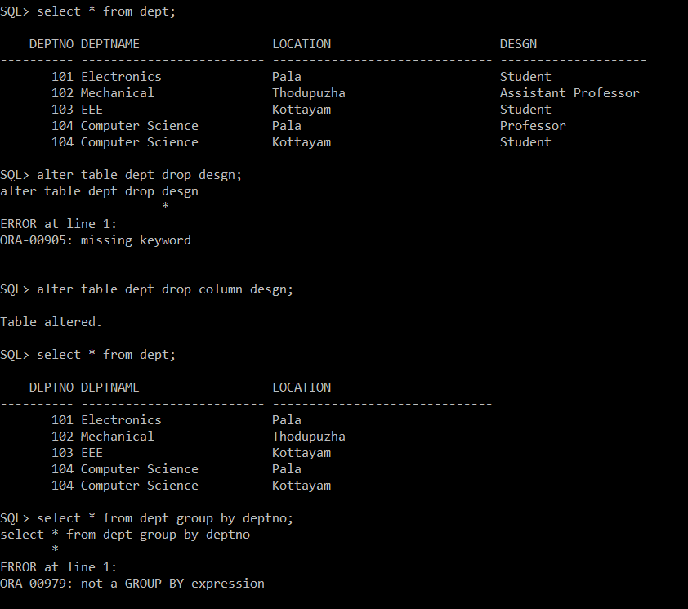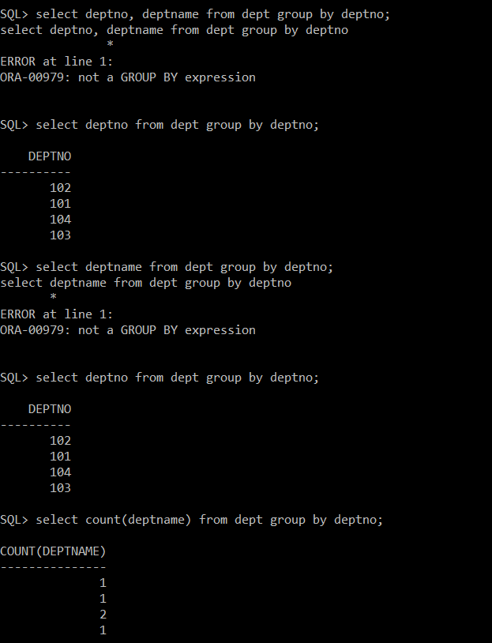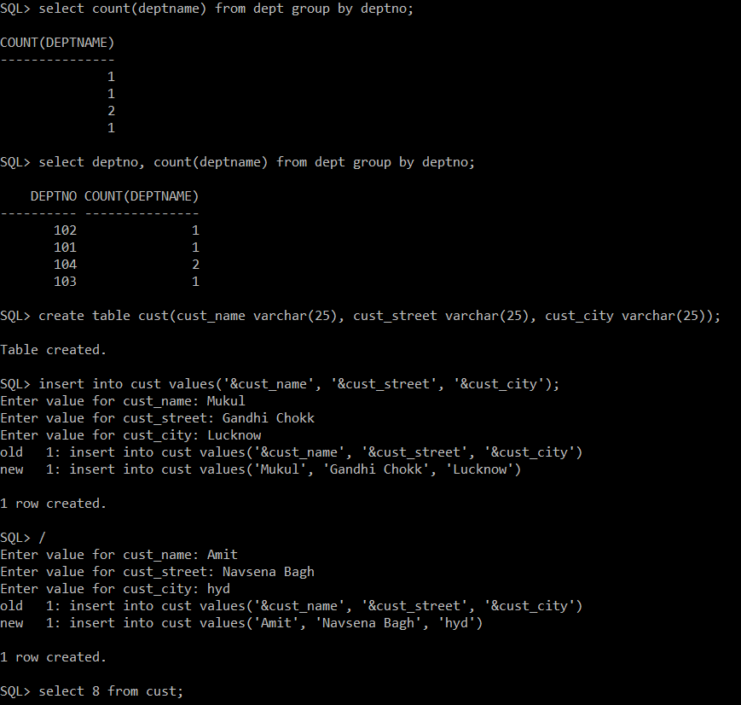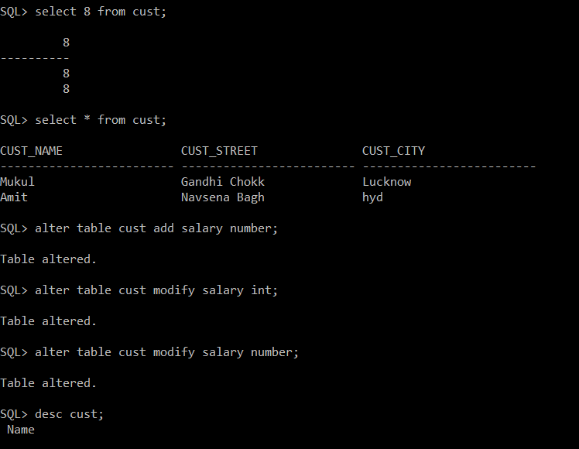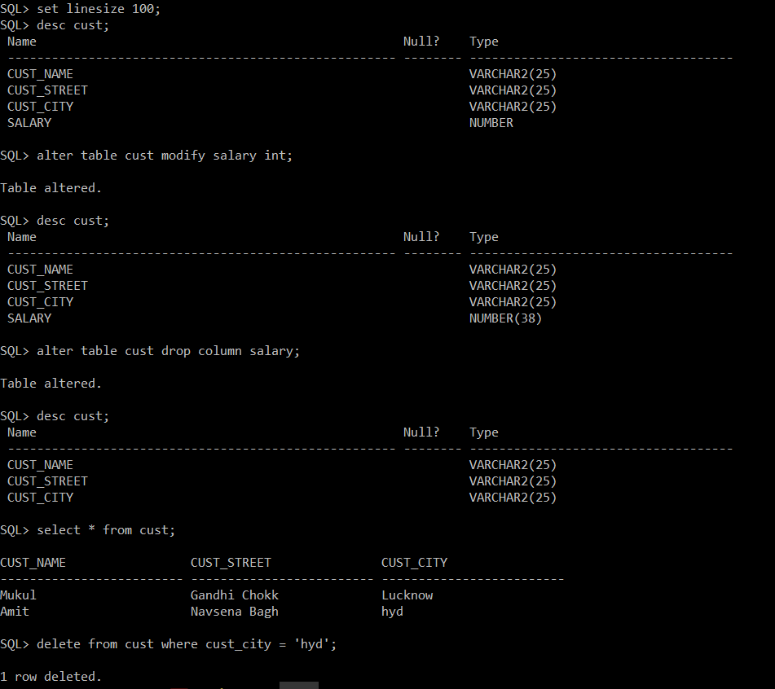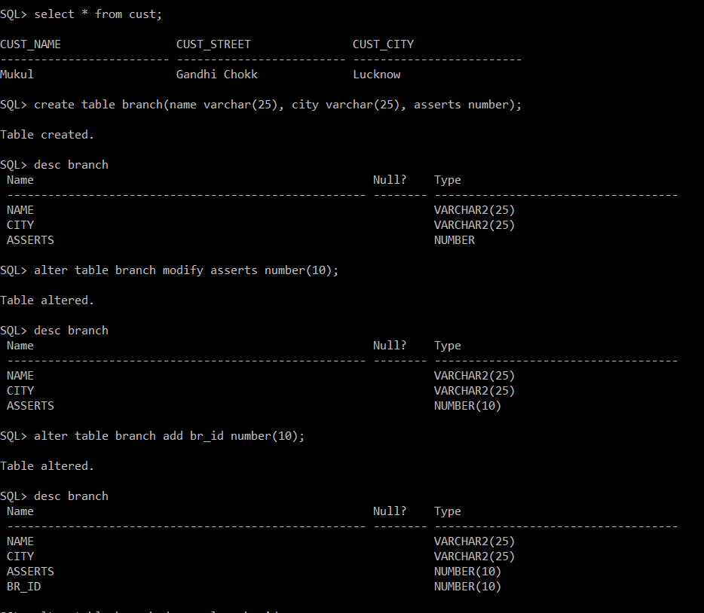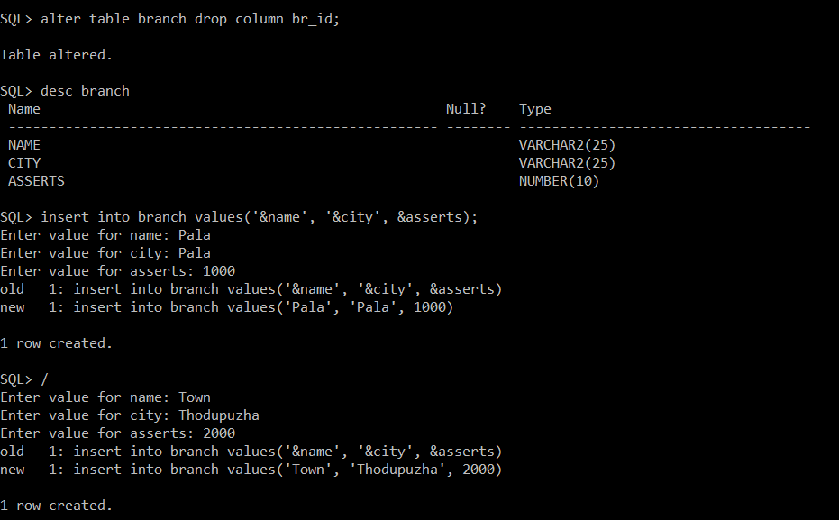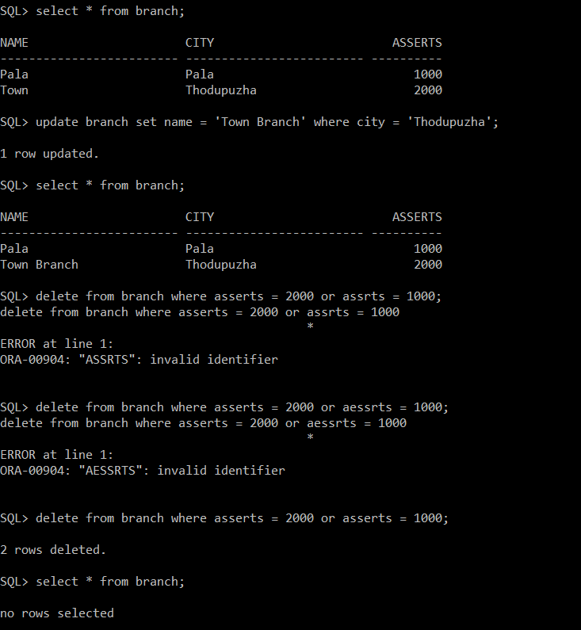

SQL> desc dept

Name Null? Type

----------------------------------------- -------- ----------------------------

DEPTNO NUMBER

DEPTNAME VARCHAR2(25)

LOCATION VARCHAR2(30)

SQL> alter table dept add desgn varchar(20);

Table altered.

SQL> insert into dept values(&deptno, '&deptname', '&location', '&desgn');

Enter value for deptno: 101

Enter value for deptname: Electronics

Enter value for location: Pala

Enter value for desgn: Student

old 1: insert into dept values(&deptno, '&deptname', '&location', '&desgn')

new 1: insert into dept values(101, 'Electronics', 'Pala', 'Student')

1 row created.

SQL> /

Enter value for deptno: 102

Enter value for deptname: Mechanical

Enter value for location: Thodupuzha

Enter value for desgn: Assistant Professor

old 1: insert into dept values(&deptno, '&deptname', '&location', '&desgn')

new 1: insert into dept values(102, 'Mechanical', 'Thodupuzha', 'Assistant Professor')

1 row created.

SQL> /

Enter value for deptno: 103

Enter value for deptname: EEE

Enter value for location: Kottayam

Enter value for desgn: Staff

old 1: insert into dept values(&deptno, '&deptname', '&location', '&desgn')

new 1: insert into dept values(103, 'EEE', 'Kottayam', 'Staff')

1 row created.

SQL> /

Enter value for deptno: 104

Enter value for deptname: Computer Science

Enter value for location: Pala

Enter value for desgn: Professor

old 1: insert into dept values(&deptno, '&deptname', '&location', '&desgn')

new 1: insert into dept values(104, 'Computer Science', 'Pala', 'Professor')

1 row created.

SQL> /

Enter value for deptno: 105

Enter value for deptname: /

Enter value for location: /

Enter value for desgn: /

old 1: insert into dept values(&deptno, '&deptname', '&location', '&desgn')

new 1: insert into dept values(105, '/', '/', '/')

1 row created.

SQL> delete from dept where deptno=105

2

SQL> delete from dept where deptno=105;

1 row deleted.

SQL> insert into dept values(&deptno, '&deptname', '&location', '&desgn');

Enter value for deptno: 104

Enter value for deptname: Computer Science

Enter value for location: Kottayam

Enter value for desgn: Student

old 1: insert into dept values(&deptno, '&deptname', '&location', '&desgn')

new 1: insert into dept values(104, 'Computer Science', 'Kottayam', 'Student')

1 row created.

SQL> select * from dept where deptno = 104;

DEPTNO DEPTNAME LOCATION

---------- ------------------------- ------------------------------

DESGN

--------------------

104 Computer Science Pala

Professor

104 Computer Science Kottayam

Student

SQL> set linesize 10000;

SQL> select * from dept where deptno = 104;

DEPTNO DEPTNAME LOCATION DESGN

---------- ------------------------- ------------------------------ --------------------

104 Computer Science Pala Professor

104 Computer Science Kottayam Student

SQL> update dept set desgn = 'Student' where empno = 103;

update dept set desgn = 'Student' where empno = 103

*

ERROR at line 1:

ORA-00904: "EMPNO": invalid identifier

SQL> update dept set desgn = 'Student' where deptno = 103;

1 row updated.

SQL> select * from dept

2

SQL> select * from dept;

DEPTNO DEPTNAME LOCATION DESGN

---------- ------------------------- ------------------------------ --------------------

101 Electronics Pala Student

102 Mechanical Thodupuzha Assistant Professor

103 EEE Kottayam Student

104 Computer Science Pala Professor

104 Computer Science Kottayam Student

SQL> alter table dept drop desgn;

alter table dept drop desgn

*

ERROR at line 1:

ORA-00905: missing keyword

SQL> alter table dept drop column desgn;

Table altered.

SQL> select * from dept;

DEPTNO DEPTNAME LOCATION

---------- ------------------------- ------------------------------

101 Electronics Pala

102 Mechanical Thodupuzha

103 EEE Kottayam

104 Computer Science Pala

104 Computer Science Kottayam

SQL> select * from dept group by deptno;

select * from dept group by deptno

*

ERROR at line 1:

ORA-00979: not a GROUP BY expression

SQL> select deptno, deptname from dept group by deptno;

select deptno, deptname from dept group by deptno

*

ERROR at line 1:

ORA-00979: not a GROUP BY expression

SQL> select deptno from dept group by deptno;

DEPTNO

----------

102

101

104

103

SQL> select deptname from dept group by deptno;

select deptname from dept group by deptno

*

ERROR at line 1:

ORA-00979: not a GROUP BY expression

SQL> select deptno from dept group by deptno;

DEPTNO

----------

102

101

104

103

SQL> select count(deptname) from dept group by deptno;

COUNT(DEPTNAME)

---------------

1

1

2

1

SQL> select deptno, count(deptname) from dept group by deptno;

DEPTNO COUNT(DEPTNAME)

---------- ---------------

102 1

101 1

104 2

103 1

SQL> create table cust(cust_name varchar(25), cust_street varchar(25), cust_city varchar(25));

Table created.

SQL> insert into cust values('&cust_name', '&cust_street', '&cust_city');

Enter value for cust_name: Mukul

Enter value for cust_street: Gandhi Chokk

Enter value for cust_city: Lucknow

old 1: insert into cust values('&cust_name', '&cust_street', '&cust_city')

new 1: insert into cust values('Mukul', 'Gandhi Chokk', 'Lucknow')

1 row created.

SQL> /

Enter value for cust_name: Amit

Enter value for cust_street: Navsena Bagh

Enter value for cust_city: hyd

old 1: insert into cust values('&cust_name', '&cust_street', '&cust_city')

new 1: insert into cust values('Amit', 'Navsena Bagh', 'hyd')

1 row created.

SQL> select 8 from cust;

8

----------

8

8

SQL> select * from cust;

CUST_NAME CUST_STREET CUST_CITY

------------------------- ------------------------- -------------------------

Mukul Gandhi Chokk Lucknow

Amit Navsena Bagh hyd

SQL> alter table cust add salary number;

Table altered.

SQL> alter table cust modify salary int;

Table altered.

SQL> alter table cust modify salary number;

Table altered.

SQL> desc cust;

Name

Null? Type

----------------------------------------------------------------------------------------------------------------------------------------------------------------------------------------------------------------------------------------------------------------------------------------------------------------------------------------------------------------------------------------------------------------------------------------------------------------------------------------------------------------------------------------------------------------------------------------------------------------------------------------------------------------------------------------------------------------------------------------------------------------------------------------------------------------------------------------------------------------------------------------------------------------------------------------------------------------------------------------------------------------------------------------------------------------------------------------------------------------------------------------------------------------------------------------------------------------------------------------------------------------------------------------------------------------------------------------------------------------------------------------------------------------------------------------------------------------------------------------------------------------------------------------------------------------------------------------------------------------------------------------------------------------------------------------------------------------------------------------------------------------------------------------------------------------------------------------------------------------------------------------------------------------------------------------------------------------------------------------------------------------------------------------------------------------------------------------------------------------------------------------------------------------------------------------------------------------------------------------------------------------------------------------------------------------------------------------------------------------------------------------------------------------------------------------------------------------------------------------------------------------------------------------------------------------------------------------------------------------------------------------------------------------------------------------------------------------------------------------------------------------------------------------------------------------------------------------------------------------------------------------------------------------------------------------------------------------------------------------------------------------------------------------------------------------------------------------------------------------------------------------------------------------------------------------------------------------------------------------------------------------------------------------------------------------------------------------------------------------------------------------------------------------------------------------------------------------------------------------------------------------------------------------------------------------------------------------------------------------------------------------------------------------------------------------------------------------------------------------------------------------------------------------------------------------------------------------------------------------------------------------------------------------------------------------------------------------------------------------------------------------------------------------------------------------------------------------------------------------------------------------------------------------------------------------------------------------------------------------------------------------------------------------------------------------------------------------------------------------------------------------------------------------------------------------------------------------------------------------------------------------------------------------------------------------------------------------------------------------------------------------------------------------------------------------------------------------------------------------------------------------------------------------------------------------------------------------------------------------------------------------------------------------------------------------------------------------------------------------------------------------------------------------------------------------------------------------------------------------------------------------------------------------------------------------------------------------------------------------------------------------------------------------------------------------------------------------------------------------------------------------------------------------------------------------------------------------------------------------------------------------------------------------------------------------------------------------------------------------------------------------------------------------------------------------------------------------------------------------------------------------------------------------------------------------------------------------------------------------------------------------------------------------------------------------------------------------------------------------------------------------------------------------------------------------------------------------------------------------------------------------------------------------------------------------------------------------------------------------- -------- ------------------------------------------------------------------------------------------------------------------------------------------------------------------------------------------------------------------------------------------------------------------------------------------------------------------------------------------------------------------------------------------------------------------------------------------------------------------------------------------------------------------------------------------------------------------------------------------------------------------------------------------------------------------------------------------------------------------------------------------------------------------------------------------------------------------------------------------------------------------------------------------------------------------------------------------------------------------------------------------------------------------------------------------------------------------------------------------------------------------------------------------------------------------------------------------------------------------------------------------------------------------------------------------------------------------------------------------------------------------------------------------------------------------------------------------------------------------------------------------------------------------------------------------------------------------------------------------------------------------------------------------------------------------------------------------------------------------------------------------------------------------------------------------------------------------------------------------------------------------------------------------------------------------------------------------------------------------------------------------------------------------------------------------------------------------------------------------------------------------------------------------------------------------------------------------------------------------------------------------------------------------------------------------------------------------------------------------------------------------------------------------------------------------------------------------------------------------------------------------------------------------------------------------------------------------------------------------------------------------------------------------------------------------------------------------------------------------------------------------------------------------------------------------------------------------------------------------------------------------------------------------------------------------------------------------------------------------------------------------------------------------------------------------------------------------------------------------------------------------------------------------------------------------------------------------------------------------------------------------------------------------------------------------------------------------------------------------------------------------------------------------------------------------------------------------------------------------------------------------------------------------------------------------------------------------------------------------------------------------------------------------------------------------------------------------------------------------------------------------------------------------------------------------------------------------------------------------------------------------------------------------------------------------------------------------------------------------------------------------------------------------------------------------------------------------------------------------------------------------------------------------------------------

CUST_NAME

VARCHAR2(25)

CUST_STREET

VARCHAR2(25)

CUST_CITY

VARCHAR2(25)

SALARY

NUMBER

SQL> set linesize 1000;

SQL> desc cust;

Name

Null? Type

----------------------------------------------------------------------------------------------------------------------------------------------------------------------------------------------------------------------------------------------------------------------------------------------------------------------------------------------------------------------------------------------------------------------------------------------------------------------------------------------------------------------------------------------------------------------------------------------------------------- -------- ------------------------------------------------------------------------------------------------------------------------------------------------------------------------------------------------------------------------------------------------------------------------------------------------------------------------------------------------------------------------------------------------------------

CUST_NAME

VARCHAR2(25)

CUST_STREET

VARCHAR2(25)

CUST_CITY

VARCHAR2(25)

SALARY

NUMBER

SQL> set linesize 500;

SQL> desc cust;

Name

Null? Type

----------------------------------------------------------------------------------------------------------------------------------------------------------------------------------------------------------------------------------------------------------------------------------------------------- -------- ----------------------------------------------------------------------------------------------------------------------------------------------------------------------------------------------------

CUST_NAME

VARCHAR2(25)

CUST_STREET

VARCHAR2(25)

CUST_CITY

VARCHAR2(25)

SALARY

NUMBER

SQL> set linesize 100;

SQL> desc cust;

Name Null? Type

----------------------------------------------------- -------- ------------------------------------

CUST_NAME VARCHAR2(25)

CUST_STREET VARCHAR2(25)

CUST_CITY VARCHAR2(25)

SALARY NUMBER

SQL> alter table cust modify salary int;

Table altered.

SQL> desc cust;

Name Null? Type

----------------------------------------------------- -------- ------------------------------------

CUST_NAME VARCHAR2(25)

CUST_STREET VARCHAR2(25)

CUST_CITY VARCHAR2(25)

SALARY NUMBER(38)

SQL> alter table cust drop column salary;

Table altered.

SQL> desc cust;

Name Null? Type

----------------------------------------------------- -------- ------------------------------------

CUST_NAME VARCHAR2(25)

CUST_STREET VARCHAR2(25)

CUST_CITY VARCHAR2(25)

SQL> select * from cust;

CUST_NAME CUST_STREET CUST_CITY

------------------------- ------------------------- -------------------------

Mukul Gandhi Chokk Lucknow

Amit Navsena Bagh hyd

SQL> delete from cust where cust_city = 'hyd';

1 row deleted.

SQL> select * from cust;

CUST_NAME CUST_STREET CUST_CITY

------------------------- ------------------------- -------------------------

Mukul Gandhi Chokk Lucknow

SQL> create table branch(name varchar(25), city varchar(25), asserts number);

Table created.

SQL> desc branch

Name Null? Type

----------------------------------------------------- -------- ------------------------------------

NAME VARCHAR2(25)

CITY VARCHAR2(25)

ASSERTS NUMBER

SQL> alter table branch modify asserts number(10);

Table altered.

SQL> desc branch

Name Null? Type

----------------------------------------------------- -------- ------------------------------------

NAME VARCHAR2(25)

CITY VARCHAR2(25)

ASSERTS NUMBER(10)

SQL> alter table branch add br_id number(10);

Table altered.

SQL> desc branch

Name Null? Type

----------------------------------------------------- -------- ------------------------------------

NAME VARCHAR2(25)

CITY VARCHAR2(25)

ASSERTS NUMBER(10)

BR_ID NUMBER(10)

SQL> alter table branch drop column br_id;

Table altered.

SQL> desc branch

Name Null? Type

----------------------------------------------------- -------- ------------------------------------

NAME VARCHAR2(25)

CITY VARCHAR2(25)

ASSERTS NUMBER(10)

SQL> insert into branch values('&name', '&city', &asserts);

Enter value for name: Pala

Enter value for city: Pala

Enter value for asserts: 1000

old 1: insert into branch values('&name', '&city', &asserts)

new 1: insert into branch values('Pala', 'Pala', 1000)

1 row created.

SQL> /

Enter value for name: Town

Enter value for city: Thodupuzha

Enter value for asserts: 2000

old 1: insert into branch values('&name', '&city', &asserts)

new 1: insert into branch values('Town', 'Thodupuzha', 2000)

1 row created.

SQL> select 8 from branch;

8

----------

8

8

SQL> select * from branch;

NAME CITY ASSERTS

------------------------- ------------------------- ----------

Pala Pala 1000

Town Thodupuzha 2000

SQL> update branch set name = 'Town Branch' where city = 'Thodupuzha';

1 row updated.

SQL> select * from branch;

NAME CITY ASSERTS

------------------------- ------------------------- ----------

Pala Pala 1000

Town Branch Thodupuzha 2000

SQL> delete from branch where asserts = 2000 or assrts = 1000;

delete from branch where asserts = 2000 or assrts = 1000

*

ERROR at line 1:

ORA-00904: "ASSRTS": invalid identifier

SQL> delete from branch where asserts = 2000 or aessrts = 1000;

delete from branch where asserts = 2000 or aessrts = 1000

*

ERROR at line 1:

ORA-00904: "AESSRTS": invalid identifier

SQL> delete from branch where asserts = 2000 or asserts = 1000;

2 rows deleted.

SQL> select * from branch;

no rows selected

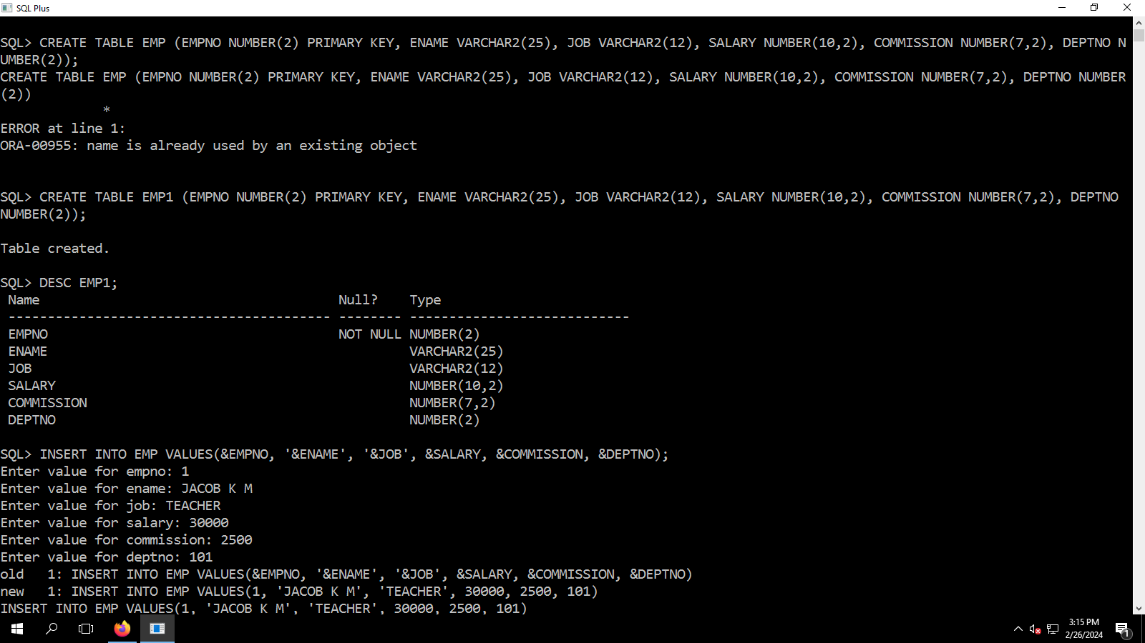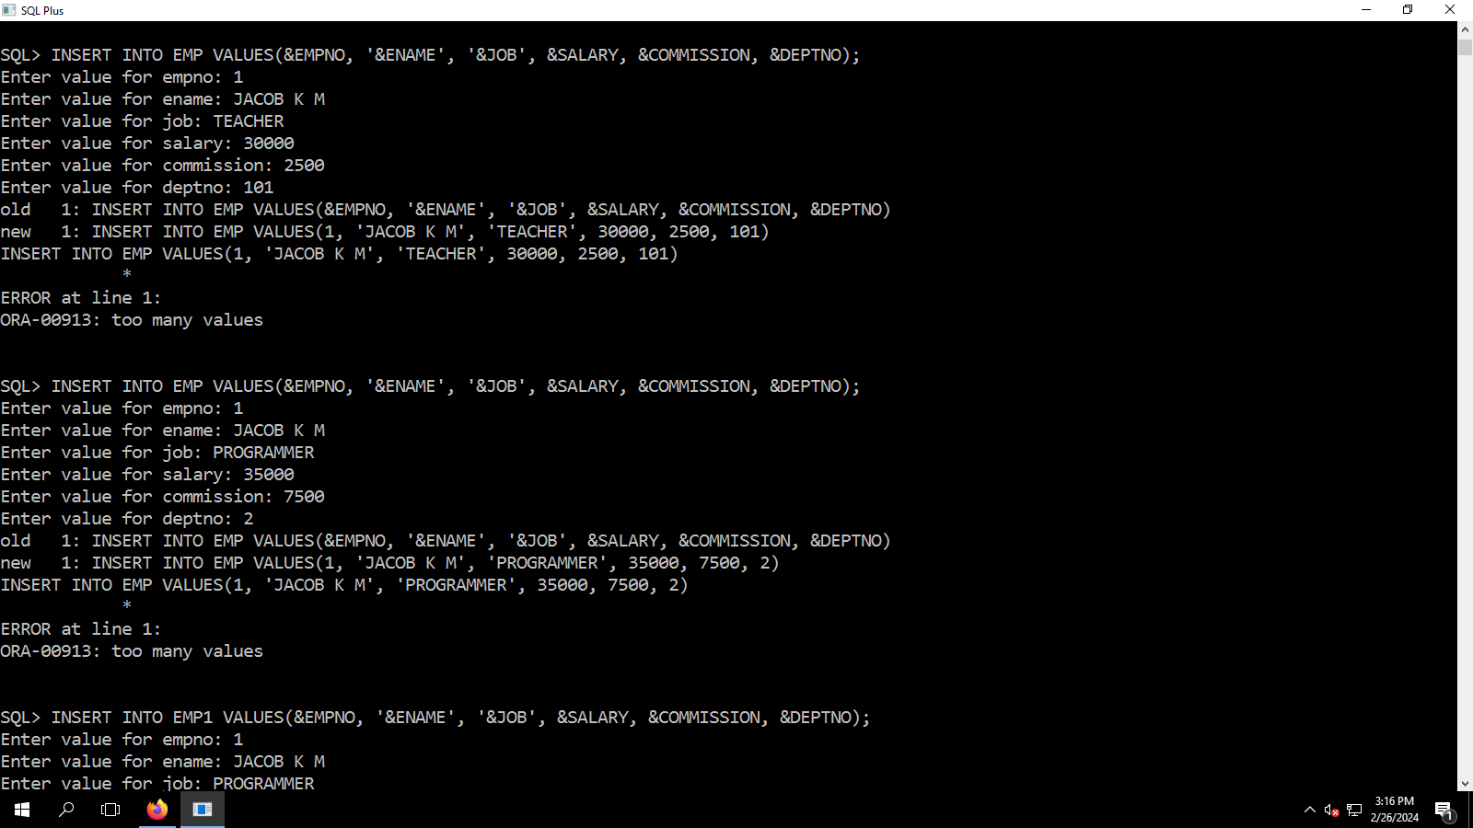

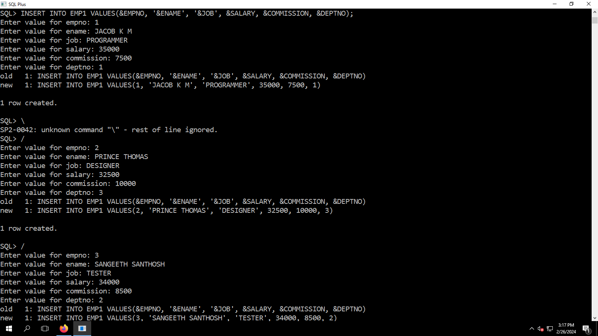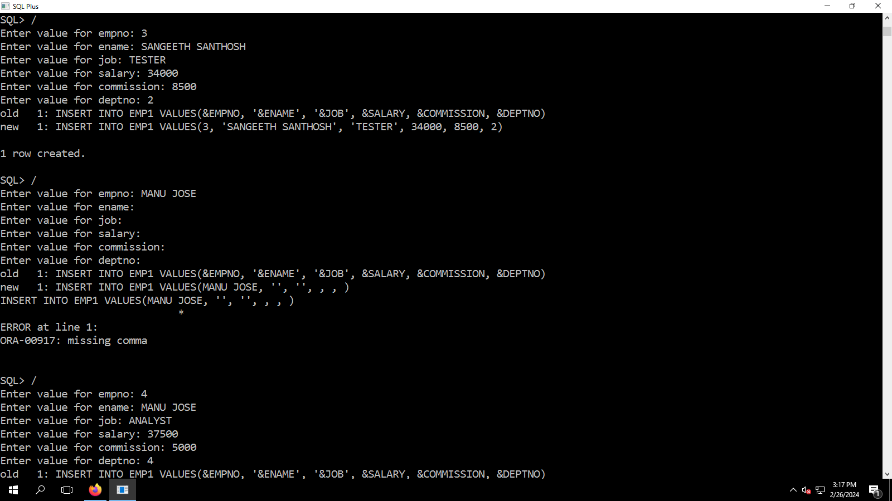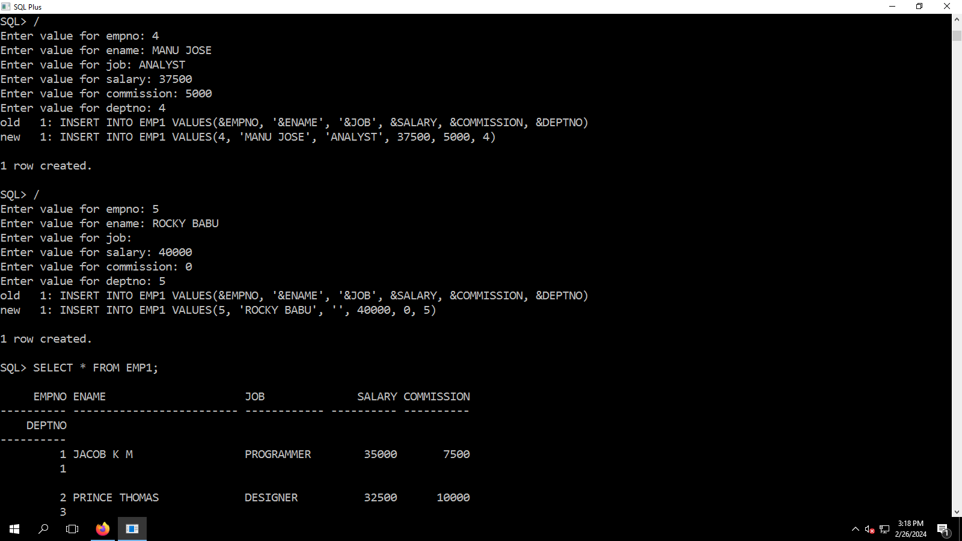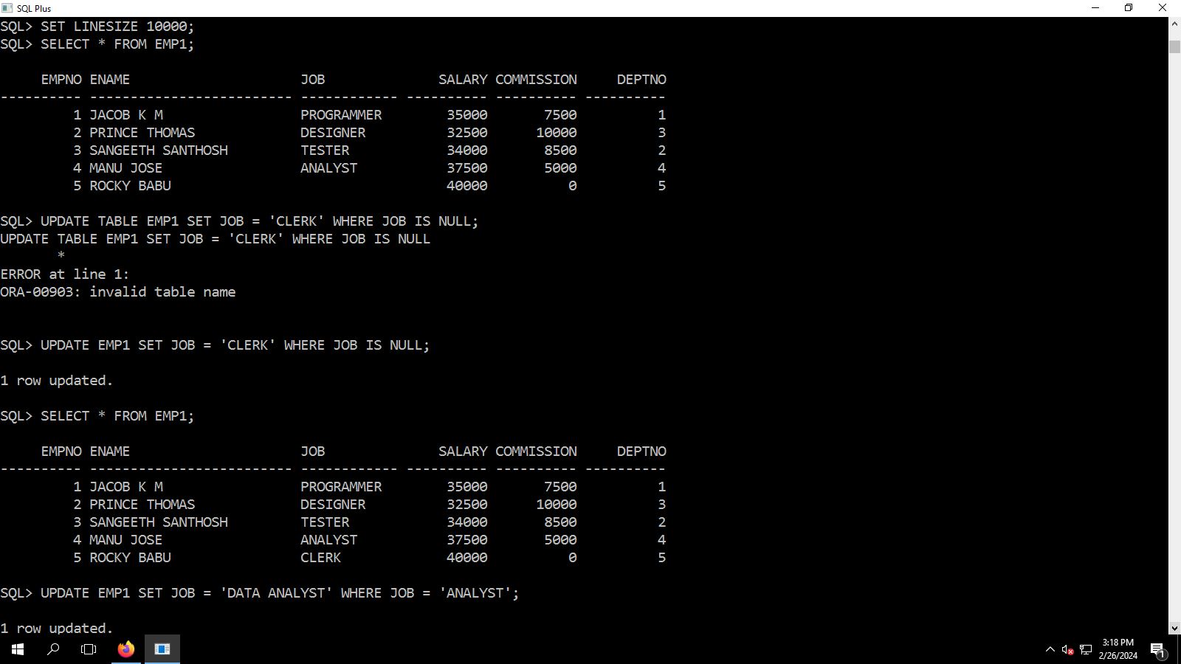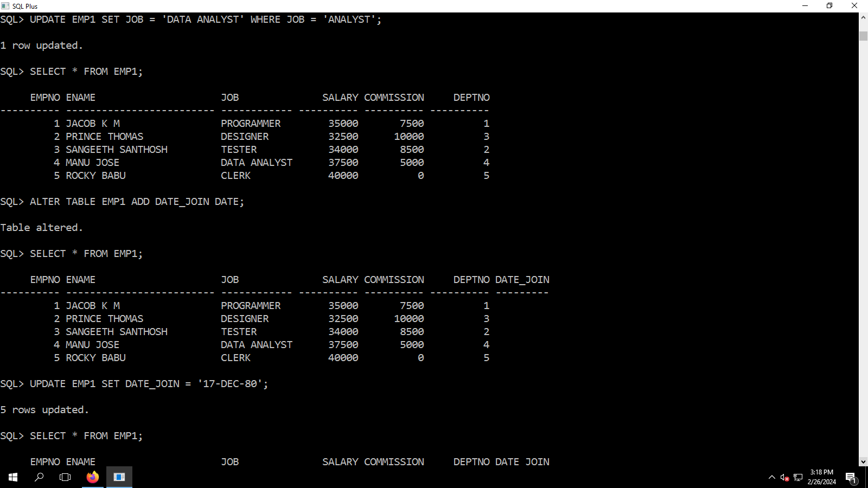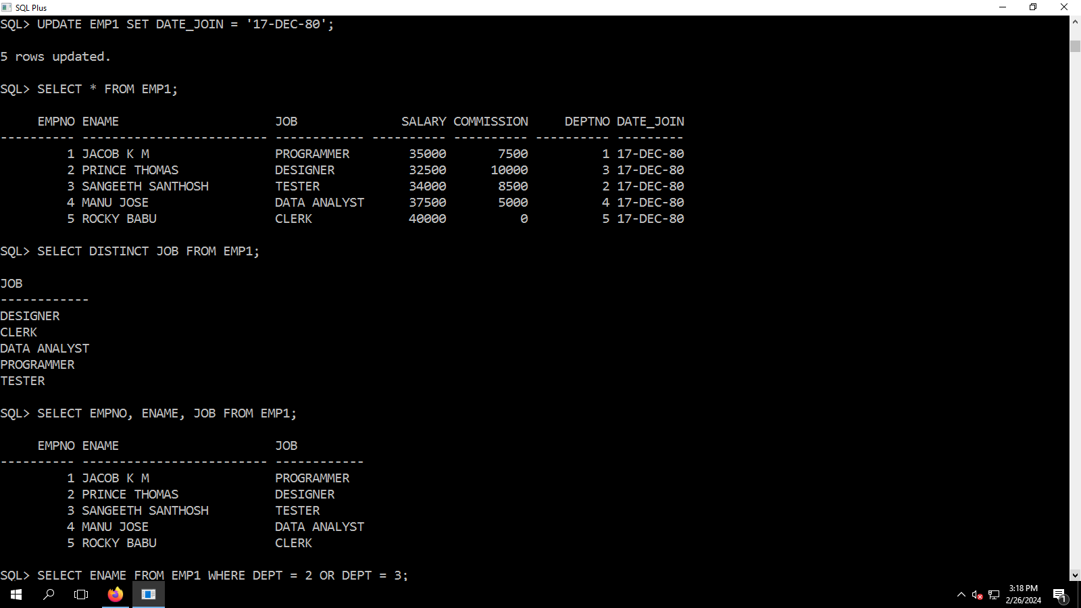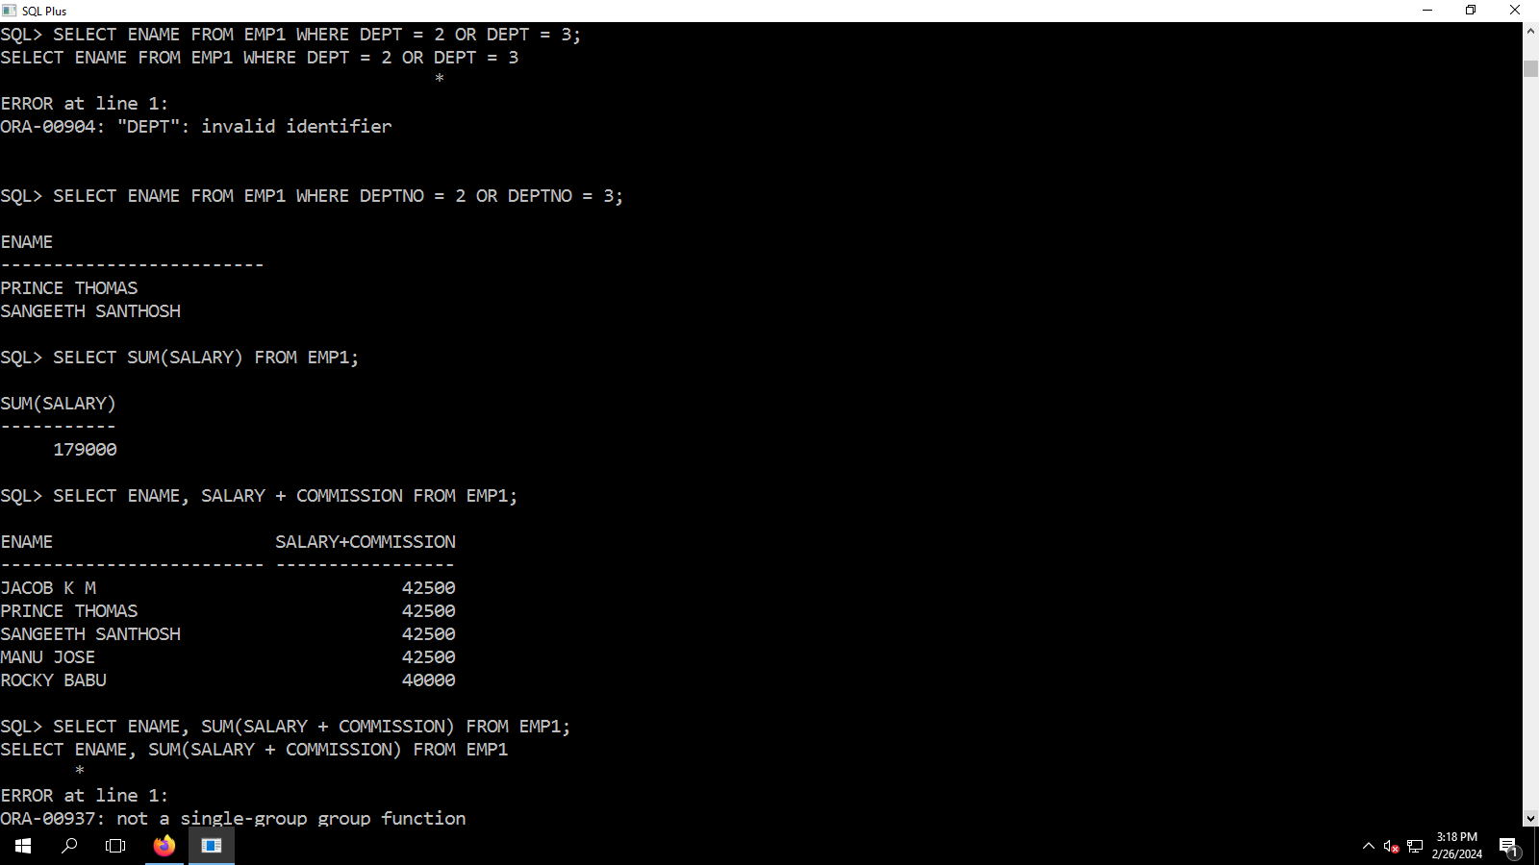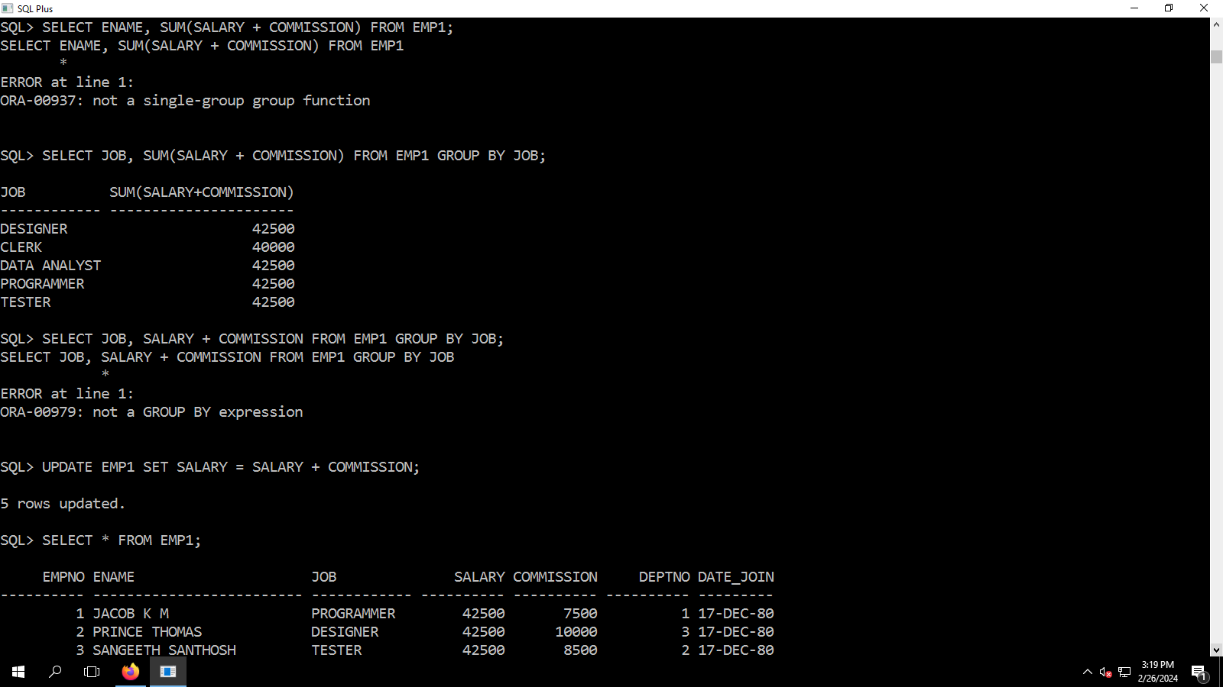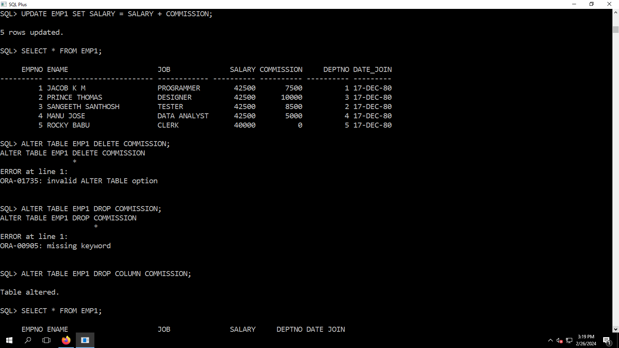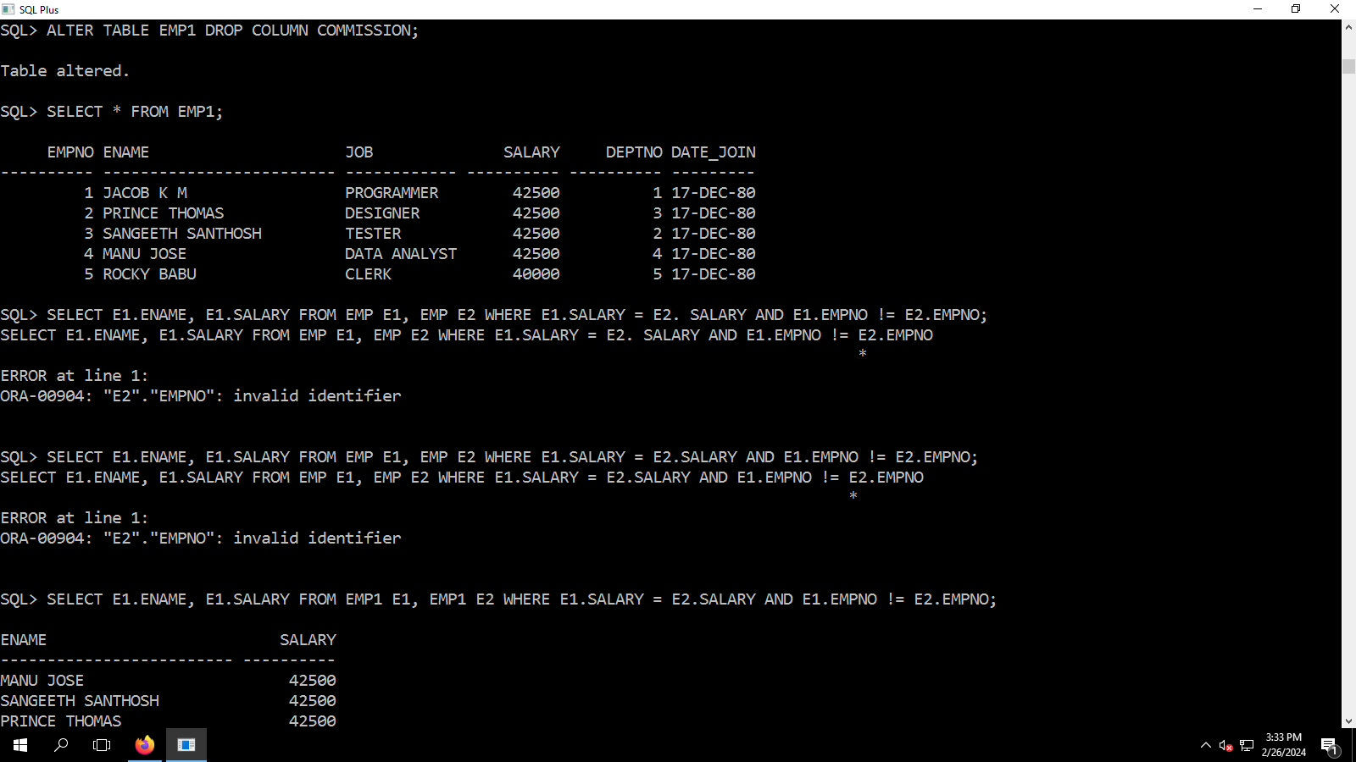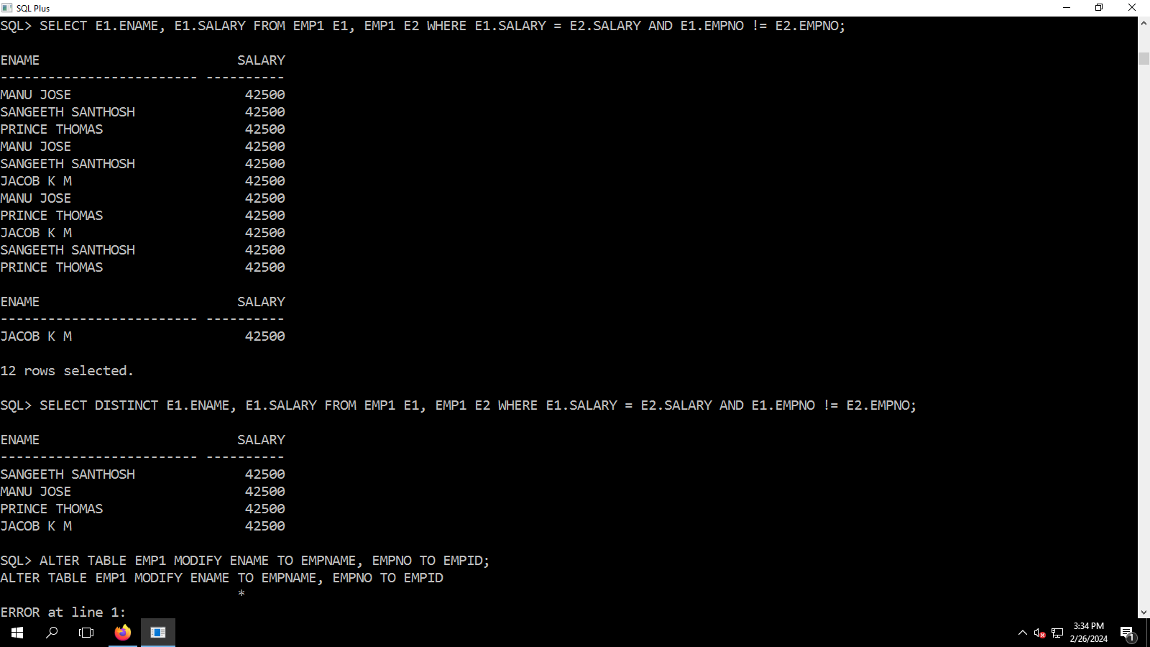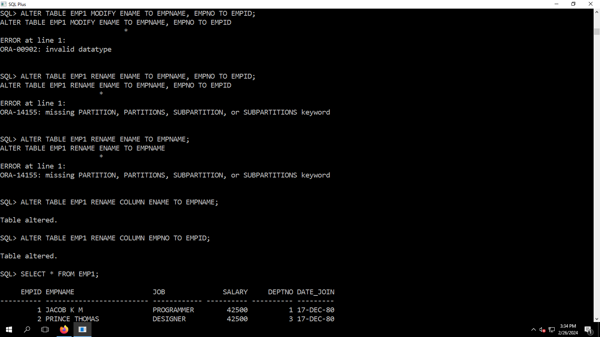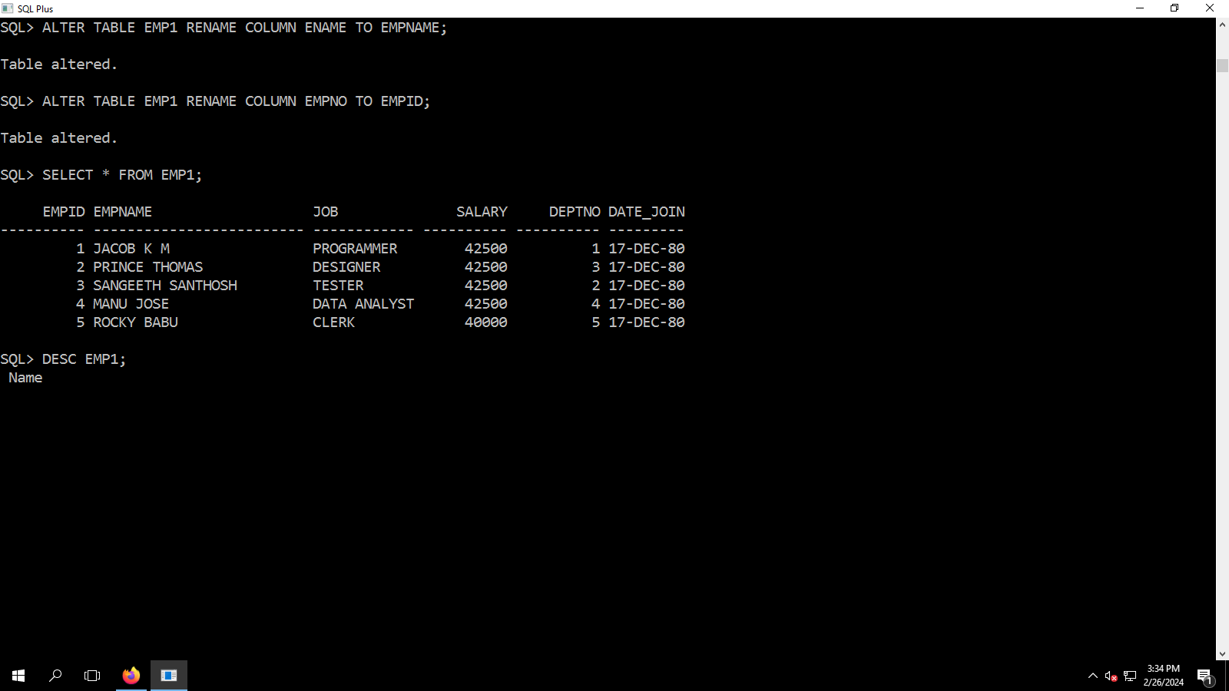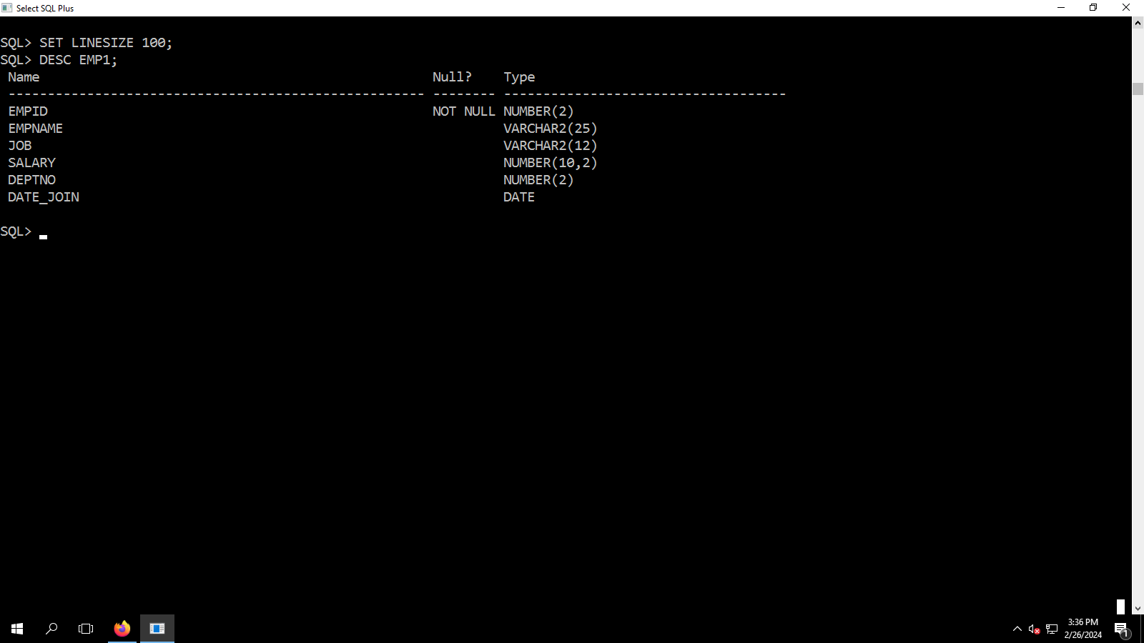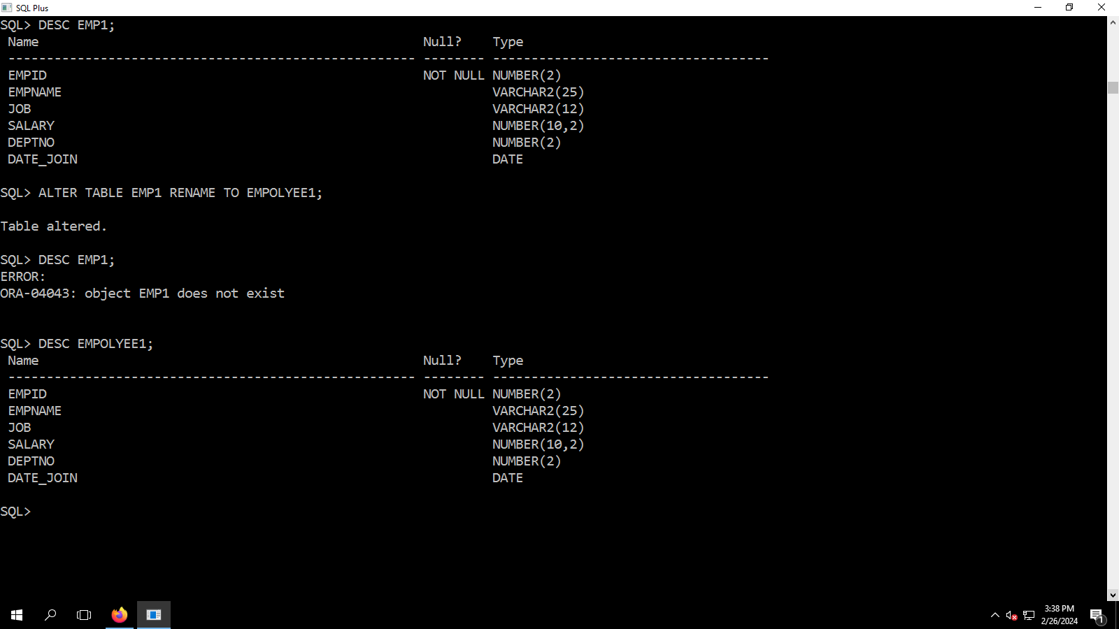

SQL*Plus: Release 12.1.0.1.0 Production on Mon Feb 26 14:34:26 2024

Copyright (c) 1982, 2013, Oracle. All rights reserved.

Enter user-name: c23MCA041@oracle

Enter password:

Last Successful login time: Mon Feb 12 2024 10:39:53 +05:30

Connected to:

Oracle Database 12c Enterprise Edition Release 12.1.0.2.0 - 64bit Production

With the Partitioning, OLAP, Advanced Analytics and Real Application Testing options

SQL> CREATE TABLE EMP (EMPNO NUMBER(2) PRIMARY KEY, ENAME VARCHAR2(25), JOB VARCHAR2(12), SALARY NUMBER(10,2), COMMISSION NUMBER(7,2), DEPTNO NUMBER(2));

CREATE TABLE EMP (EMPNO NUMBER(2) PRIMARY KEY, ENAME VARCHAR2(25), JOB VARCHAR2(12), SALARY NUMBER(10,2), COMMISSION NUMBER(7,2), DEPTNO NUMBER(2))

*

ERROR at line 1:

ORA-00955: name is already used by an existing object

SQL> CREATE TABLE EMP1 (EMPNO NUMBER(2) PRIMARY KEY, ENAME VARCHAR2(25), JOB VARCHAR2(12), SALARY NUMBER(10,2), COMMISSION NUMBER(7,2), DEPTNO NUMBER(2));

Table created.

SQL> DESC EMP1;

Name Null? Type

----------------------------------------- -------- ----------------------------

EMPNO NOT NULL NUMBER(2)

ENAME VARCHAR2(25)

JOB VARCHAR2(12)

SALARY NUMBER(10,2)

COMMISSION NUMBER(7,2)

DEPTNO NUMBER(2)

SQL> INSERT INTO EMP VALUES(&EMPNO, '&ENAME', '&JOB', &SALARY, &COMMISSION, &DEPTNO);

Enter value for empno: 1

Enter value for ename: JACOB K M

Enter value for job: TEACHER

Enter value for salary: 30000

Enter value for commission: 2500

Enter value for deptno: 101

old 1: INSERT INTO EMP VALUES(&EMPNO, '&ENAME', '&JOB', &SALARY, &COMMISSION, &DEPTNO)

new 1: INSERT INTO EMP VALUES(1, 'JACOB K M', 'TEACHER', 30000, 2500, 101)

INSERT INTO EMP VALUES(1, 'JACOB K M', 'TEACHER', 30000, 2500, 101)

*

ERROR at line 1:

ORA-00913: too many values

SQL> INSERT INTO EMP VALUES(&EMPNO, '&ENAME', '&JOB', &SALARY, &COMMISSION, &DEPTNO);

Enter value for empno: 1

Enter value for ename: JACOB K M

Enter value for job: PROGRAMMER

Enter value for salary: 35000

Enter value for commission: 7500

Enter value for deptno: 2

old 1: INSERT INTO EMP VALUES(&EMPNO, '&ENAME', '&JOB', &SALARY, &COMMISSION, &DEPTNO)

new 1: INSERT INTO EMP VALUES(1, 'JACOB K M', 'PROGRAMMER', 35000, 7500, 2)

INSERT INTO EMP VALUES(1, 'JACOB K M', 'PROGRAMMER', 35000, 7500, 2)

*

ERROR at line 1:

ORA-00913: too many values

SQL> INSERT INTO EMP1 VALUES(&EMPNO, '&ENAME', '&JOB', &SALARY, &COMMISSION, &DEPTNO);

Enter value for empno: 1

Enter value for ename: JACOB K M

Enter value for job: PROGRAMMER

Enter value for salary: 35000

Enter value for commission: 7500

Enter value for deptno: 1

old 1: INSERT INTO EMP1 VALUES(&EMPNO, '&ENAME', '&JOB', &SALARY, &COMMISSION, &DEPTNO)

new 1: INSERT INTO EMP1 VALUES(1, 'JACOB K M', 'PROGRAMMER', 35000, 7500, 1)

1 row created.

SQL> \

SP2-0042: unknown command "\" - rest of line ignored.

SQL> /

Enter value for empno: 2

Enter value for ename: PRINCE THOMAS

Enter value for job: DESIGNER

Enter value for salary: 32500

Enter value for commission: 10000

Enter value for deptno: 3

old 1: INSERT INTO EMP1 VALUES(&EMPNO, '&ENAME', '&JOB', &SALARY, &COMMISSION, &DEPTNO)

new 1: INSERT INTO EMP1 VALUES(2, 'PRINCE THOMAS', 'DESIGNER', 32500, 10000, 3)

1 row created.

SQL> /

Enter value for empno: 3

Enter value for ename: SANGEETH SANTHOSH

Enter value for job: TESTER

Enter value for salary: 34000

Enter value for commission: 8500

Enter value for deptno: 2

old 1: INSERT INTO EMP1 VALUES(&EMPNO, '&ENAME', '&JOB', &SALARY, &COMMISSION, &DEPTNO)

new 1: INSERT INTO EMP1 VALUES(3, 'SANGEETH SANTHOSH', 'TESTER', 34000, 8500, 2)

1 row created.

SQL> /

Enter value for empno: MANU JOSE

Enter value for ename:

Enter value for job:

Enter value for salary:

Enter value for commission:

Enter value for deptno:

old 1: INSERT INTO EMP1 VALUES(&EMPNO, '&ENAME', '&JOB', &SALARY, &COMMISSION, &DEPTNO)

new 1: INSERT INTO EMP1 VALUES(MANU JOSE, '', '', , , )

INSERT INTO EMP1 VALUES(MANU JOSE, '', '', , , )

*

ERROR at line 1:

ORA-00917: missing comma

SQL> /

Enter value for empno: 4

Enter value for ename: MANU JOSE

Enter value for job: ANALYST

Enter value for salary: 37500

Enter value for commission: 5000

Enter value for deptno: 4

old 1: INSERT INTO EMP1 VALUES(&EMPNO, '&ENAME', '&JOB', &SALARY, &COMMISSION, &DEPTNO)

new 1: INSERT INTO EMP1 VALUES(4, 'MANU JOSE', 'ANALYST', 37500, 5000, 4)

1 row created.

SQL> /

Enter value for empno: 5

Enter value for ename: ROCKY BABU

Enter value for job:

Enter value for salary: 40000

Enter value for commission: 0

Enter value for deptno: 5

old 1: INSERT INTO EMP1 VALUES(&EMPNO, '&ENAME', '&JOB', &SALARY, &COMMISSION, &DEPTNO)

new 1: INSERT INTO EMP1 VALUES(5, 'ROCKY BABU', '', 40000, 0, 5)

1 row created.

SQL> SELECT * FROM EMP1;

EMPNO ENAME JOB SALARY COMMISSION

---------- ------------------------- ------------ ---------- ----------

DEPTNO

----------

1 JACOB K M PROGRAMMER 35000 7500

1

2 PRINCE THOMAS DESIGNER 32500 10000

3

3 SANGEETH SANTHOSH TESTER 34000 8500

2

EMPNO ENAME JOB SALARY COMMISSION

---------- ------------------------- ------------ ---------- ----------

DEPTNO

----------

4 MANU JOSE ANALYST 37500 5000

4

5 ROCKY BABU 40000 0

5

SQL> SET LINESIZE 10000;

SQL> SELECT * FROM EMP1;

EMPNO ENAME JOB SALARY COMMISSION DEPTNO

---------- ------------------------- ------------ ---------- ---------- ----------

1 JACOB K M PROGRAMMER 35000 7500 1

2 PRINCE THOMAS DESIGNER 32500 10000 3

3 SANGEETH SANTHOSH TESTER 34000 8500 2

4 MANU JOSE ANALYST 37500 5000 4

5 ROCKY BABU 40000 0 5

SQL> UPDATE TABLE EMP1 SET JOB = 'CLERK' WHERE JOB IS NULL;

UPDATE TABLE EMP1 SET JOB = 'CLERK' WHERE JOB IS NULL

*

ERROR at line 1:

ORA-00903: invalid table name

SQL> UPDATE EMP1 SET JOB = 'CLERK' WHERE JOB IS NULL;

1 row updated.

SQL> SELECT * FROM EMP1;

EMPNO ENAME JOB SALARY COMMISSION DEPTNO

---------- ------------------------- ------------ ---------- ---------- ----------

1 JACOB K M PROGRAMMER 35000 7500 1

2 PRINCE THOMAS DESIGNER 32500 10000 3

3 SANGEETH SANTHOSH TESTER 34000 8500 2

4 MANU JOSE ANALYST 37500 5000 4

5 ROCKY BABU CLERK 40000 0 5

SQL> UPDATE EMP1 SET JOB = 'DATA ANALYST' WHERE JOB = 'ANALYST';

1 row updated.

SQL> SELECT * FROM EMP1;

EMPNO ENAME JOB SALARY COMMISSION DEPTNO

---------- ------------------------- ------------ ---------- ---------- ----------

1 JACOB K M PROGRAMMER 35000 7500 1

2 PRINCE THOMAS DESIGNER 32500 10000 3

3 SANGEETH SANTHOSH TESTER 34000 8500 2

4 MANU JOSE DATA ANALYST 37500 5000 4

5 ROCKY BABU CLERK 40000 0 5

SQL> ALTER TABLE EMP1 ADD DATE_JOIN DATE;

Table altered.

SQL> SELECT * FROM EMP1;

EMPNO ENAME JOB SALARY COMMISSION DEPTNO DATE_JOIN

---------- ------------------------- ------------ ---------- ---------- ---------- ---------

1 JACOB K M PROGRAMMER 35000 7500 1

2 PRINCE THOMAS DESIGNER 32500 10000 3

3 SANGEETH SANTHOSH TESTER 34000 8500 2

4 MANU JOSE DATA ANALYST 37500 5000 4

5 ROCKY BABU CLERK 40000 0 5

SQL> UPDATE EMP1 SET DATE_JOIN = '17-DEC-80';

5 rows updated.

SQL> SELECT * FROM EMP1;

EMPNO ENAME JOB SALARY COMMISSION DEPTNO DATE_JOIN

---------- ------------------------- ------------ ---------- ---------- ---------- ---------

1 JACOB K M PROGRAMMER 35000 7500 1 17-DEC-80

2 PRINCE THOMAS DESIGNER 32500 10000 3 17-DEC-80

3 SANGEETH SANTHOSH TESTER 34000 8500 2 17-DEC-80

4 MANU JOSE DATA ANALYST 37500 5000 4 17-DEC-80

5 ROCKY BABU CLERK 40000 0 5 17-DEC-80

SQL> SELECT DISTINCT JOB FROM EMP1;

JOB

------------

DESIGNER

CLERK

DATA ANALYST

PROGRAMMER

TESTER

SQL> SELECT EMPNO, ENAME, JOB FROM EMP1;

EMPNO ENAME JOB

---------- ------------------------- ------------

1 JACOB K M PROGRAMMER

2 PRINCE THOMAS DESIGNER

3 SANGEETH SANTHOSH TESTER

4 MANU JOSE DATA ANALYST

5 ROCKY BABU CLERK

SQL> SELECT ENAME FROM EMP1 WHERE DEPT = 2 OR DEPT = 3;

SELECT ENAME FROM EMP1 WHERE DEPT = 2 OR DEPT = 3

*

ERROR at line 1:

ORA-00904: "DEPT": invalid identifier

SQL> SELECT ENAME FROM EMP1 WHERE DEPTNO = 2 OR DEPTNO = 3;

ENAME

-------------------------

PRINCE THOMAS

SANGEETH SANTHOSH

SQL> SELECT SUM(SALARY) FROM EMP1;

SUM(SALARY)

-----------

179000

SQL> SELECT ENAME, SALARY + COMMISSION FROM EMP1;

ENAME SALARY+COMMISSION

------------------------- -----------------

JACOB K M 42500

PRINCE THOMAS 42500

SANGEETH SANTHOSH 42500

MANU JOSE 42500

ROCKY BABU 40000

SQL> SELECT ENAME, SUM(SALARY + COMMISSION) FROM EMP1;

SELECT ENAME, SUM(SALARY + COMMISSION) FROM EMP1

*

ERROR at line 1:

ORA-00937: not a single-group group function

SQL> SELECT JOB, SUM(SALARY + COMMISSION) FROM EMP1 GROUP BY JOB;

JOB SUM(SALARY+COMMISSION)

------------ ----------------------

DESIGNER 42500

CLERK 40000

DATA ANALYST 42500

PROGRAMMER 42500

TESTER 42500

SQL> SELECT JOB, SALARY + COMMISSION FROM EMP1 GROUP BY JOB;

SELECT JOB, SALARY + COMMISSION FROM EMP1 GROUP BY JOB

*

ERROR at line 1:

ORA-00979: not a GROUP BY expression

SQL> UPDATE EMP1 SET SALARY = SALARY + COMMISSION;

5 rows updated.

SQL> SELECT * FROM EMP1;

EMPNO ENAME JOB SALARY COMMISSION DEPTNO DATE_JOIN

---------- ------------------------- ------------ ---------- ---------- ---------- ---------

1 JACOB K M PROGRAMMER 42500 7500 1 17-DEC-80

2 PRINCE THOMAS DESIGNER 42500 10000 3 17-DEC-80

3 SANGEETH SANTHOSH TESTER 42500 8500 2 17-DEC-80

4 MANU JOSE DATA ANALYST 42500 5000 4 17-DEC-80

5 ROCKY BABU CLERK 40000 0 5 17-DEC-80

SQL> ALTER TABLE EMP1 DELETE COMMISSION;

ALTER TABLE EMP1 DELETE COMMISSION

*

ERROR at line 1:

ORA-01735: invalid ALTER TABLE option

SQL> ALTER TABLE EMP1 DROP COMMISSION;

ALTER TABLE EMP1 DROP COMMISSION

*

ERROR at line 1:

ORA-00905: missing keyword

SQL> ALTER TABLE EMP1 DROP COLUMN COMMISSION;

Table altered.

SQL> SELECT * FROM EMP1;

EMPNO ENAME JOB SALARY DEPTNO DATE_JOIN

---------- ------------------------- ------------ ---------- ---------- ---------

1 JACOB K M PROGRAMMER 42500 1 17-DEC-80

2 PRINCE THOMAS DESIGNER 42500 3 17-DEC-80

3 SANGEETH SANTHOSH TESTER 42500 2 17-DEC-80

4 MANU JOSE DATA ANALYST 42500 4 17-DEC-80

5 ROCKY BABU CLERK 40000 5 17-DEC-80

SQL>

SQL> DESC EMP1;

Name Null? Type

----------------------------------------------------- -------- ------------------------------------

EMPID NOT NULL NUMBER(2)

EMPNAME VARCHAR2(25)

JOB VARCHAR2(12)

SALARY NUMBER(10,2)

DEPTNO NUMBER(2)

DATE_JOIN DATE

SQL> ALTER TABLE EMP1 RENAME TO EMPOLYEE1;

Table altered.

SQL> DESC EMP1;

ERROR:

ORA-04043: object EMP1 does not exist

SQL> DESC EMPOLYEE1;

Name Null? Type

----------------------------------------------------- -------- ------------------------------------

EMPID NOT NULL NUMBER(2)

EMPNAME VARCHAR2(25)

JOB VARCHAR2(12)

SALARY NUMBER(10,2)

DEPTNO NUMBER(2)

DATE_JOIN DATE

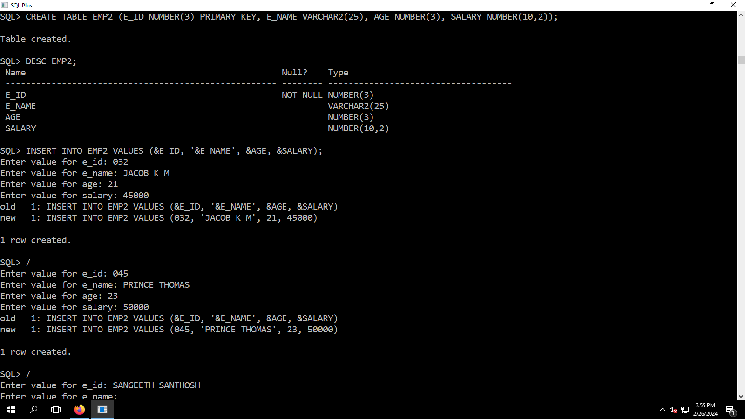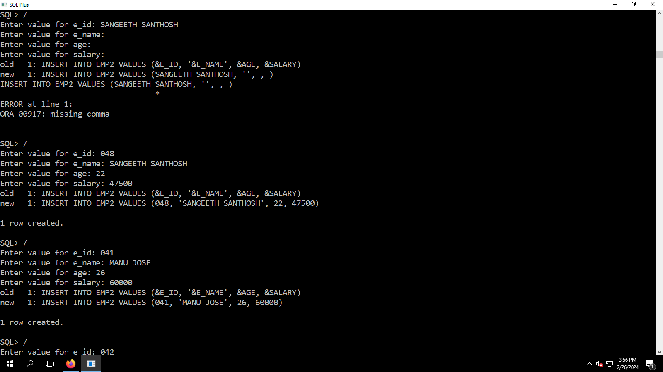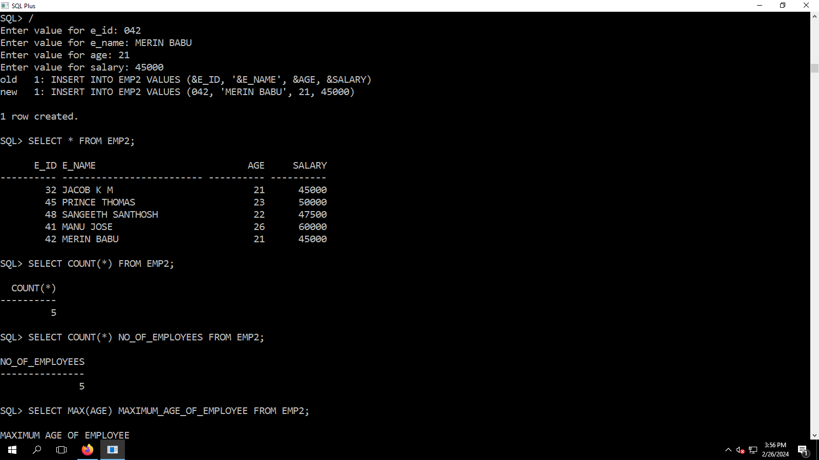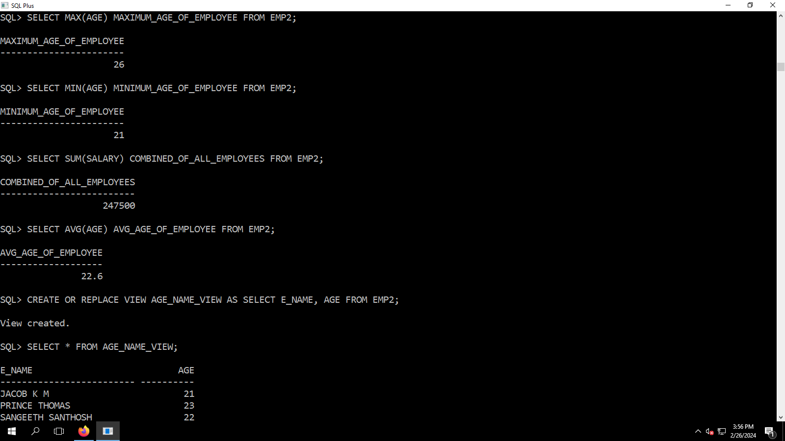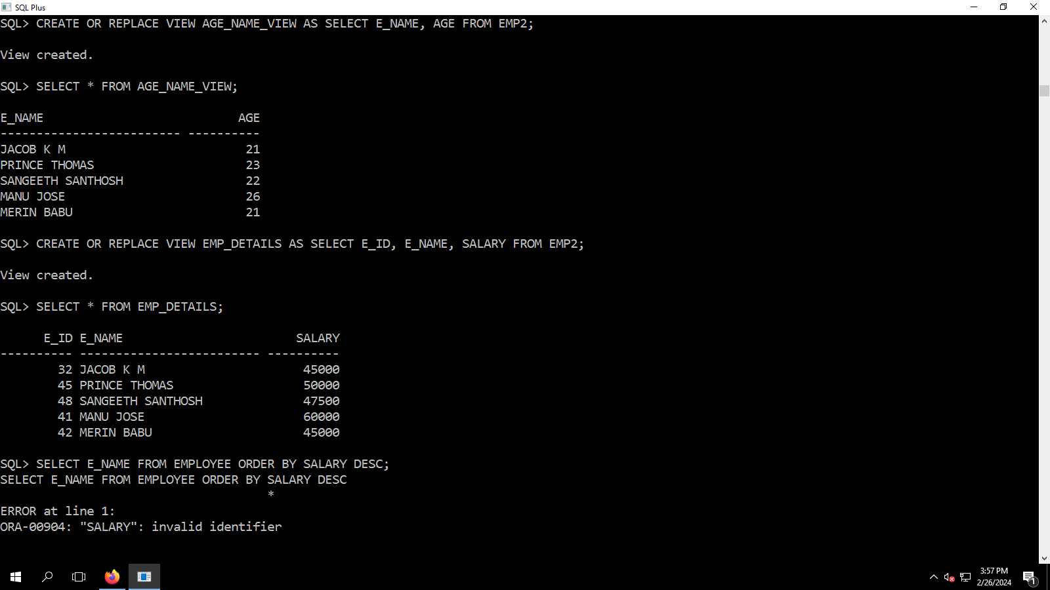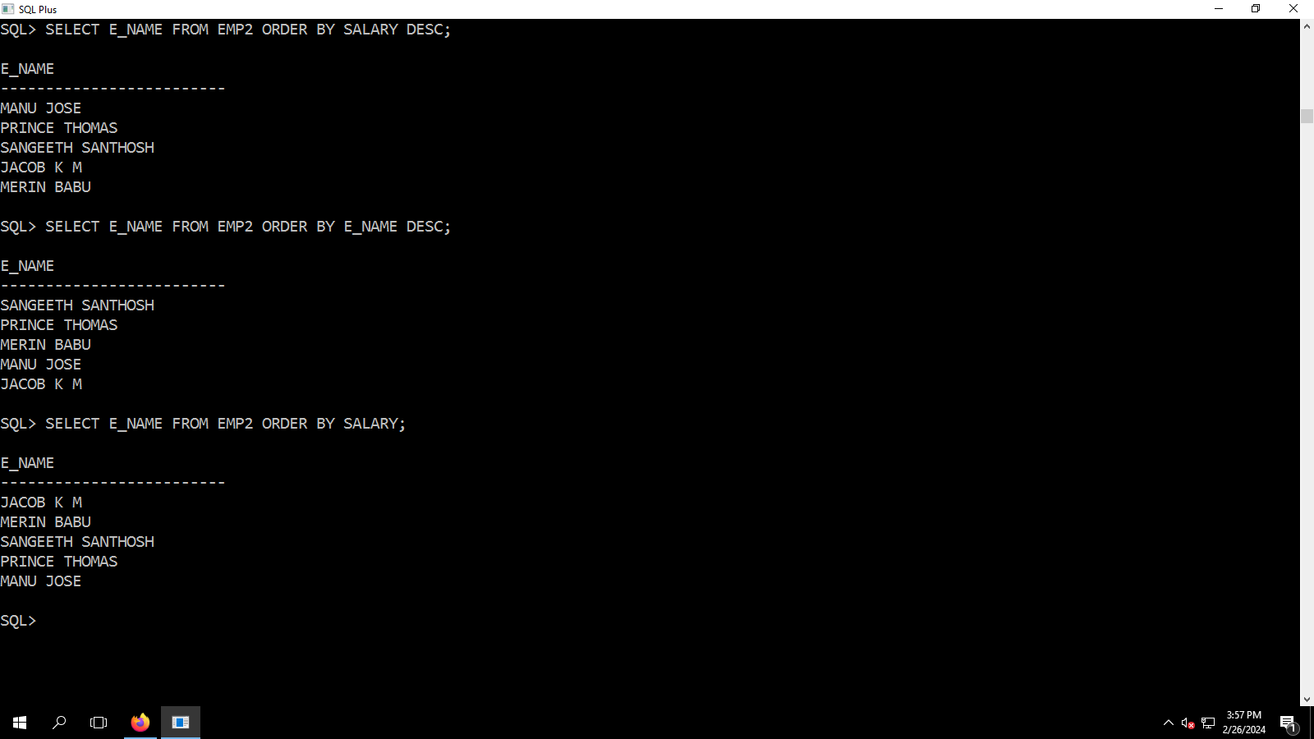

SQL> CREATE TABLE EMP2 (E_ID NUMBER(3) PRIMARY KEY, E_NAME VARCHAR2(25), AGE NUMBER(3), SALARY NUMBER(10,2));

Table created.

SQL> DESC EMP2;

Name Null? Type

----------------------------------------------------- -------- ------------------------------------

E_ID NOT NULL NUMBER(3)

E_NAME VARCHAR2(25)

AGE NUMBER(3)

SALARY NUMBER(10,2)

SQL> INSERT INTO EMP2 VALUES (&E_ID, '&E_NAME', &AGE, &SALARY);

Enter value for e_id: 032

Enter value for e_name: JACOB K M

Enter value for age: 21

Enter value for salary: 45000

old 1: INSERT INTO EMP2 VALUES (&E_ID, '&E_NAME', &AGE, &SALARY)

new 1: INSERT INTO EMP2 VALUES (032, 'JACOB K M', 21, 45000)

1 row created.

SQL> /

Enter value for e_id: 045

Enter value for e_name: PRINCE THOMAS

Enter value for age: 23

Enter value for salary: 50000

old 1: INSERT INTO EMP2 VALUES (&E_ID, '&E_NAME', &AGE, &SALARY)

new 1: INSERT INTO EMP2 VALUES (045, 'PRINCE THOMAS', 23, 50000)

1 row created.

SQL> /

Enter value for e_id: SANGEETH SANTHOSH

Enter value for e_name:

Enter value for age:

Enter value for salary:

old 1: INSERT INTO EMP2 VALUES (&E_ID, '&E_NAME', &AGE, &SALARY)

new 1: INSERT INTO EMP2 VALUES (SANGEETH SANTHOSH, '', , )

INSERT INTO EMP2 VALUES (SANGEETH SANTHOSH, '', , )

*

ERROR at line 1:

ORA-00917: missing comma

SQL> /

Enter value for e_id: 048

Enter value for e_name: SANGEETH SANTHOSH

Enter value for age: 22

Enter value for salary: 47500

old 1: INSERT INTO EMP2 VALUES (&E_ID, '&E_NAME', &AGE, &SALARY)

new 1: INSERT INTO EMP2 VALUES (048, 'SANGEETH SANTHOSH', 22, 47500)

1 row created.

SQL> /

Enter value for e_id: 041

Enter value for e_name: MANU JOSE

Enter value for age: 26

Enter value for salary: 60000

old 1: INSERT INTO EMP2 VALUES (&E_ID, '&E_NAME', &AGE, &SALARY)

new 1: INSERT INTO EMP2 VALUES (041, 'MANU JOSE', 26, 60000)

1 row created.

SQL> /

Enter value for e_id: 042

Enter value for e_name: MERIN BABU

Enter value for age: 21

Enter value for salary: 45000

old 1: INSERT INTO EMP2 VALUES (&E_ID, '&E_NAME', &AGE, &SALARY)

new 1: INSERT INTO EMP2 VALUES (042, 'MERIN BABU', 21, 45000)

1 row created.

SQL> SELECT * FROM EMP2;

E_ID E_NAME AGE SALARY

---------- ------------------------- ---------- ----------

32 JACOB K M 21 45000

45 PRINCE THOMAS 23 50000

48 SANGEETH SANTHOSH 22 47500

41 MANU JOSE 26 60000

42 MERIN BABU 21 45000

SQL> SELECT COUNT(*) FROM EMP2;

COUNT(*)

----------

5

SQL> SELECT COUNT(*) NO_OF_EMPLOYEES FROM EMP2;

NO_OF_EMPLOYEES

---------------

5

SQL> SELECT MAX(AGE) MAXIMUM_AGE_OF_EMPLOYEE FROM EMP2;

MAXIMUM_AGE_OF_EMPLOYEE

-----------------------

26

SQL> SELECT MIN(AGE) MINIMUM_AGE_OF_EMPLOYEE FROM EMP2;

MINIMUM_AGE_OF_EMPLOYEE

-----------------------

21

SQL> SELECT SUM(SALARY) COMBINED_OF_ALL_EMPLOYEES FROM EMP2;

COMBINED_OF_ALL_EMPLOYEES

-------------------------

247500

SQL> SELECT AVG(AGE) AVG_AGE_OF_EMPLOYEE FROM EMP2;

AVG_AGE_OF_EMPLOYEE

-------------------

22.6

SQL> CREATE OR REPLACE VIEW AGE_NAME_VIEW AS SELECT E_NAME, AGE FROM EMP2;

View created.

SQL> SELECT * FROM AGE_NAME_VIEW;

E_NAME AGE

------------------------- ----------

JACOB K M 21

PRINCE THOMAS 23

SANGEETH SANTHOSH 22

MANU JOSE 26

MERIN BABU 21

SQL> CREATE OR REPLACE VIEW EMP_DETAILS AS SELECT E_ID, E_NAME, SALARY FROM EMP2;

View created.

SQL> SELECT * FROM EMP_DETAILS;

E_ID E_NAME SALARY

---------- ------------------------- ----------

32 JACOB K M 45000

45 PRINCE THOMAS 50000

48 SANGEETH SANTHOSH 47500

41 MANU JOSE 60000

42 MERIN BABU 45000

SQL> SELECT E_NAME FROM EMPLOYEE ORDER BY SALARY DESC;

SELECT E_NAME FROM EMPLOYEE ORDER BY SALARY DESC

*

ERROR at line 1:

ORA-00904: "SALARY": invalid identifier

SQL> SELECT E_NAME FROM EMP2 ORDER BY SALARY DESC;

E_NAME

-------------------------

MANU JOSE

PRINCE THOMAS

SANGEETH SANTHOSH

JACOB K M

MERIN BABU

SQL> SELECT E_NAME FROM EMP2 ORDER BY E_NAME DESC;

E_NAME

-------------------------

SANGEETH SANTHOSH

PRINCE THOMAS

MERIN BABU

MANU JOSE

JACOB K M

SQL> SELECT E_NAME FROM EMP2 ORDER BY SALARY;

E_NAME

-------------------------

JACOB K M

MERIN BABU

SANGEETH SANTHOSH

PRINCE THOMAS

MANU JOSE

SQL>

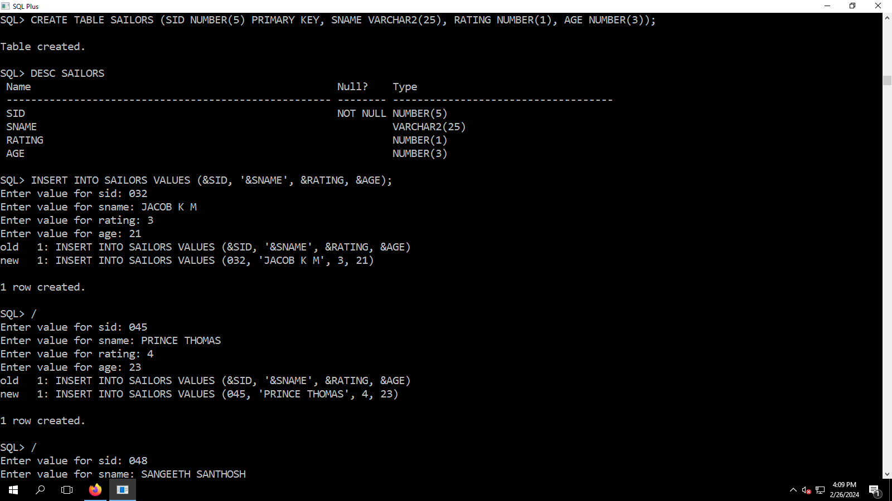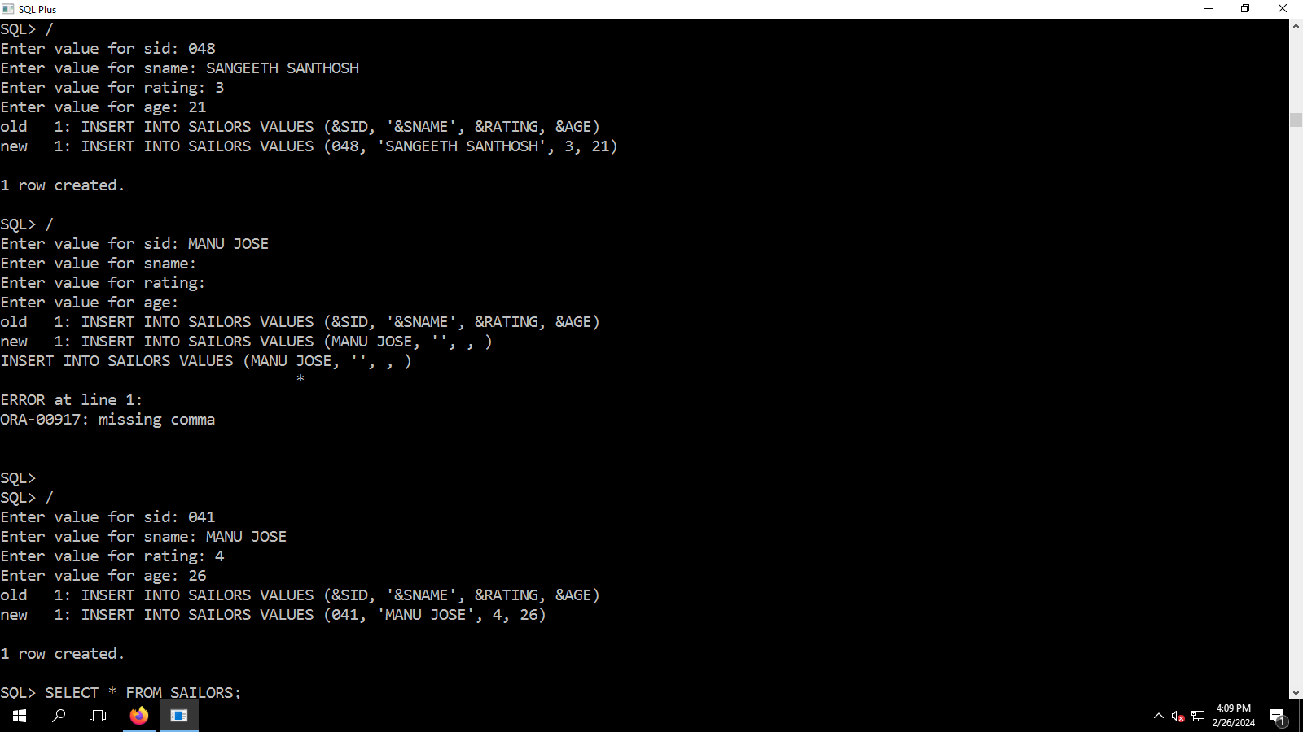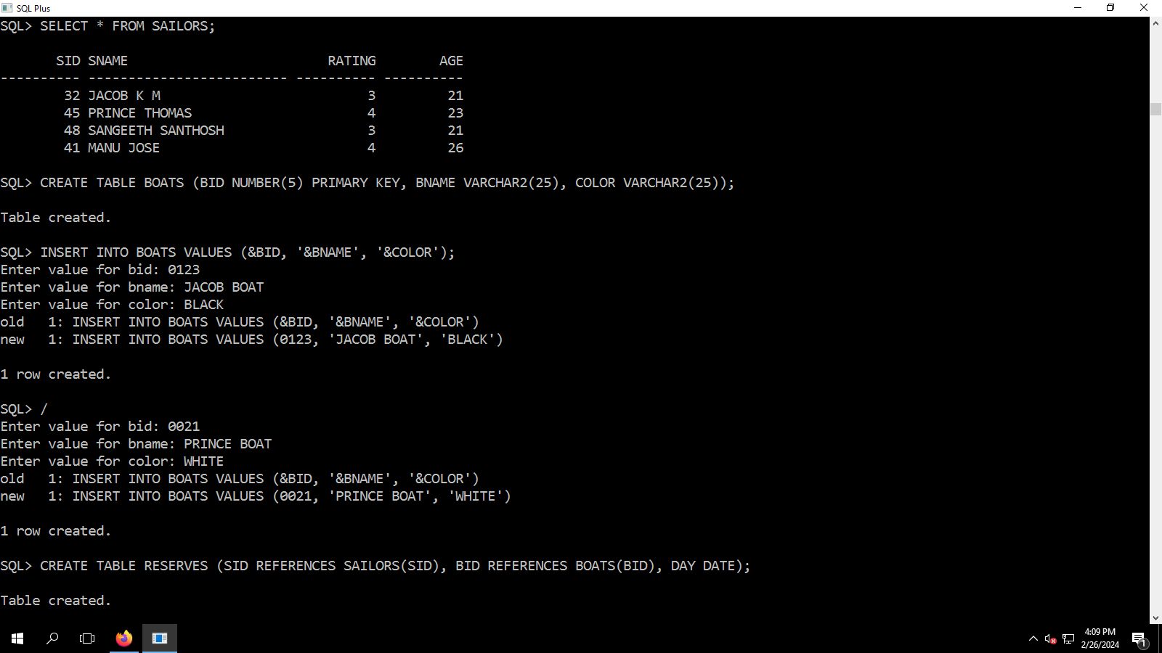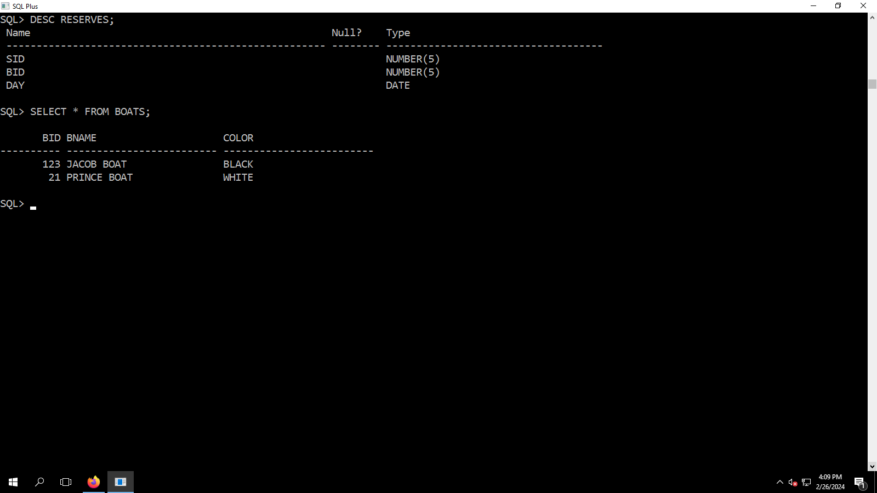SQL> CREATE TABLE SAILORS (SID NUMBER(5) PRIMARY KEY, SNAME VARCHAR2(25), RATING NUMBER(1), AGE NUMBER(3));

Table created.

SQL> DESC SAILORS

Name Null? Type

----------------------------------------------------- -------- ------------------------------------

SID NOT NULL NUMBER(5)

SNAME VARCHAR2(25)

RATING NUMBER(1)

AGE NUMBER(3)

SQL> INSERT INTO SAILORS VALUES (&SID, '&SNAME', &RATING, &AGE);

Enter value for sid: 032

Enter value for sname: JACOB K M

Enter value for rating: 3

Enter value for age: 21

old 1: INSERT INTO SAILORS VALUES (&SID, '&SNAME', &RATING, &AGE)

new 1: INSERT INTO SAILORS VALUES (032, 'JACOB K M', 3, 21)

1 row created.

SQL> /

Enter value for sid: 045

Enter value for sname: PRINCE THOMAS

Enter value for rating: 4

Enter value for age: 23

old 1: INSERT INTO SAILORS VALUES (&SID, '&SNAME', &RATING, &AGE)

new 1: INSERT INTO SAILORS VALUES (045, 'PRINCE THOMAS', 4, 23)

1 row created.

SQL> /

Enter value for sid: 048

Enter value for sname: SANGEETH SANTHOSH

Enter value for rating: 3

Enter value for age: 21

old 1: INSERT INTO SAILORS VALUES (&SID, '&SNAME', &RATING, &AGE)

new 1: INSERT INTO SAILORS VALUES (048, 'SANGEETH SANTHOSH', 3, 21)

1 row created.

SQL> /

Enter value for sid: MANU JOSE

Enter value for sname:

Enter value for rating:

Enter value for age:

old 1: INSERT INTO SAILORS VALUES (&SID, '&SNAME', &RATING, &AGE)

new 1: INSERT INTO SAILORS VALUES (MANU JOSE, '', , )

INSERT INTO SAILORS VALUES (MANU JOSE, '', , )

*

ERROR at line 1:

ORA-00917: missing comma

SQL>

SQL> /

Enter value for sid: 041

Enter value for sname: MANU JOSE

Enter value for rating: 4

Enter value for age: 26

old 1: INSERT INTO SAILORS VALUES (&SID, '&SNAME', &RATING, &AGE)

new 1: INSERT INTO SAILORS VALUES (041, 'MANU JOSE', 4, 26)

1 row created.

SQL> SELECT * FROM SAILORS;

SID SNAME RATING AGE

---------- ------------------------- ---------- ----------

32 JACOB K M 3 21

45 PRINCE THOMAS 4 23

48 SANGEETH SANTHOSH 3 21

41 MANU JOSE 4 26

SQL> CREATE TABLE BOATS (BID NUMBER(5) PRIMARY KEY, BNAME VARCHAR2(25), COLOR VARCHAR2(25));

Table created.

SQL> INSERT INTO BOATS VALUES (&BID, '&BNAME', '&COLOR');

Enter value for bid: 0123

Enter value for bname: JACOB BOAT

Enter value for color: BLACK

old 1: INSERT INTO BOATS VALUES (&BID, '&BNAME', '&COLOR')

new 1: INSERT INTO BOATS VALUES (0123, 'JACOB BOAT', 'BLACK')

1 row created.

SQL> /

Enter value for bid: 0021

Enter value for bname: PRINCE BOAT

Enter value for color: WHITE

old 1: INSERT INTO BOATS VALUES (&BID, '&BNAME', '&COLOR')

new 1: INSERT INTO BOATS VALUES (0021, 'PRINCE BOAT', 'WHITE')

1 row created.

SQL> CREATE TABLE RESERVES (SID REFERENCES SAILORS(SID), BID REFERENCES BOATS(BID), DAY DATE);

Table created.

SQL> DESC RESERVES;

Name Null? Type

----------------------------------------------------- -------- ------------------------------------

SID NUMBER(5)

BID NUMBER(5)

DAY DATE

SQL> SELECT * FROM BOATS;

BID BNAME COLOR

---------- ------------------------- -------------------------

123 JACOB BOAT BLACK

21 PRINCE BOAT WHITE

SQL>

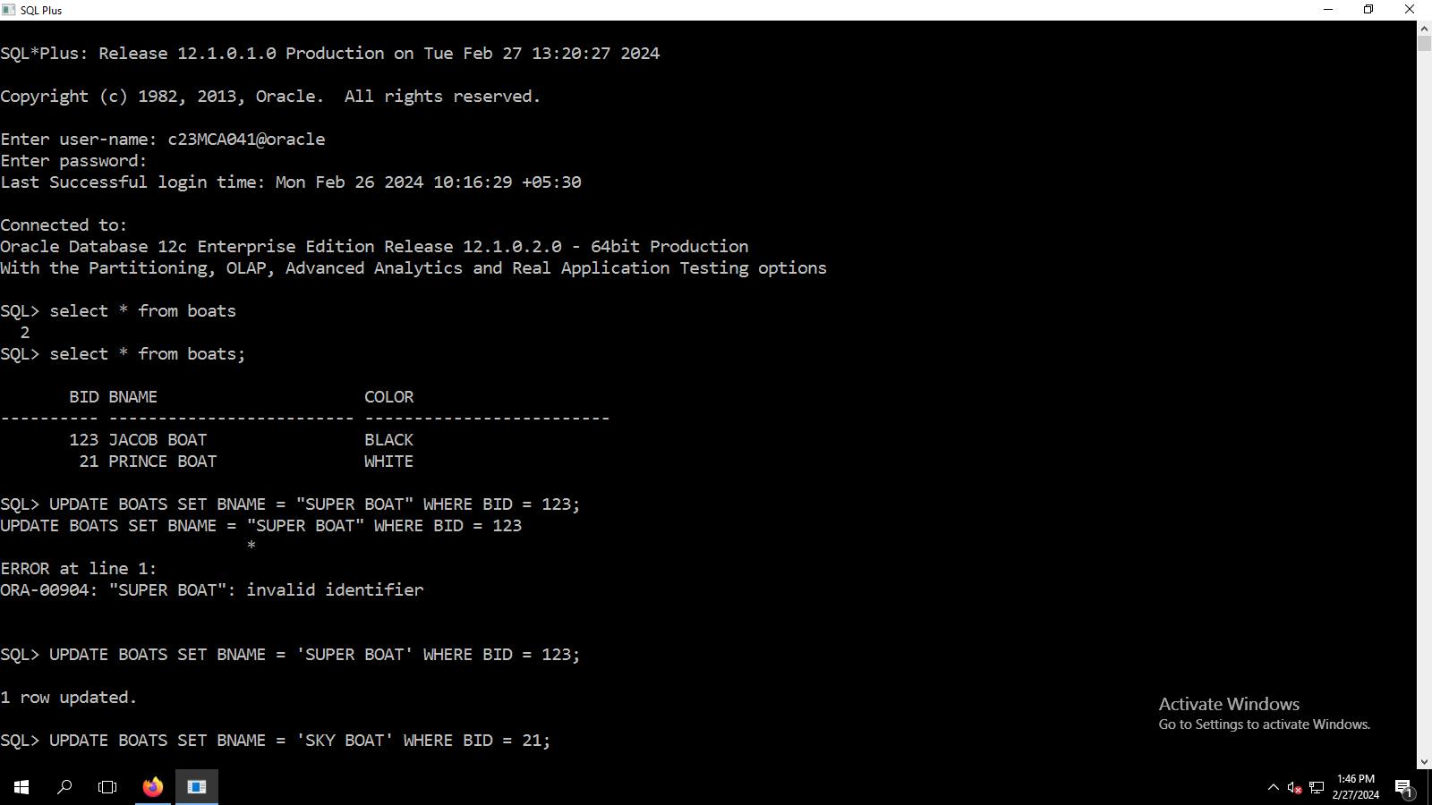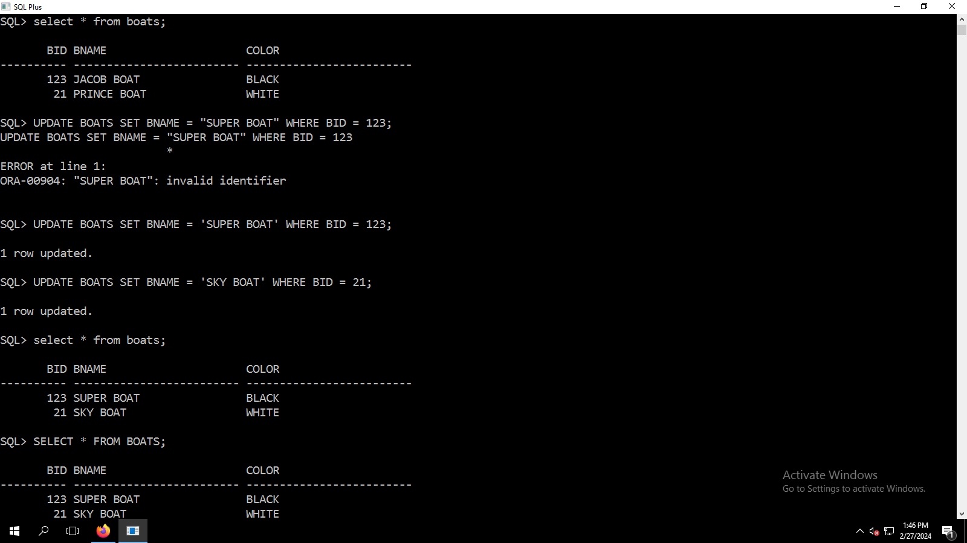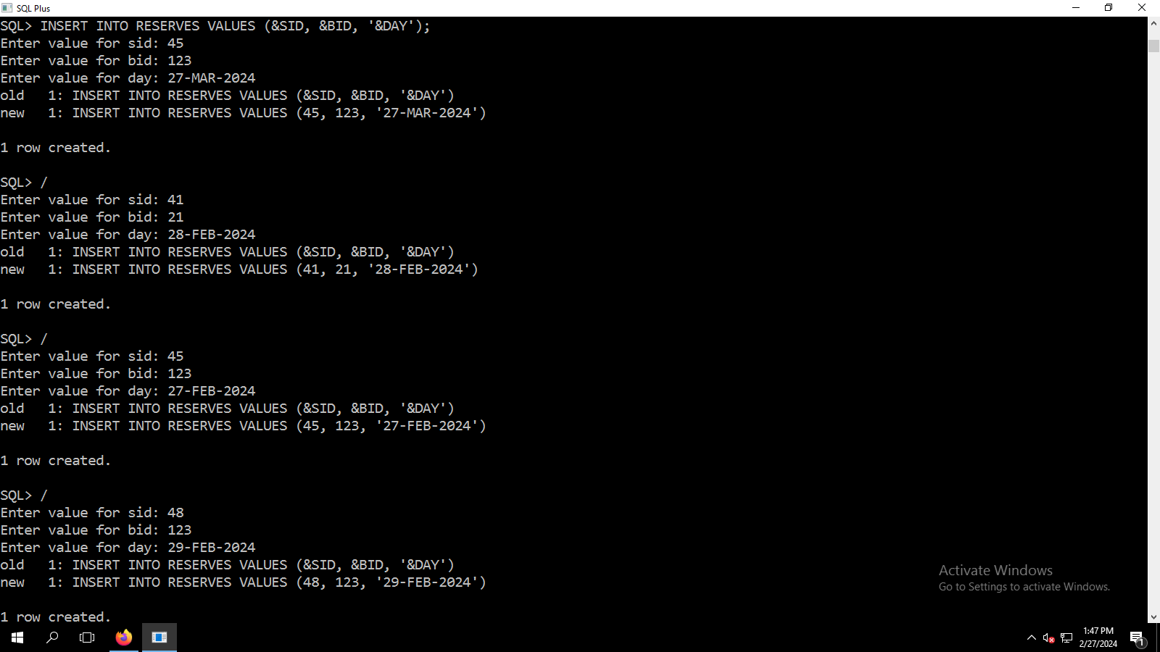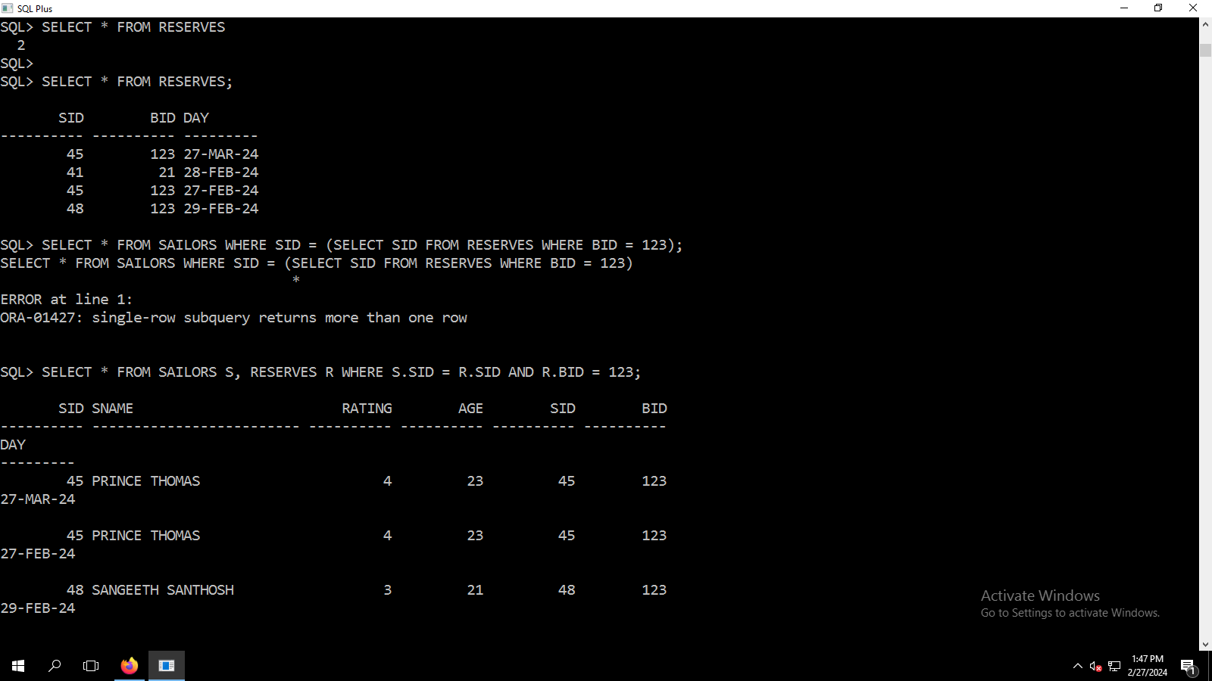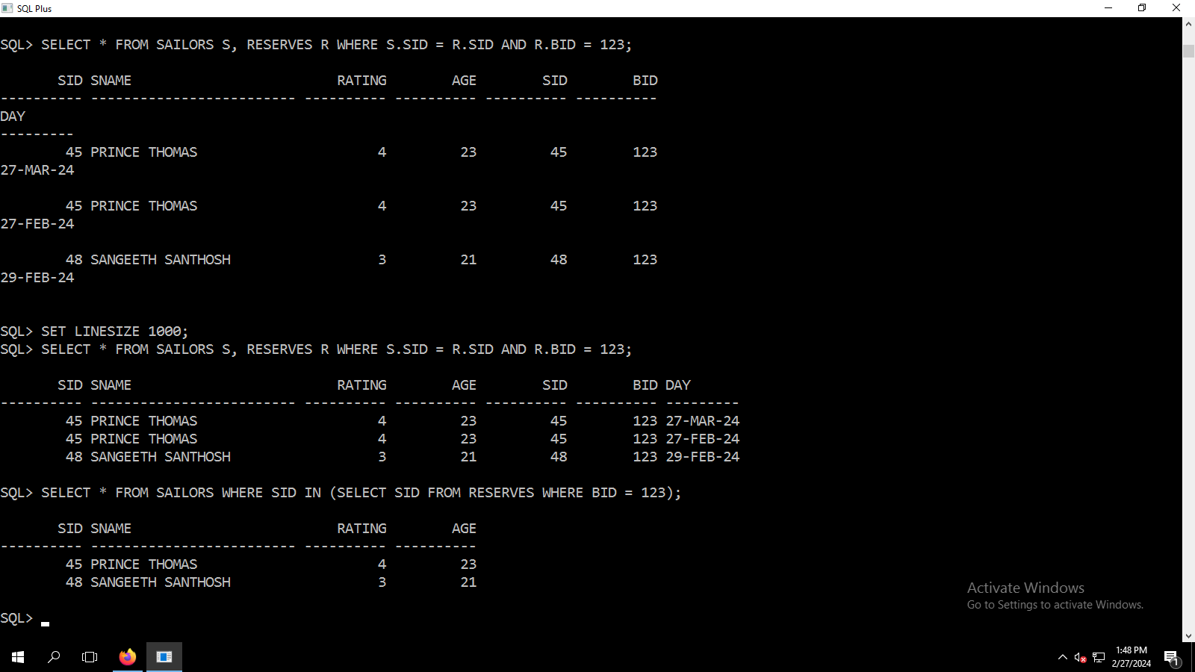

SQL*Plus: Release 12.1.0.1.0 Production on Tue Feb 27 13:20:27 2024

Copyright (c) 1982, 2013, Oracle. All rights reserved.

Enter user-name: c23MCA041@oracle

Enter password:

Last Successful login time: Mon Feb 26 2024 10:16:29 +05:30

Connected to:

Oracle Database 12c Enterprise Edition Release 12.1.0.2.0 - 64bit Production

With the Partitioning, OLAP, Advanced Analytics and Real Application Testing options

SQL> select * from boats

2

SQL> select * from boats;

BID BNAME COLOR

---------- ------------------------- -------------------------

123 JACOB BOAT BLACK

21 PRINCE BOAT WHITE

SQL> UPDATE BOATS SET BNAME = "SUPER BOAT" WHERE BID = 123;

UPDATE BOATS SET BNAME = "SUPER BOAT" WHERE BID = 123

*

ERROR at line 1:

ORA-00904: "SUPER BOAT": invalid identifier

SQL> UPDATE BOATS SET BNAME = 'SUPER BOAT' WHERE BID = 123;

1 row updated.

SQL> UPDATE BOATS SET BNAME = 'SKY BOAT' WHERE BID = 21;

1 row updated.

SQL> select * from boats;

BID BNAME COLOR

---------- ------------------------- -------------------------

123 SUPER BOAT BLACK

21 SKY BOAT WHITE

SQL> SELECT * FROM BOATS;

BID BNAME COLOR

---------- ------------------------- -------------------------

123 SUPER BOAT BLACK

21 SKY BOAT WHITE

SQL> SELECT SNAME, AGE FROM SAILORS;

SNAME AGE

------------------------- ----------

JACOB K M 21

PRINCE THOMAS 23

SANGEETH SANTHOSH 21

MANU JOSE 26

SQL> SELECT * FROM RESERVERS;

SELECT * FROM RESERVERS

*

ERROR at line 1:

ORA-00942: table or view does not exist

SQL> SELECT * FROM RESERVES;

no rows selected

SQL> INSERT INTO RESERVES VALUES (&SID, &BID, &DAY);

Enter value for sid: 45

Enter value for bid: 123

Enter value for day: 27-02-2024

old 1: INSERT INTO RESERVES VALUES (&SID, &BID, &DAY)

new 1: INSERT INTO RESERVES VALUES (45, 123, 27-02-2024)

INSERT INTO RESERVES VALUES (45, 123, 27-02-2024)

*

ERROR at line 1:

ORA-00932: inconsistent datatypes: expected DATE got NUMBER

SQL> /

Enter value for sid: 45

Enter value for bid: 123

Enter value for day: 27-MAR-2024

old 1: INSERT INTO RESERVES VALUES (&SID, &BID, &DAY)

new 1: INSERT INTO RESERVES VALUES (45, 123, 27-MAR-2024)

INSERT INTO RESERVES VALUES (45, 123, 27-MAR-2024)

*

ERROR at line 1:

ORA-00984: column not allowed here

SQL> DESC RESERVES;

Name Null? Type

----------------------------------------- -------- ----------------------------

SID NUMBER(5)

BID NUMBER(5)

DAY DATE

SQL> /

Enter value for sid: 45

Enter value for bid: 123

Enter value for day: 27-MAR-24

old 1: INSERT INTO RESERVES VALUES (&SID, &BID, &DAY)

new 1: INSERT INTO RESERVES VALUES (45, 123, 27-MAR-24)

INSERT INTO RESERVES VALUES (45, 123, 27-MAR-24)

*

ERROR at line 1:

ORA-00984: column not allowed here

SQL> /

Enter value for sid: 45

Enter value for bid: 123

Enter value for day: 27-02-24

old 1: INSERT INTO RESERVES VALUES (&SID, &BID, &DAY)

new 1: INSERT INTO RESERVES VALUES (45, 123, 27-02-24)

INSERT INTO RESERVES VALUES (45, 123, 27-02-24)

*

ERROR at line 1:

ORA-00932: inconsistent datatypes: expected DATE got NUMBER

SQL> /

Enter value for sid: 45

Enter value for bid: 123

Enter value for day: 02-27-24

old 1: INSERT INTO RESERVES VALUES (&SID, &BID, &DAY)

new 1: INSERT INTO RESERVES VALUES (45, 123, 02-27-24)

INSERT INTO RESERVES VALUES (45, 123, 02-27-24)

*

ERROR at line 1:

ORA-00932: inconsistent datatypes: expected DATE got NUMBER

SQL> /

Enter value for sid: 45

Enter value for bid: 123

Enter value for day: 27/02/2024

old 1: INSERT INTO RESERVES VALUES (&SID, &BID, &DAY)

new 1: INSERT INTO RESERVES VALUES (45, 123, 27/02/2024)

INSERT INTO RESERVES VALUES (45, 123, 27/02/2024)

*

ERROR at line 1:

ORA-00932: inconsistent datatypes: expected DATE got NUMBER

SQL> /

Enter value for sid: 45

Enter value for bid: 123

Enter value for day: 27/MAR/24

old 1: INSERT INTO RESERVES VALUES (&SID, &BID, &DAY)

new 1: INSERT INTO RESERVES VALUES (45, 123, 27/MAR/24)

INSERT INTO RESERVES VALUES (45, 123, 27/MAR/24)

*

ERROR at line 1:

ORA-00984: column not allowed here

SQL>

SQL> /

Enter value for sid: 45

Enter value for bid: 123

Enter value for day: 2024-02-27

old 1: INSERT INTO RESERVES VALUES (&SID, &BID, &DAY)

new 1: INSERT INTO RESERVES VALUES (45, 123, 2024-02-27)

INSERT INTO RESERVES VALUES (45, 123, 2024-02-27)

*

ERROR at line 1:

ORA-00932: inconsistent datatypes: expected DATE got NUMBER

SQL> INSERT INTO RESERVES VALUES (&SID, &BID, '&DAY');

Enter value for sid: 45

Enter value for bid: 123

Enter value for day: 27-MAR-2024

old 1: INSERT INTO RESERVES VALUES (&SID, &BID, '&DAY')

new 1: INSERT INTO RESERVES VALUES (45, 123, '27-MAR-2024')

1 row created.

SQL> /

Enter value for sid: 41

Enter value for bid: 21

Enter value for day: 28-FEB-2024

old 1: INSERT INTO RESERVES VALUES (&SID, &BID, '&DAY')

new 1: INSERT INTO RESERVES VALUES (41, 21, '28-FEB-2024')

1 row created.

SQL> /

Enter value for sid: 45

Enter value for bid: 123

Enter value for day: 27-FEB-2024

old 1: INSERT INTO RESERVES VALUES (&SID, &BID, '&DAY')

new 1: INSERT INTO RESERVES VALUES (45, 123, '27-FEB-2024')

1 row created.

SQL> /

Enter value for sid: 48

Enter value for bid: 123

Enter value for day: 29-FEB-2024

old 1: INSERT INTO RESERVES VALUES (&SID, &BID, '&DAY')

new 1: INSERT INTO RESERVES VALUES (48, 123, '29-FEB-2024')

1 row created.

SQL> SELECT * FROM RESERVES

2

SQL>

SQL> SELECT * FROM RESERVES;

SID BID DAY

---------- ---------- ---------

45 123 27-MAR-24

41 21 28-FEB-24

45 123 27-FEB-24

48 123 29-FEB-24

SQL> SELECT * FROM SAILORS WHERE SID = (SELECT SID FROM RESERVES WHERE BID = 123);

SELECT * FROM SAILORS WHERE SID = (SELECT SID FROM RESERVES WHERE BID = 123)

*

ERROR at line 1:

ORA-01427: single-row subquery returns more than one row

SQL> SELECT * FROM SAILORS S, RESERVES R WHERE S.SID = R.SID AND R.BID = 123;

SID SNAME RATING AGE SID BID

---------- ------------------------- ---------- ---------- ---------- ----------

DAY

---------

45 PRINCE THOMAS 4 23 45 123

27-MAR-24

45 PRINCE THOMAS 4 23 45 123

27-FEB-24

48 SANGEETH SANTHOSH 3 21 48 123

29-FEB-24

SQL> SET LINESIZE 1000;

SQL> SELECT * FROM SAILORS S, RESERVES R WHERE S.SID = R.SID AND R.BID = 123;

SID SNAME RATING AGE SID BID DAY

---------- ------------------------- ---------- ---------- ---------- ---------- ---------

45 PRINCE THOMAS 4 23 45 123 27-MAR-24

45 PRINCE THOMAS 4 23 45 123 27-FEB-24

48 SANGEETH SANTHOSH 3 21 48 123 29-FEB-24

SQL> SELECT * FROM SAILORS WHERE SID IN (SELECT SID FROM RESERVES WHERE BID = 123);

SID SNAME RATING AGE

---------- ------------------------- ---------- ----------

45 PRINCE THOMAS 4 23

48 SANGEETH SANTHOSH 3 21

SQL>

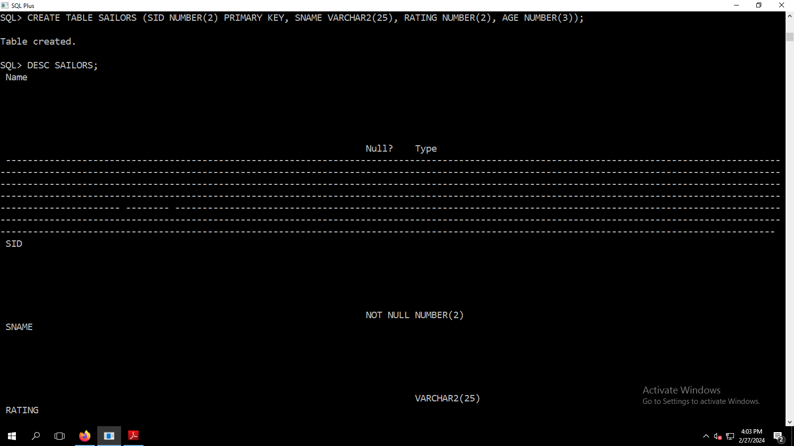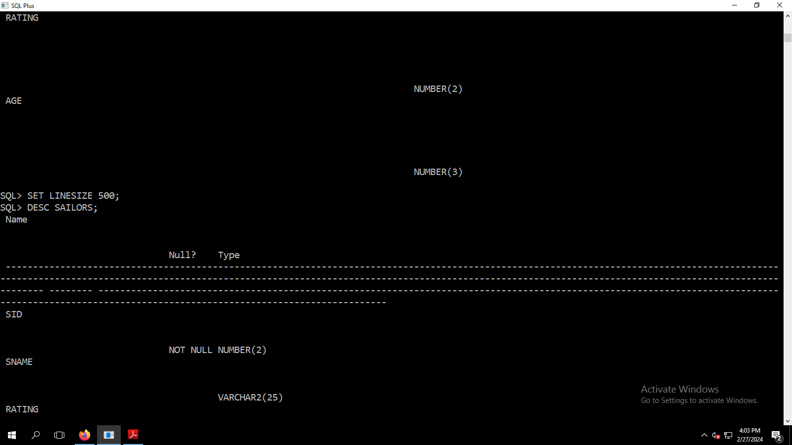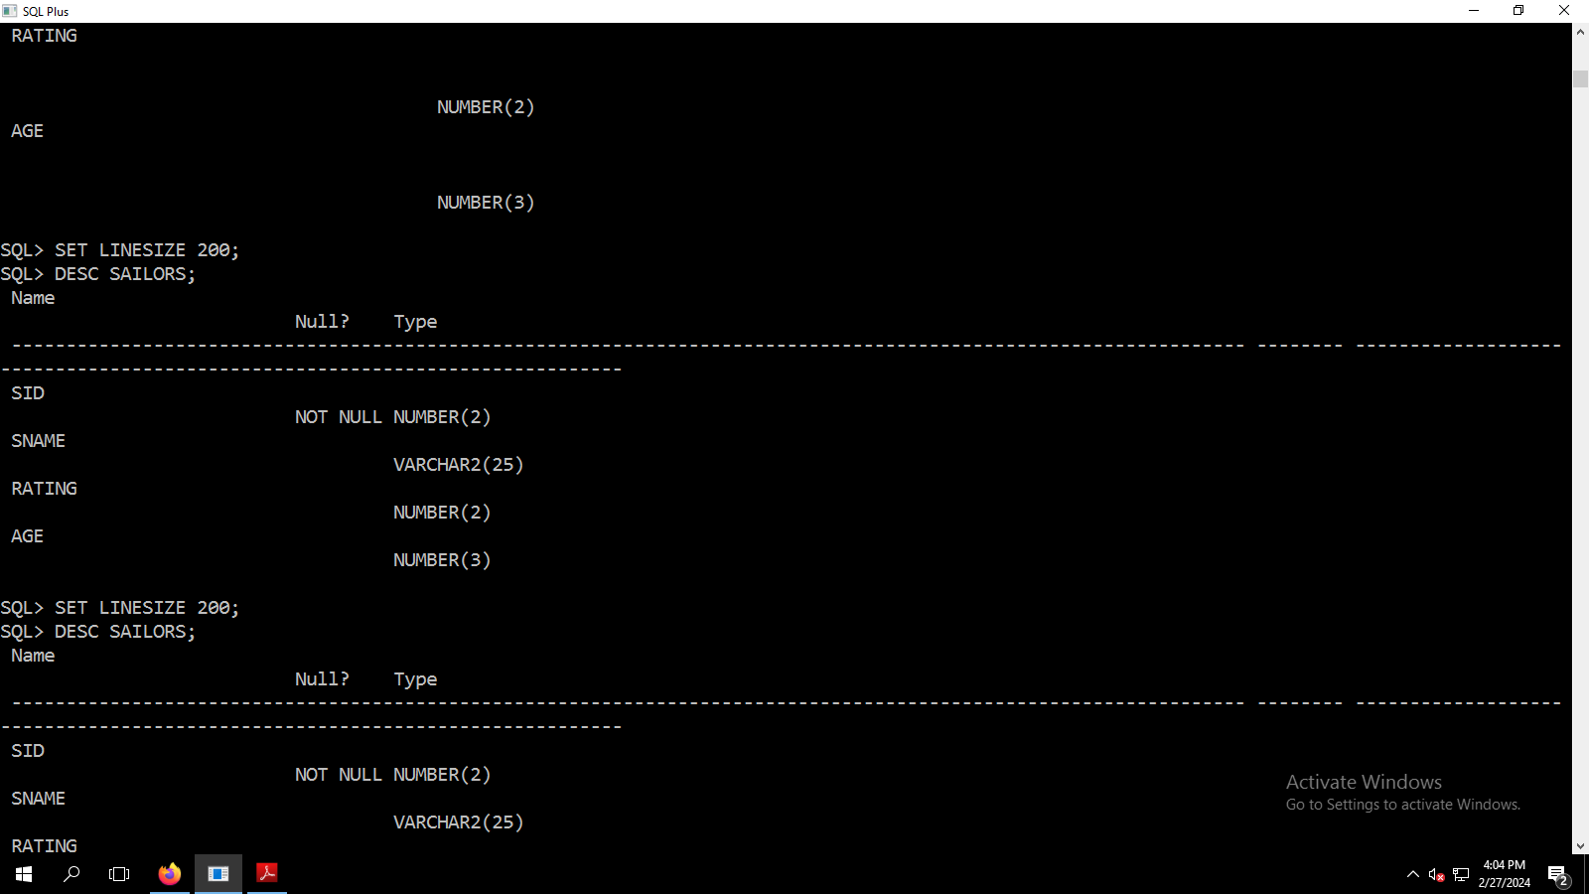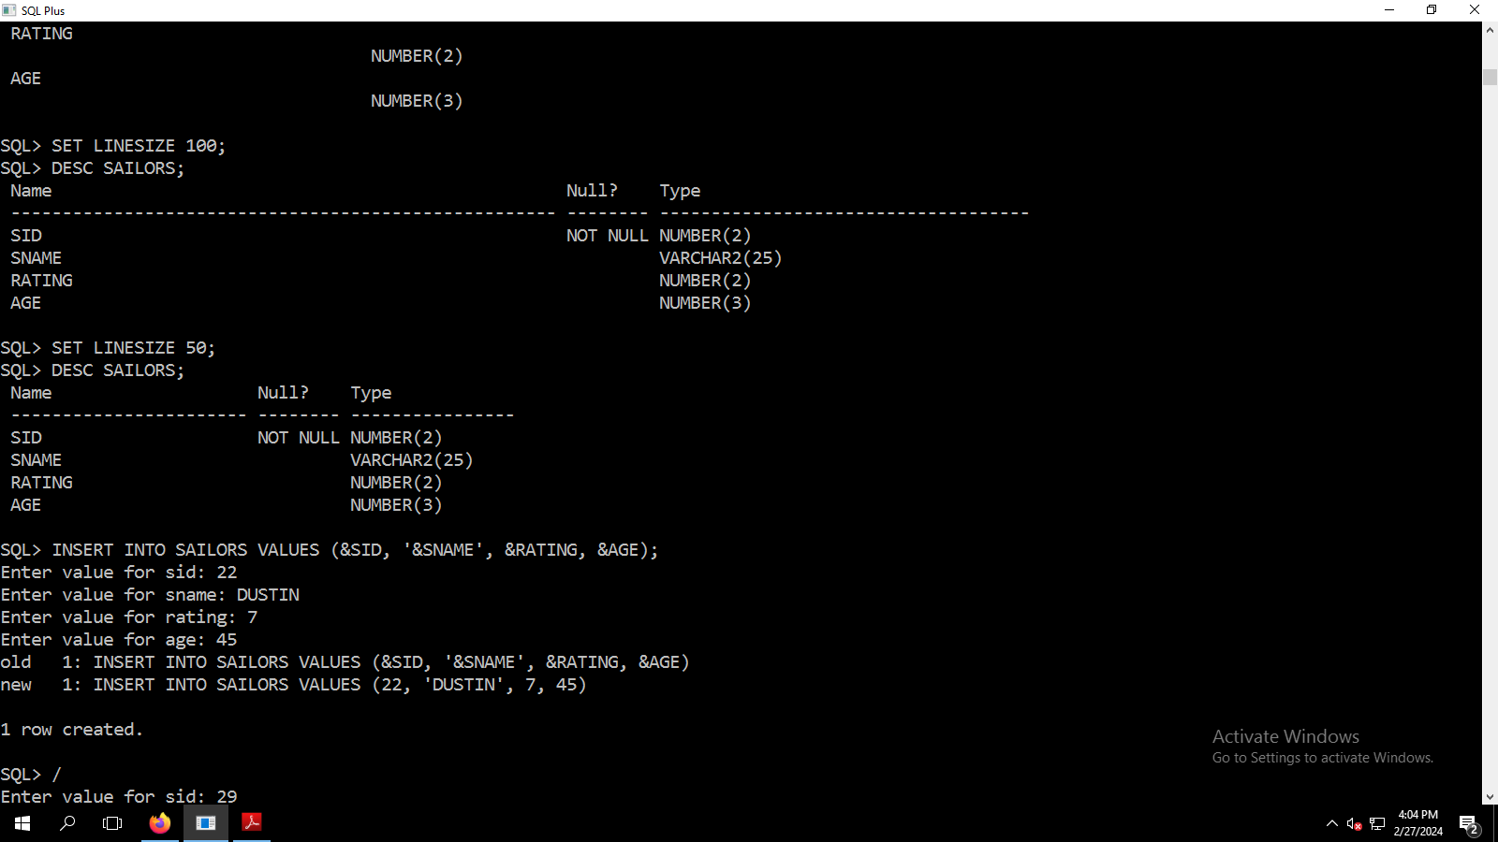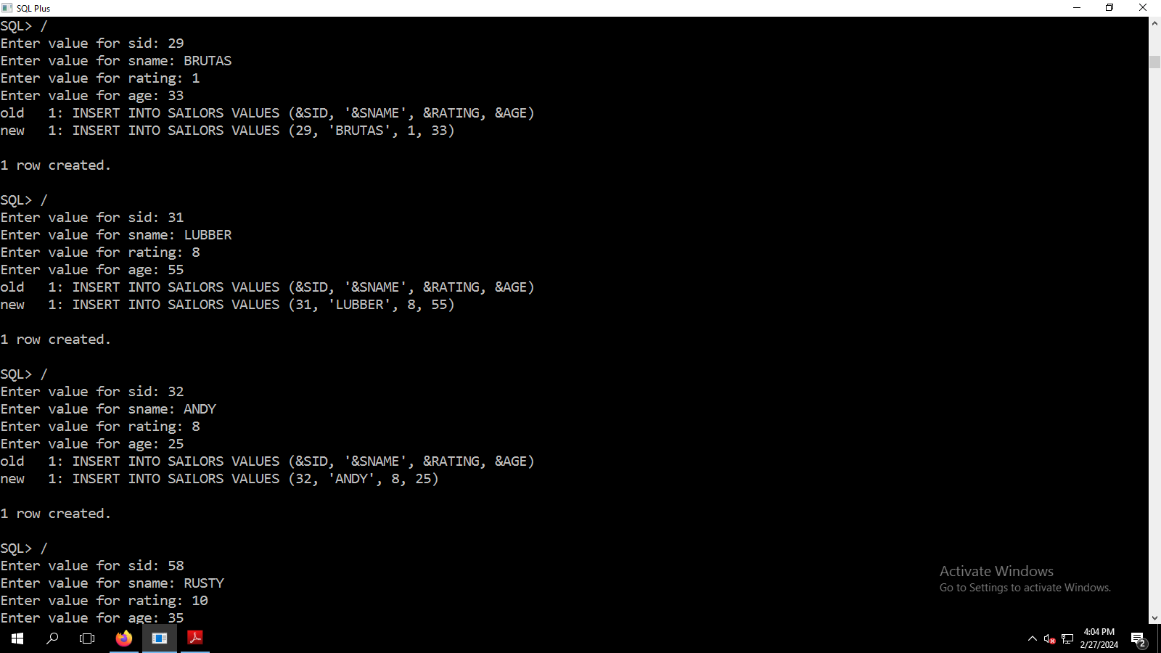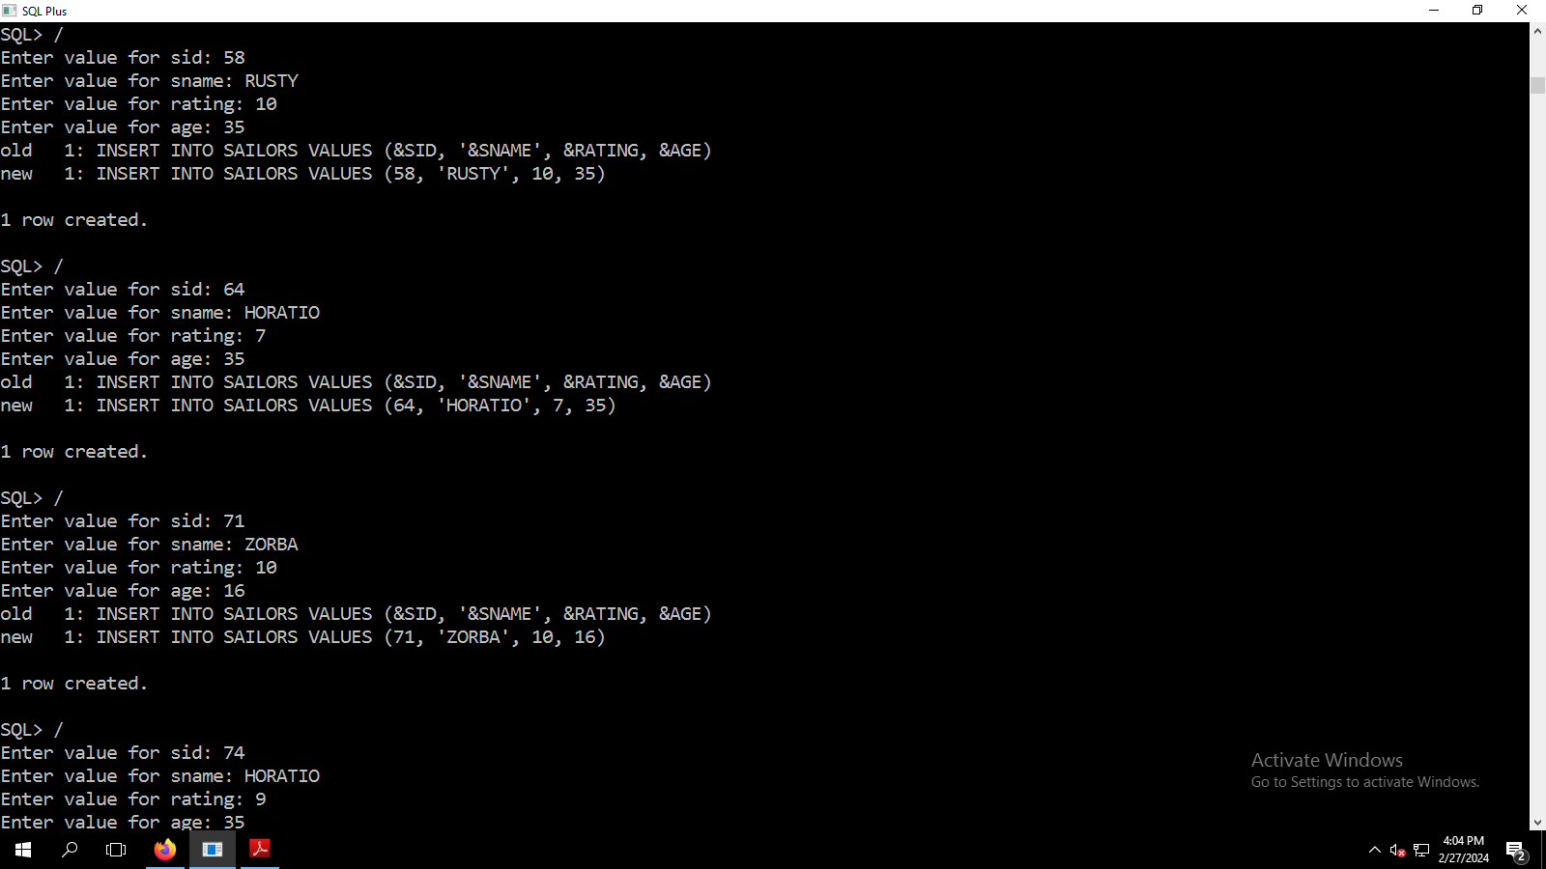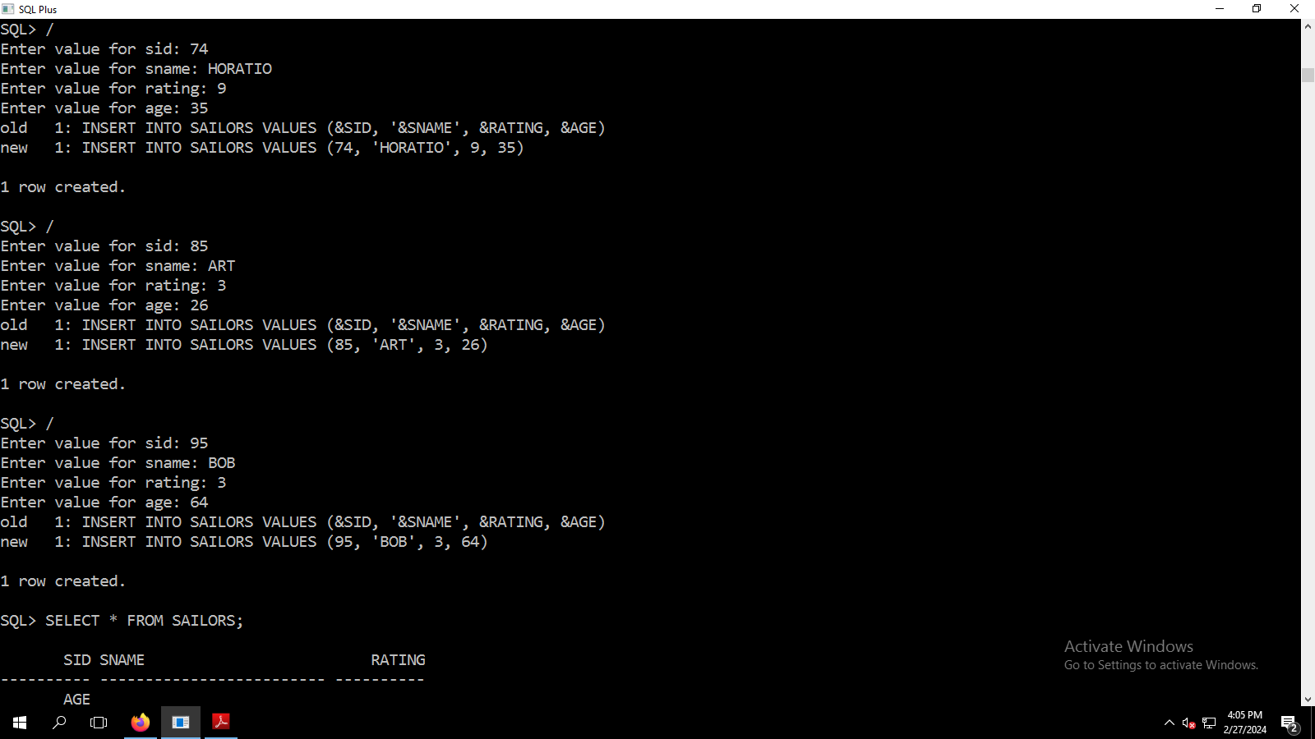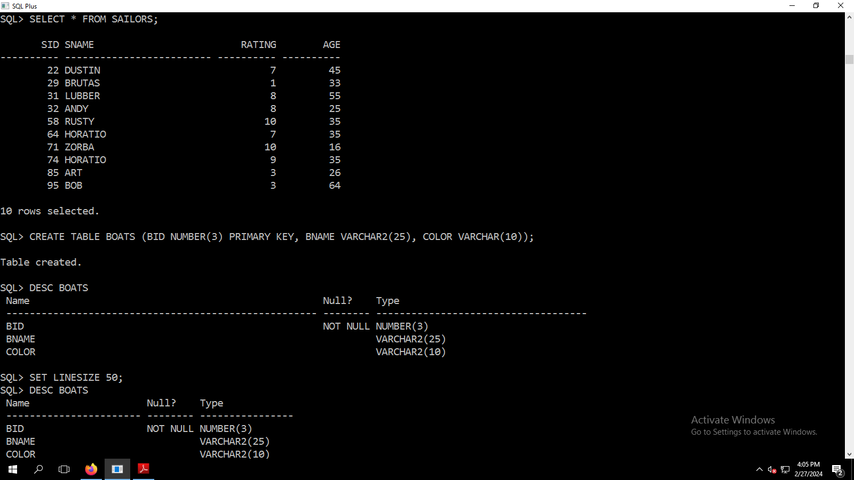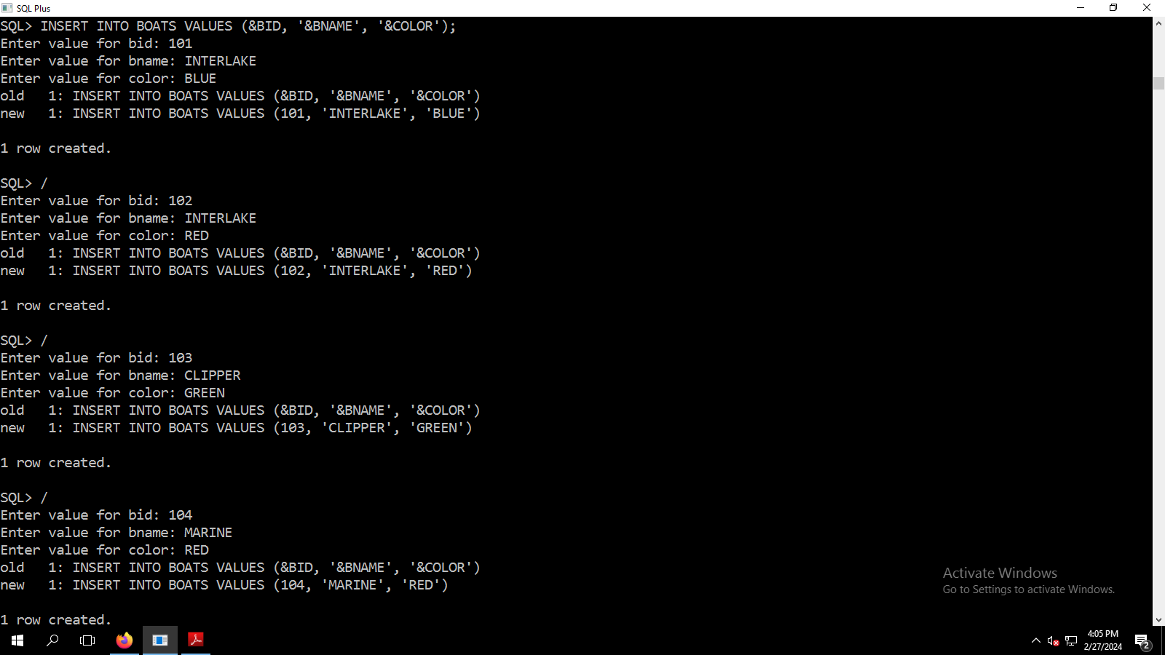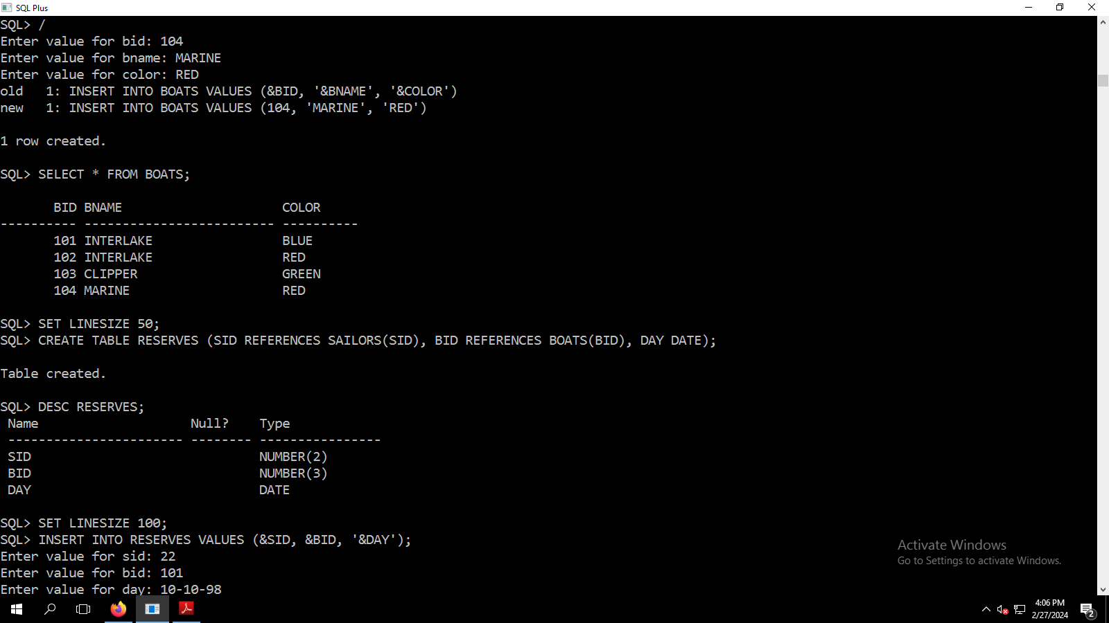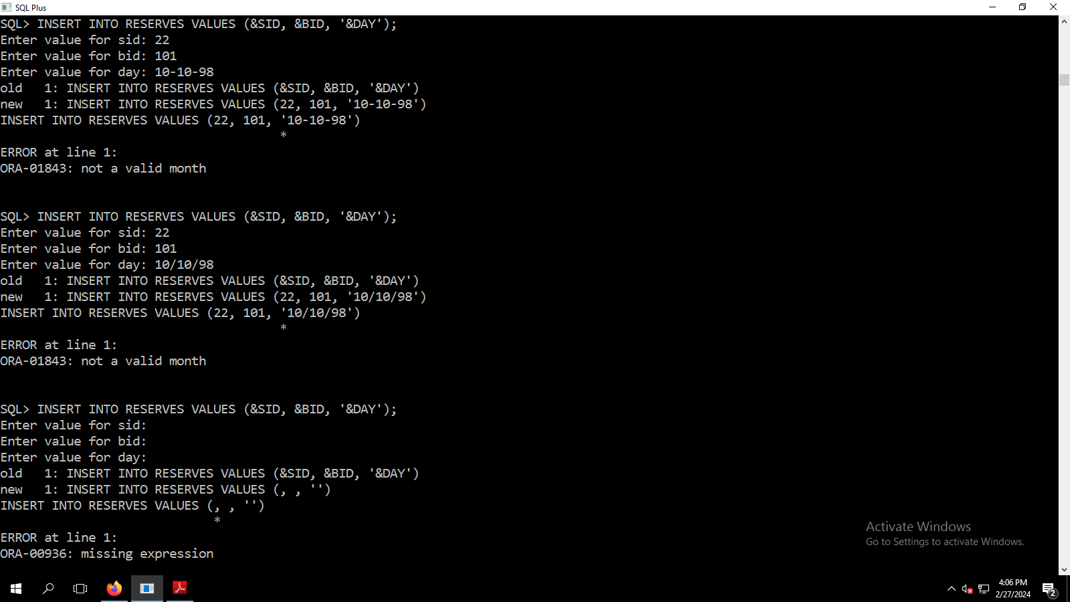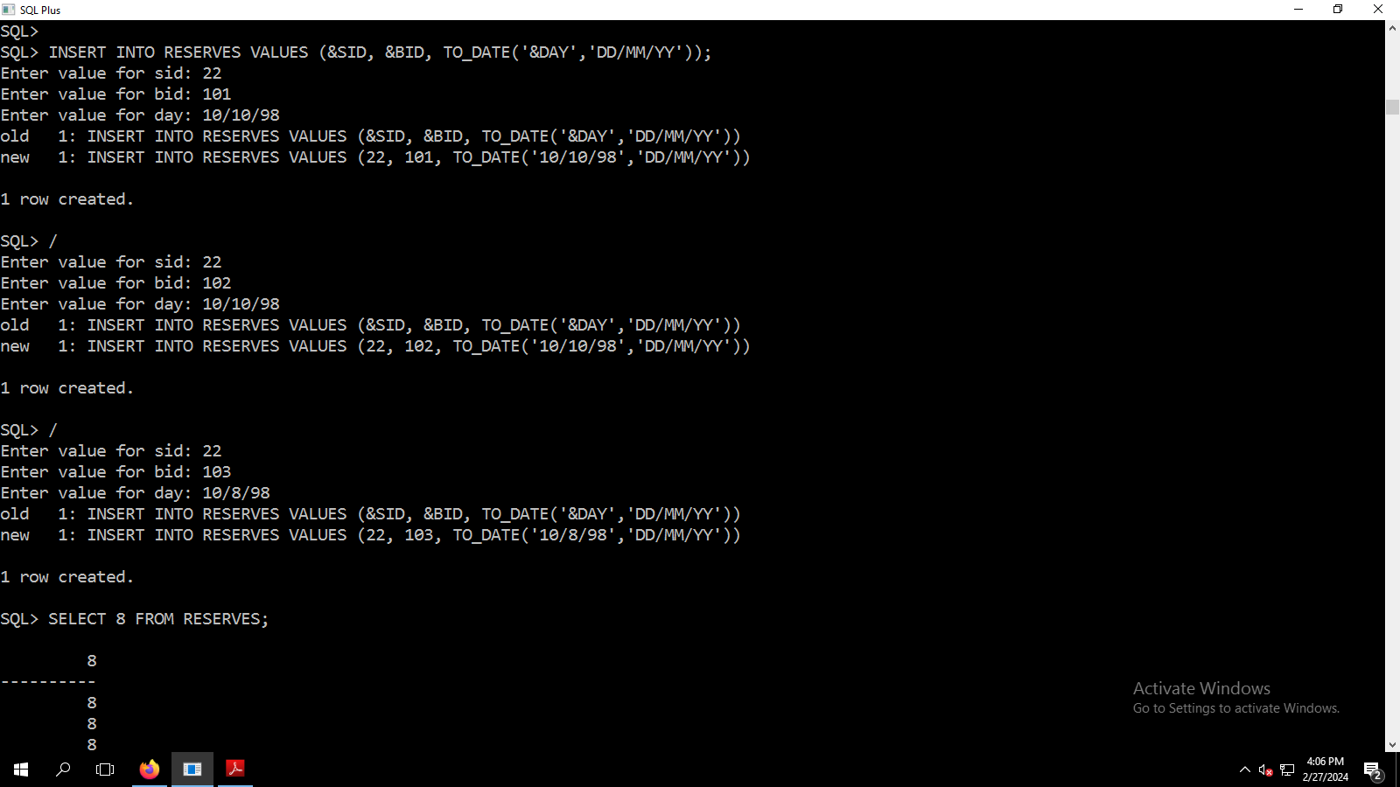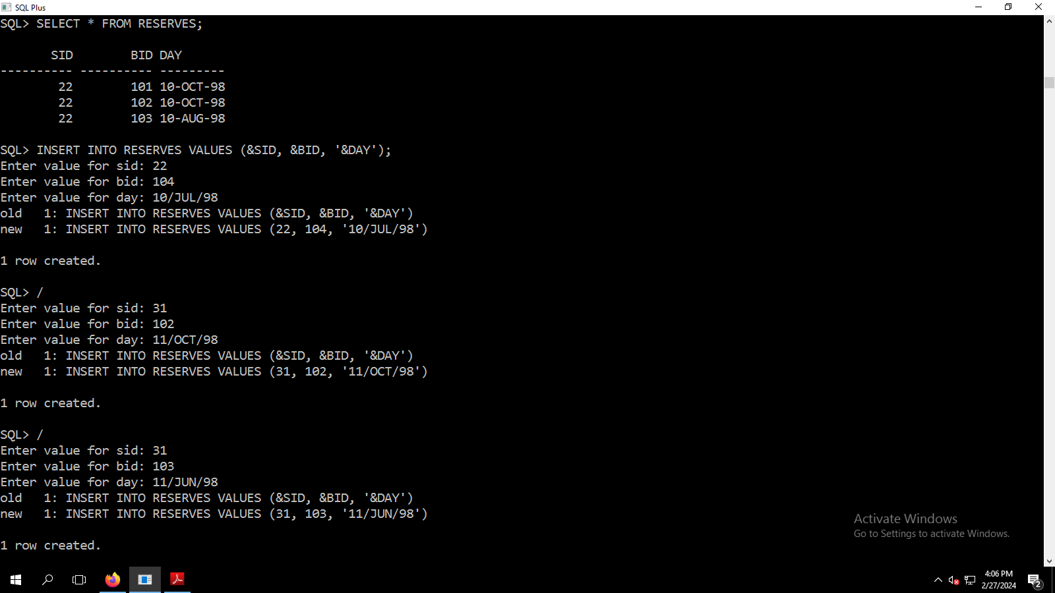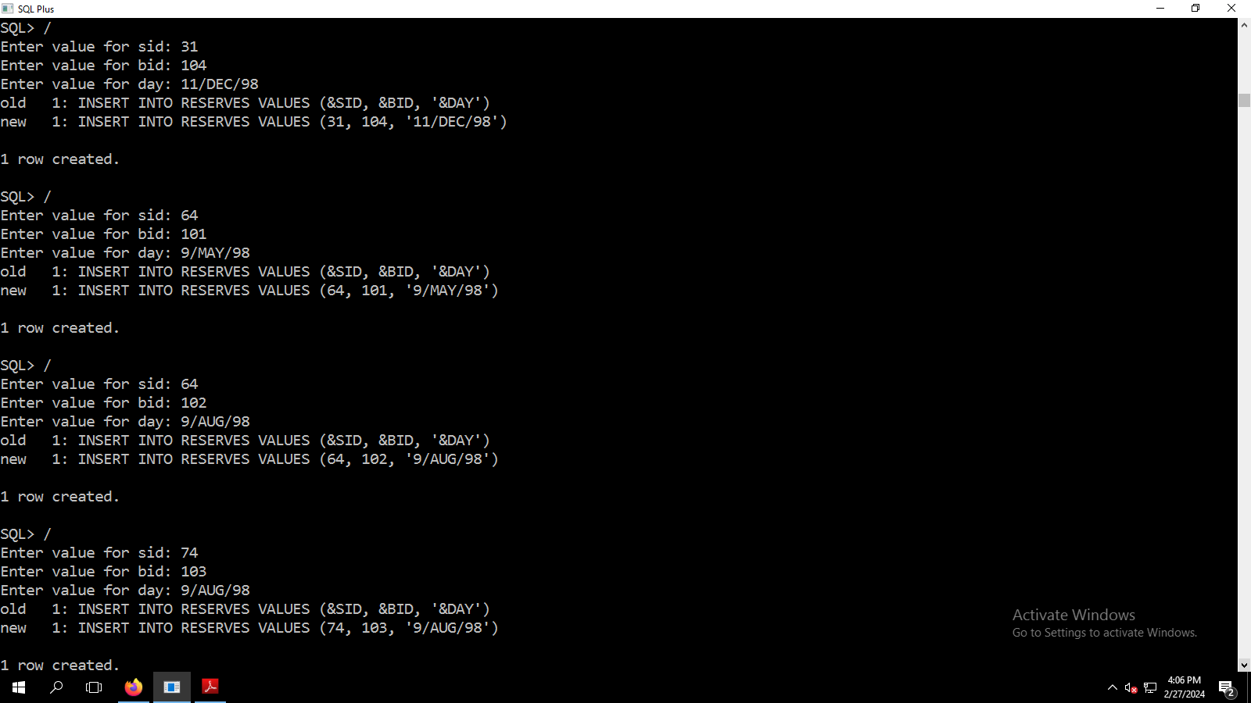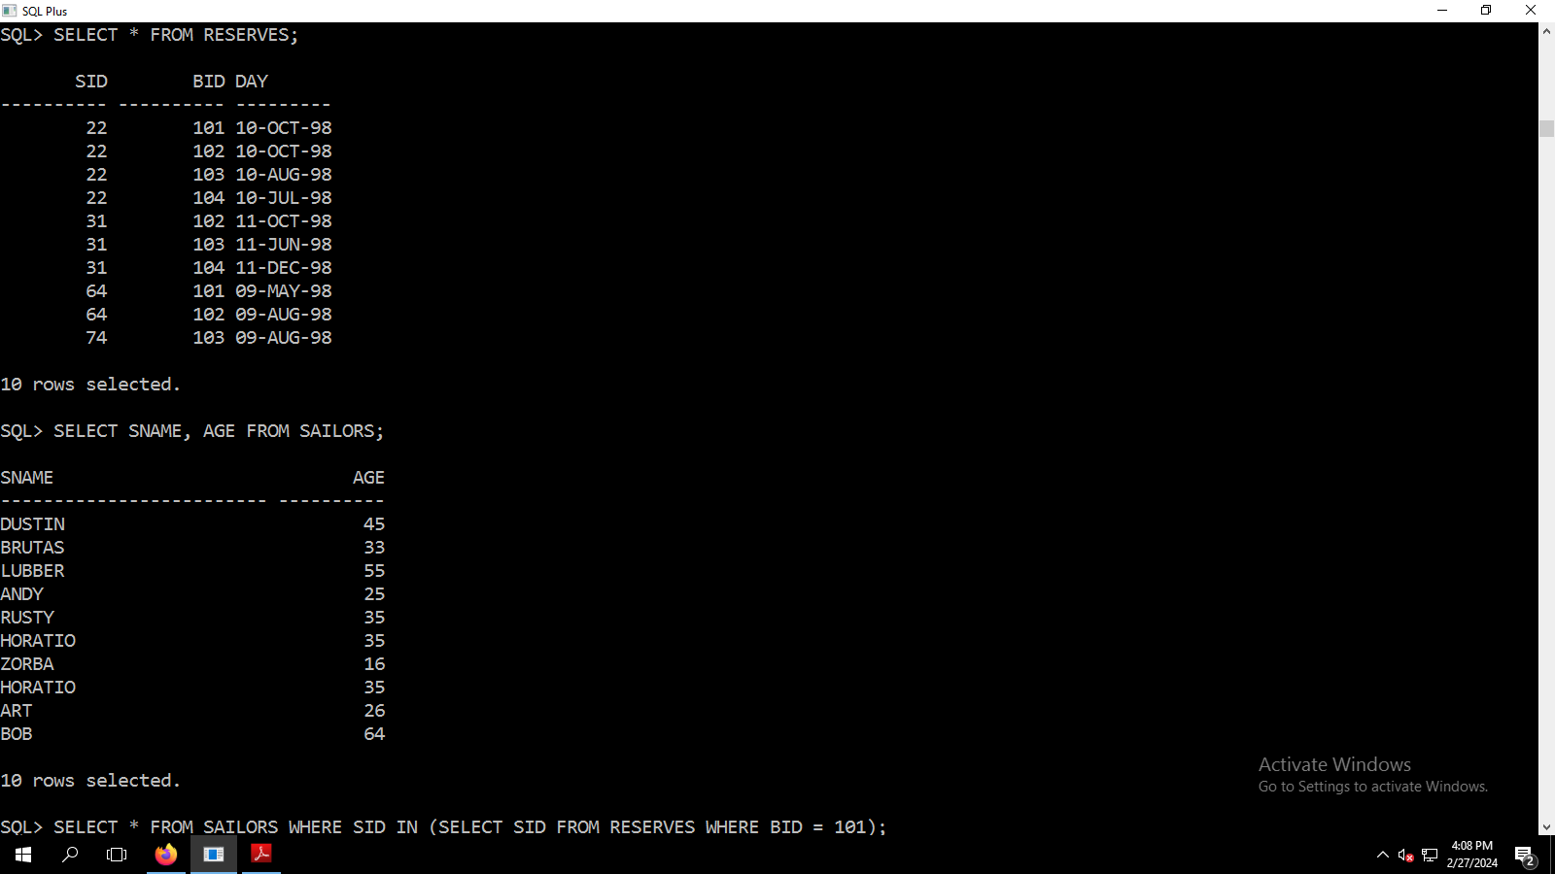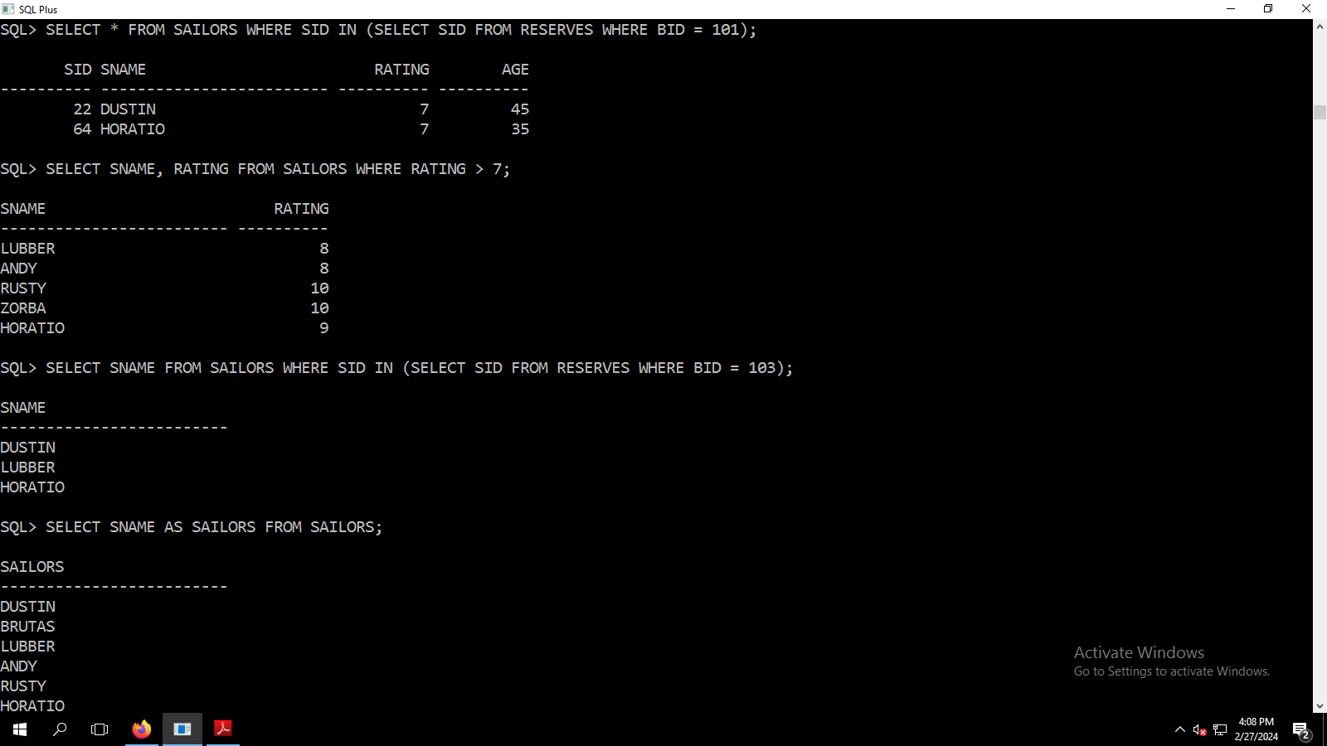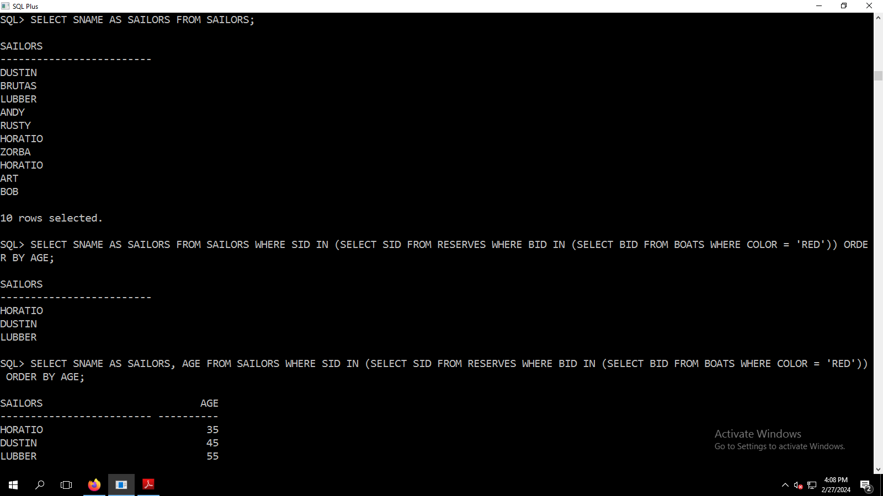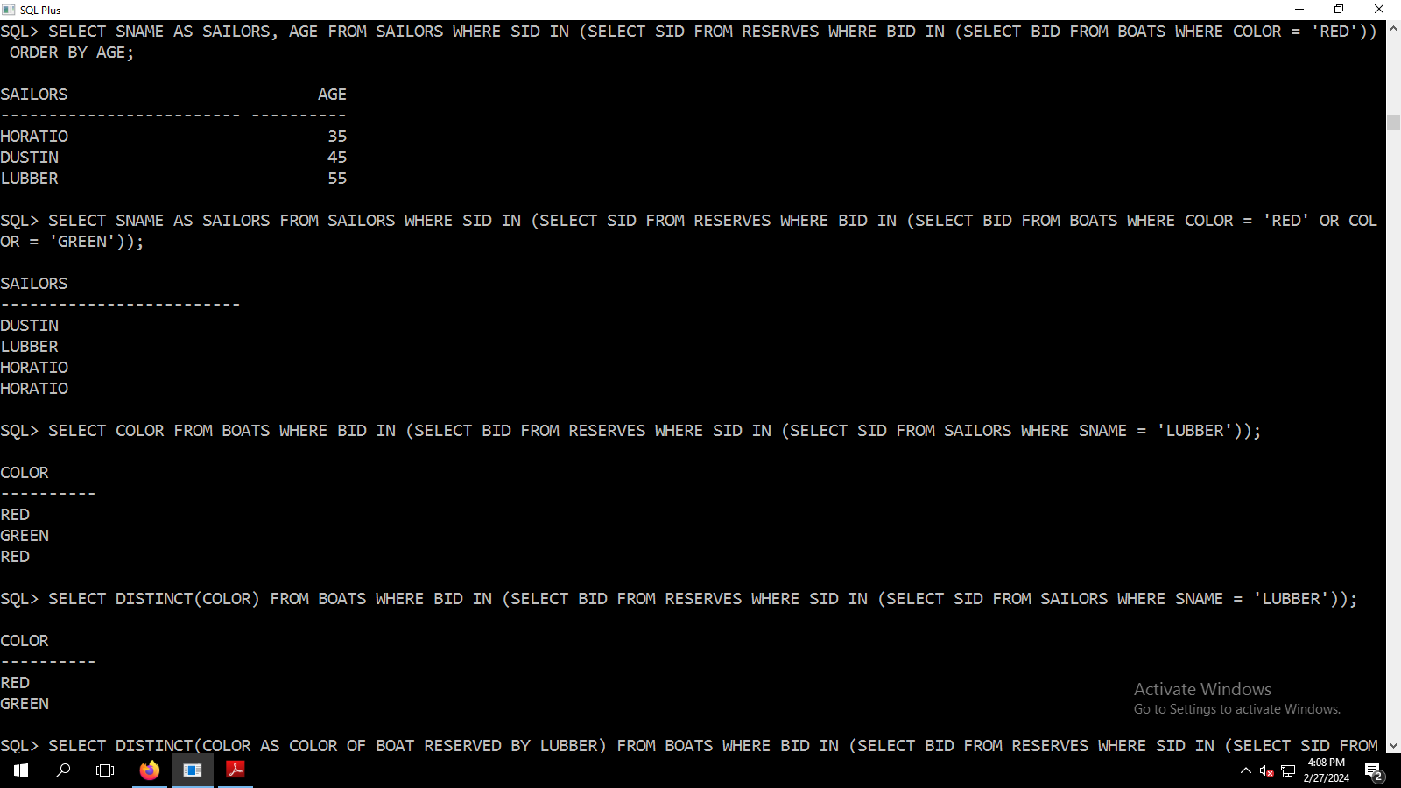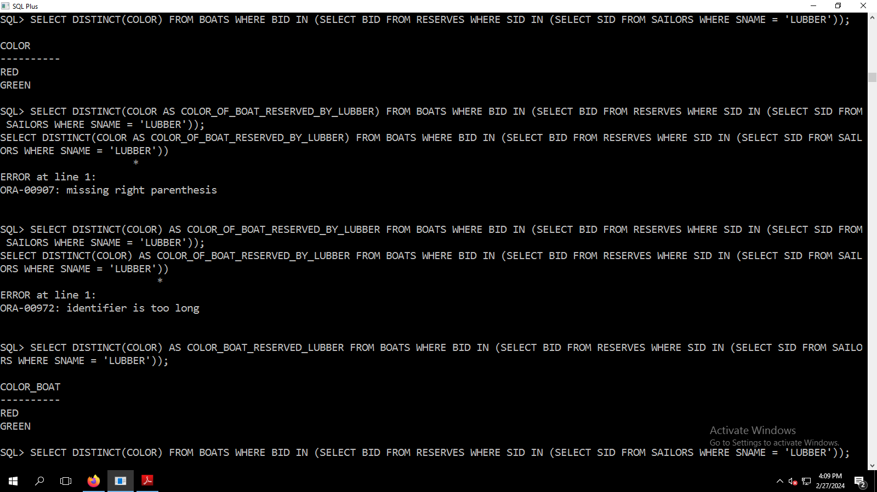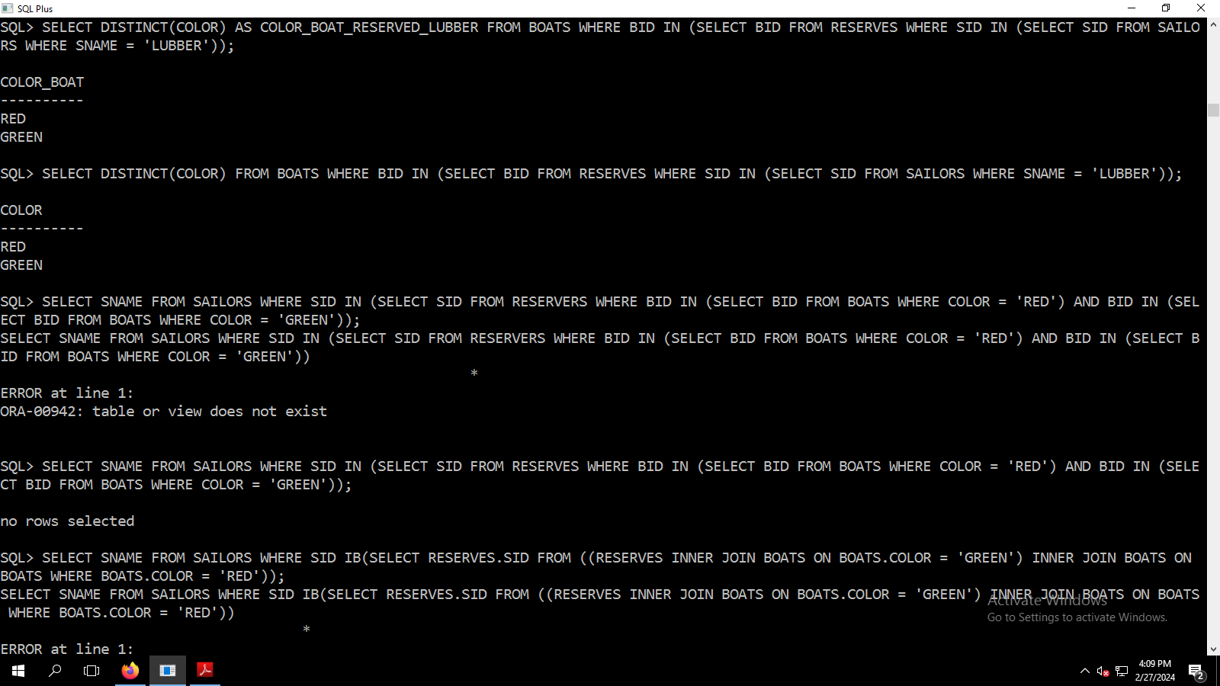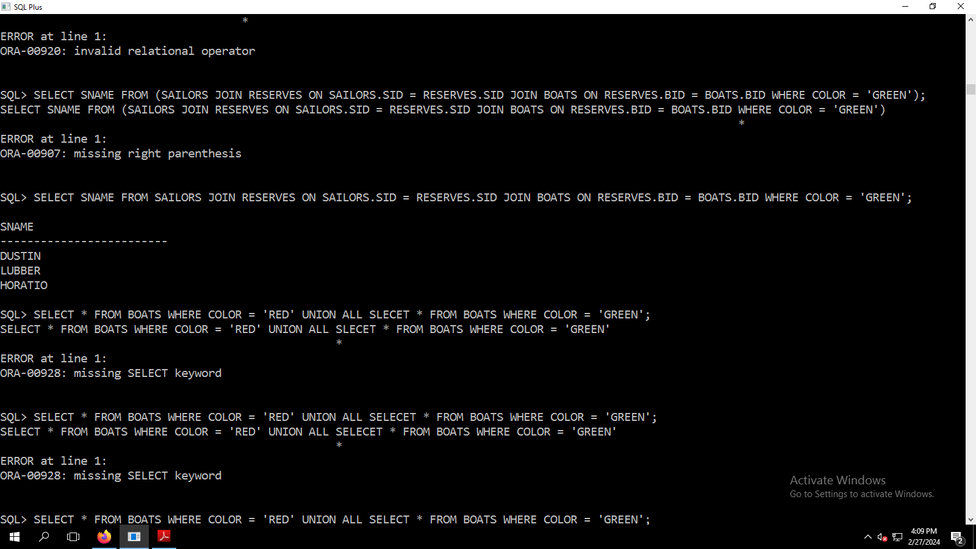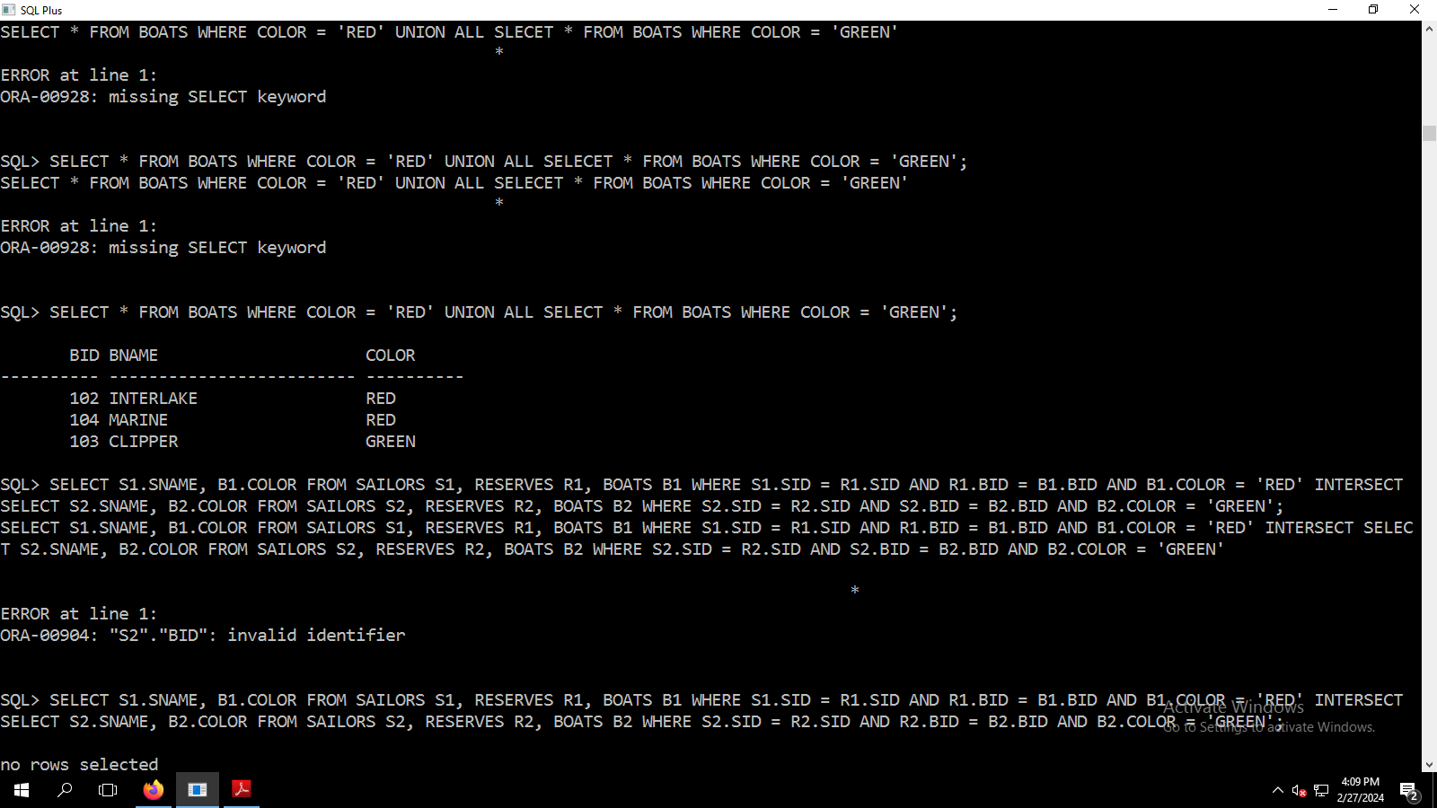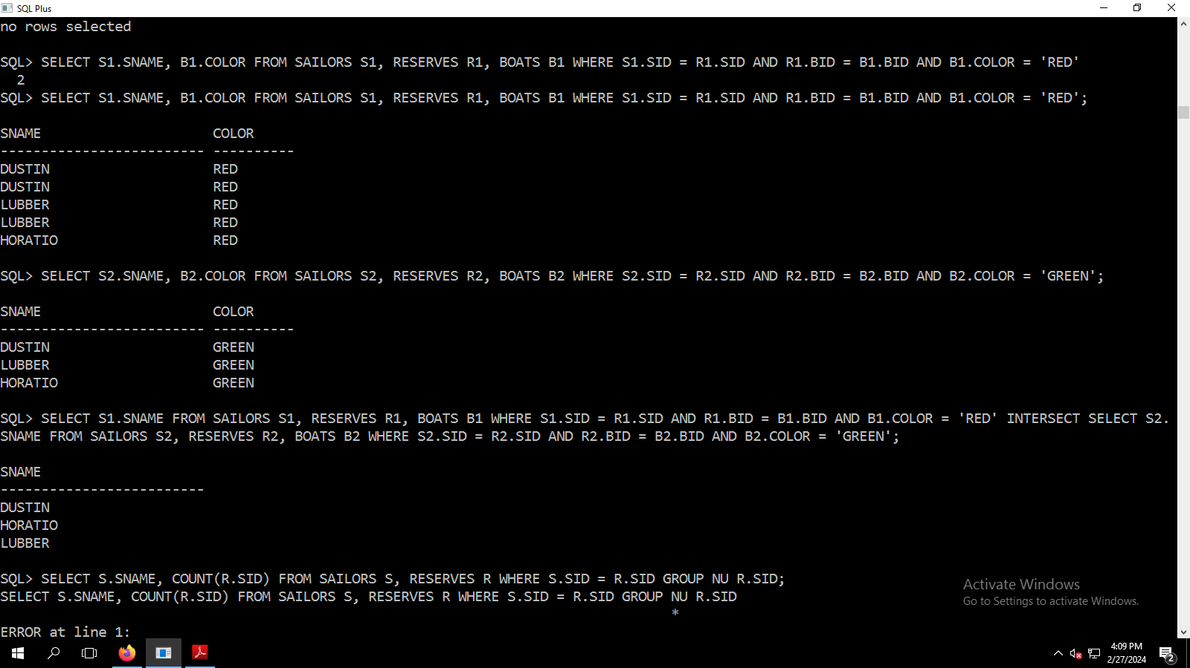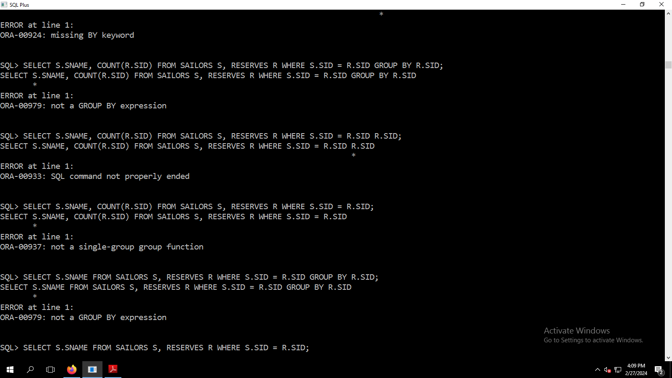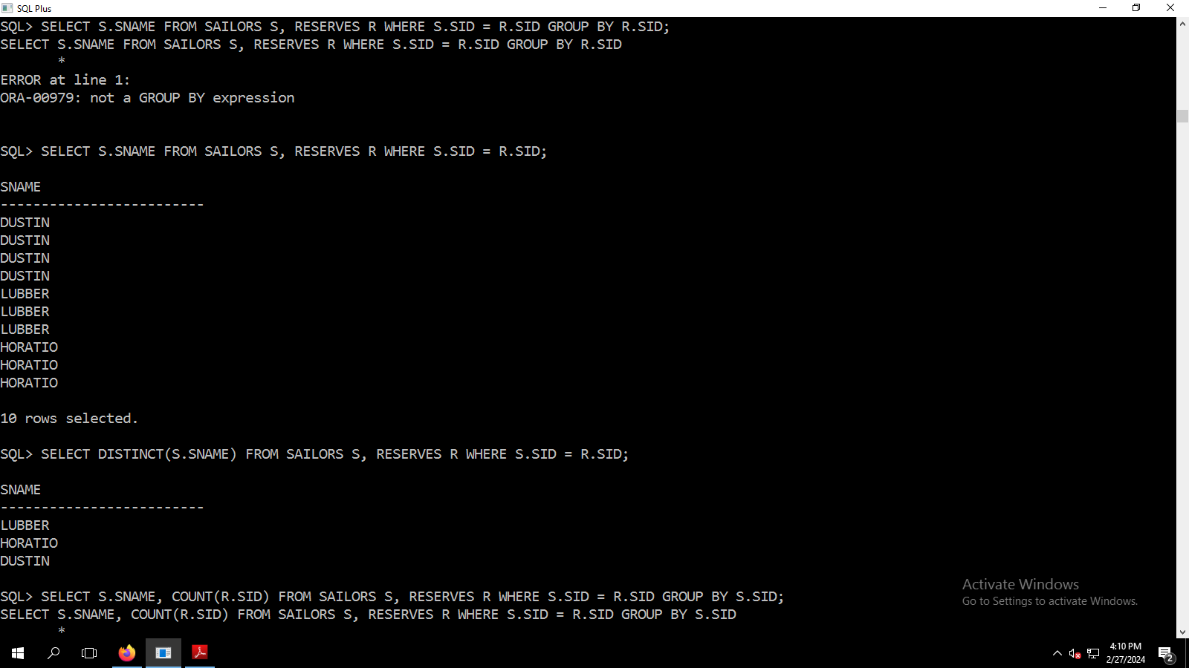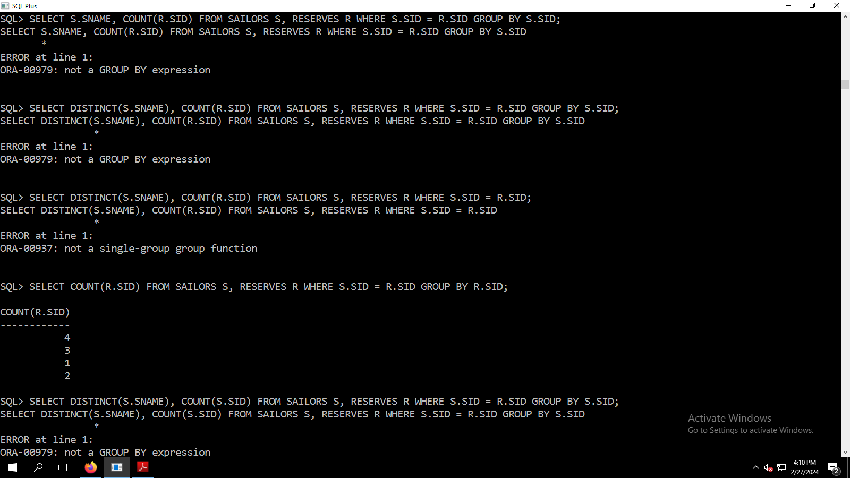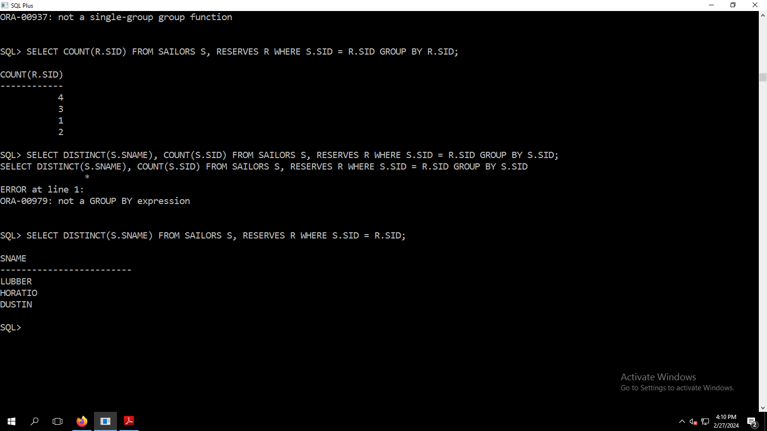SQL> CREATE TABLE SAILORS (SID NUMBER(2) PRIMARY KEY, SNAME VARCHAR2(25), RATING NUMBER(2), AGE NUMBER(3));

Table created.

SQL> DESC SAILORS;

Name

Null? Type

----------------------------------------------------------------------------------------------------------------------------------------------------------------------------------------------------------------------------------------------------------------------------------------------------------------------------------------------------------------------------------------------------------------------------------------------------------------------------------------------------------------------------------------------------------------------------------------------------------------- -------- ------------------------------------------------------------------------------------------------------------------------------------------------------------------------------------------------------------------------------------------------------------------------------------------------------------------------------------------------------------------------------------------------------------

SID

NOT NULL NUMBER(2)

SNAME

VARCHAR2(25)

RATING

NUMBER(2)

AGE

NUMBER(3)

SQL> SET LINESIZE 500;

SQL> DESC SAILORS;

Name

Null? Type

----------------------------------------------------------------------------------------------------------------------------------------------------------------------------------------------------------------------------------------------------------------------------------------------------- -------- ----------------------------------------------------------------------------------------------------------------------------------------------------------------------------------------------------

SID

NOT NULL NUMBER(2)

SNAME

VARCHAR2(25)

RATING

NUMBER(2)

AGE

NUMBER(3)

SQL> SET LINESIZE 200;

SQL> DESC SAILORS;

Name

Null? Type

----------------------------------------------------------------------------------------------------------------- -------- ----------------------------------------------------------------------------

SID

NOT NULL NUMBER(2)

SNAME

VARCHAR2(25)

RATING

NUMBER(2)

AGE

NUMBER(3)

SQL> SET LINESIZE 200;

SQL> DESC SAILORS;

Name

Null? Type

----------------------------------------------------------------------------------------------------------------- -------- ----------------------------------------------------------------------------

SID

NOT NULL NUMBER(2)

SNAME

VARCHAR2(25)

RATING

NUMBER(2)

AGE

NUMBER(3)

SQL> SET LINESIZE 100;

SQL> DESC SAILORS;

Name Null? Type

----------------------------------------------------- -------- ------------------------------------

SID NOT NULL NUMBER(2)

SNAME VARCHAR2(25)

RATING NUMBER(2)

AGE NUMBER(3)

SQL> SET LINESIZE 50;

SQL> DESC SAILORS;

Name Null? Type

----------------------- -------- ----------------

SID NOT NULL NUMBER(2)

SNAME VARCHAR2(25)

RATING NUMBER(2)

AGE NUMBER(3)

SQL> INSERT INTO SAILORS VALUES (&SID, '&SNAME', &RATING, &AGE);

Enter value for sid: 22

Enter value for sname: DUSTIN

Enter value for rating: 7

Enter value for age: 45

old 1: INSERT INTO SAILORS VALUES (&SID, '&SNAME', &RATING, &AGE)

new 1: INSERT INTO SAILORS VALUES (22, 'DUSTIN', 7, 45)

1 row created.

SQL> /

Enter value for sid: 29

Enter value for sname: BRUTAS

Enter value for rating: 1

Enter value for age: 33

old 1: INSERT INTO SAILORS VALUES (&SID, '&SNAME', &RATING, &AGE)

new 1: INSERT INTO SAILORS VALUES (29, 'BRUTAS', 1, 33)

1 row created.

SQL> /

Enter value for sid: 31

Enter value for sname: LUBBER

Enter value for rating: 8

Enter value for age: 55

old 1: INSERT INTO SAILORS VALUES (&SID, '&SNAME', &RATING, &AGE)

new 1: INSERT INTO SAILORS VALUES (31, 'LUBBER', 8, 55)

1 row created.

SQL> /

Enter value for sid: 32

Enter value for sname: ANDY

Enter value for rating: 8

Enter value for age: 25

old 1: INSERT INTO SAILORS VALUES (&SID, '&SNAME', &RATING, &AGE)

new 1: INSERT INTO SAILORS VALUES (32, 'ANDY', 8, 25)

1 row created.

SQL> /

Enter value for sid: 58

Enter value for sname: RUSTY

Enter value for rating: 10

Enter value for age: 35

old 1: INSERT INTO SAILORS VALUES (&SID, '&SNAME', &RATING, &AGE)

new 1: INSERT INTO SAILORS VALUES (58, 'RUSTY', 10, 35)

1 row created.

SQL> /

Enter value for sid: 64

Enter value for sname: HORATIO

Enter value for rating: 7

Enter value for age: 35

old 1: INSERT INTO SAILORS VALUES (&SID, '&SNAME', &RATING, &AGE)

new 1: INSERT INTO SAILORS VALUES (64, 'HORATIO', 7, 35)

1 row created.

SQL> /

Enter value for sid: 71

Enter value for sname: ZORBA

Enter value for rating: 10

Enter value for age: 16

old 1: INSERT INTO SAILORS VALUES (&SID, '&SNAME', &RATING, &AGE)

new 1: INSERT INTO SAILORS VALUES (71, 'ZORBA', 10, 16)

1 row created.

SQL> /

Enter value for sid: 74

Enter value for sname: HORATIO

Enter value for rating: 9

Enter value for age: 35

old 1: INSERT INTO SAILORS VALUES (&SID, '&SNAME', &RATING, &AGE)

new 1: INSERT INTO SAILORS VALUES (74, 'HORATIO', 9, 35)

1 row created.

SQL> /

Enter value for sid: 85

Enter value for sname: ART

Enter value for rating: 3

Enter value for age: 26

old 1: INSERT INTO SAILORS VALUES (&SID, '&SNAME', &RATING, &AGE)

new 1: INSERT INTO SAILORS VALUES (85, 'ART', 3, 26)

1 row created.

SQL> /

Enter value for sid: 95

Enter value for sname: BOB

Enter value for rating: 3

Enter value for age: 64

old 1: INSERT INTO SAILORS VALUES (&SID, '&SNAME', &RATING, &AGE)

new 1: INSERT INTO SAILORS VALUES (95, 'BOB', 3, 64)

1 row created.

SQL> SELECT * FROM SAILORS;

SID SNAME RATING

---------- ------------------------- ----------

AGE

----------

22 DUSTIN 7

45

29 BRUTAS 1

33

31 LUBBER 8

55

SID SNAME RATING

---------- ------------------------- ----------

AGE

----------

32 ANDY 8

25

58 RUSTY 10

35

64 HORATIO 7

35

SID SNAME RATING

---------- ------------------------- ----------

AGE

----------

71 ZORBA 10

16

74 HORATIO 9

35

85 ART 3

26

SID SNAME RATING

---------- ------------------------- ----------

AGE

----------

95 BOB 3

64

10 rows selected.

SQL> SET LINESIZE 10;

SQL> SELECT * FROM SAILORS;

SID

----------

SNAME

----------

RATING

----------

AGE

----------

22

DUSTIN

7

45

SID

----------

SNAME

----------

RATING

----------

AGE

----------

29

BRUTAS

1

33

SID

----------

SNAME

----------

RATING

----------

AGE

----------

31

LUBBER

8

55

SID

----------

SNAME

----------

RATING

----------

AGE

----------

32

ANDY

8

25

SID

----------

SNAME

----------

RATING

----------

AGE

----------

58

RUSTY

10

35

SID

----------

SNAME

----------

RATING

----------

AGE

----------

64

HORATIO

7

35

SID

----------

SNAME

----------

RATING

----------

AGE

----------

71

ZORBA

10

16

SID

----------

SNAME

----------

RATING

----------

AGE

----------

74

HORATIO

9

35

SID

----------

SNAME

----------

RATING

----------

AGE

----------

85

ART

3

26

SID

----------

SNAME

----------

RATING

----------

AGE

----------

95

BOB

3

64

10 rows selected.

SQL> SET LINESIZE 100;

SQL> SELECT * FROM SAILORS;

SID SNAME RATING AGE

---------- ------------------------- ---------- ----------

22 DUSTIN 7 45

29 BRUTAS 1 33

31 LUBBER 8 55

32 ANDY 8 25

58 RUSTY 10 35

64 HORATIO 7 35

71 ZORBA 10 16

74 HORATIO 9 35

85 ART 3 26

95 BOB 3 64

10 rows selected.

SQL> CREATE TABLE BOATS (BID NUMBER(3) PRIMARY KEY, BNAME VARCHAR2(25), COLOR VARCHAR(10));

Table created.

SQL> DESC BOATS

Name Null? Type

----------------------------------------------------- -------- ------------------------------------

BID NOT NULL NUMBER(3)

BNAME VARCHAR2(25)

COLOR VARCHAR2(10)

SQL> SET LINESIZE 50;

SQL> DESC BOATS

Name Null? Type

----------------------- -------- ----------------

BID NOT NULL NUMBER(3)

BNAME VARCHAR2(25)

COLOR VARCHAR2(10)

SQL> SET LINESIZE 100;

SQL> INSERT INTO BOATS VALUES (&BID, '&BNAME', '&COLOR');

Enter value for bid: 101

Enter value for bname: INTERLAKE

Enter value for color: BLUE

old 1: INSERT INTO BOATS VALUES (&BID, '&BNAME', '&COLOR')

new 1: INSERT INTO BOATS VALUES (101, 'INTERLAKE', 'BLUE')

1 row created.

SQL> /

Enter value for bid: 102

Enter value for bname: INTERLAKE

Enter value for color: RED

old 1: INSERT INTO BOATS VALUES (&BID, '&BNAME', '&COLOR')

new 1: INSERT INTO BOATS VALUES (102, 'INTERLAKE', 'RED')

1 row created.

SQL> /

Enter value for bid: 103

Enter value for bname: CLIPPER

Enter value for color: GREEN

old 1: INSERT INTO BOATS VALUES (&BID, '&BNAME', '&COLOR')

new 1: INSERT INTO BOATS VALUES (103, 'CLIPPER', 'GREEN')

1 row created.

SQL> /

Enter value for bid: 104

Enter value for bname: MARINE

Enter value for color: RED

old 1: INSERT INTO BOATS VALUES (&BID, '&BNAME', '&COLOR')

new 1: INSERT INTO BOATS VALUES (104, 'MARINE', 'RED')

1 row created.

SQL> SELECT * FROM BOATS;

BID BNAME COLOR

---------- ------------------------- ----------

101 INTERLAKE BLUE

102 INTERLAKE RED

103 CLIPPER GREEN

104 MARINE RED

SQL> SET LINESIZE 50;

SQL> CREATE TABLE RESERVES (SID REFERENCES SAILORS(SID), BID REFERENCES BOATS(BID), DAY DATE);

Table created.

SQL> DESC RESERVES;

Name Null? Type

----------------------- -------- ----------------

SID NUMBER(2)

BID NUMBER(3)

DAY DATE

SQL> SET LINESIZE 100;

SQL> INSERT INTO RESERVES VALUES (&SID, &BID, '&DAY');

Enter value for sid: 22

Enter value for bid: 101

Enter value for day: 10-10-98

old 1: INSERT INTO RESERVES VALUES (&SID, &BID, '&DAY')

new 1: INSERT INTO RESERVES VALUES (22, 101, '10-10-98')

INSERT INTO RESERVES VALUES (22, 101, '10-10-98')

*

ERROR at line 1:

ORA-01843: not a valid month

SQL> INSERT INTO RESERVES VALUES (&SID, &BID, '&DAY');

Enter value for sid: 22

Enter value for bid: 101

Enter value for day: 10/10/98

old 1: INSERT INTO RESERVES VALUES (&SID, &BID, '&DAY')

new 1: INSERT INTO RESERVES VALUES (22, 101, '10/10/98')

INSERT INTO RESERVES VALUES (22, 101, '10/10/98')

*

ERROR at line 1:

ORA-01843: not a valid month

SQL> INSERT INTO RESERVES VALUES (&SID, &BID, '&DAY');

Enter value for sid:

Enter value for bid:

Enter value for day:

old 1: INSERT INTO RESERVES VALUES (&SID, &BID, '&DAY')

new 1: INSERT INTO RESERVES VALUES (, , '')

INSERT INTO RESERVES VALUES (, , '')

*

ERROR at line 1:

ORA-00936: missing expression

SQL>

SQL> INSERT INTO RESERVES VALUES (&SID, &BID, TO_DATE('&DAY','DD/MM/YY'));

Enter value for sid: 22

Enter value for bid: 101

Enter value for day: 10/10/98

old 1: INSERT INTO RESERVES VALUES (&SID, &BID, TO_DATE('&DAY','DD/MM/YY'))

new 1: INSERT INTO RESERVES VALUES (22, 101, TO_DATE('10/10/98','DD/MM/YY'))

1 row created.

SQL> /

Enter value for sid: 22

Enter value for bid: 102

Enter value for day: 10/10/98

old 1: INSERT INTO RESERVES VALUES (&SID, &BID, TO_DATE('&DAY','DD/MM/YY'))

new 1: INSERT INTO RESERVES VALUES (22, 102, TO_DATE('10/10/98','DD/MM/YY'))

1 row created.

SQL> /

Enter value for sid: 22

Enter value for bid: 103

Enter value for day: 10/8/98

old 1: INSERT INTO RESERVES VALUES (&SID, &BID, TO_DATE('&DAY','DD/MM/YY'))

new 1: INSERT INTO RESERVES VALUES (22, 103, TO_DATE('10/8/98','DD/MM/YY'))

1 row created.

SQL> SELECT 8 FROM RESERVES;

8

----------

8

8

8

SQL> SELECT * FROM RESERVES;

SID BID DAY

---------- ---------- ---------

22 101 10-OCT-98

22 102 10-OCT-98

22 103 10-AUG-98

SQL> INSERT INTO RESERVES VALUES (&SID, &BID, '&DAY');

Enter value for sid: 22

Enter value for bid: 104

Enter value for day: 10/JUL/98

old 1: INSERT INTO RESERVES VALUES (&SID, &BID, '&DAY')

new 1: INSERT INTO RESERVES VALUES (22, 104, '10/JUL/98')

1 row created.

SQL> /

Enter value for sid: 31

Enter value for bid: 102

Enter value for day: 11/OCT/98

old 1: INSERT INTO RESERVES VALUES (&SID, &BID, '&DAY')

new 1: INSERT INTO RESERVES VALUES (31, 102, '11/OCT/98')

1 row created.

SQL> /

Enter value for sid: 31

Enter value for bid: 103

Enter value for day: 11/JUN/98

old 1: INSERT INTO RESERVES VALUES (&SID, &BID, '&DAY')

new 1: INSERT INTO RESERVES VALUES (31, 103, '11/JUN/98')

1 row created.

SQL> /

Enter value for sid: 31

Enter value for bid: 104

Enter value for day: 11/DEC/98

old 1: INSERT INTO RESERVES VALUES (&SID, &BID, '&DAY')

new 1: INSERT INTO RESERVES VALUES (31, 104, '11/DEC/98')

1 row created.

SQL> /

Enter value for sid: 64

Enter value for bid: 101

Enter value for day: 9/MAY/98

old 1: INSERT INTO RESERVES VALUES (&SID, &BID, '&DAY')

new 1: INSERT INTO RESERVES VALUES (64, 101, '9/MAY/98')

1 row created.

SQL> /

Enter value for sid: 64

Enter value for bid: 102

Enter value for day: 9/AUG/98

old 1: INSERT INTO RESERVES VALUES (&SID, &BID, '&DAY')

new 1: INSERT INTO RESERVES VALUES (64, 102, '9/AUG/98')

1 row created.

SQL> /

Enter value for sid: 74

Enter value for bid: 103

Enter value for day: 9/AUG/98

old 1: INSERT INTO RESERVES VALUES (&SID, &BID, '&DAY')

new 1: INSERT INTO RESERVES VALUES (74, 103, '9/AUG/98')

1 row created.

SQL> SELECT * FROM RESERVES;

SID BID DAY

---------- ---------- ---------

22 101 10-OCT-98

22 102 10-OCT-98

22 103 10-AUG-98

22 104 10-JUL-98

31 102 11-OCT-98

31 103 11-JUN-98

31 104 11-DEC-98

64 101 09-MAY-98

64 102 09-AUG-98

74 103 09-AUG-98

10 rows selected.

SQL> SELECT SNAME, AGE FROM SAILORS;

SNAME AGE

------------------------- ----------

DUSTIN 45

BRUTAS 33

LUBBER 55

ANDY 25

RUSTY 35

HORATIO 35

ZORBA 16

HORATIO 35

ART 26

BOB 64

10 rows selected.

SQL> SELECT * FROM SAILORS WHERE SID IN (SELECT SID FROM RESERVES WHERE BID = 101);

SID SNAME RATING AGE

---------- ------------------------- ---------- ----------

22 DUSTIN 7 45

64 HORATIO 7 35

SQL> SELECT SNAME, RATING FROM SAILORS WHERE RATING > 7;

SNAME RATING

------------------------- ----------

LUBBER 8

ANDY 8

RUSTY 10

ZORBA 10

HORATIO 9

SQL> SELECT SNAME FROM SAILORS WHERE SID IN (SELECT SID FROM RESERVES WHERE BID = 103);

SNAME

-------------------------

DUSTIN

LUBBER

HORATIO

SQL> SELECT SNAME AS SAILORS FROM SAILORS;

SAILORS

-------------------------

DUSTIN

BRUTAS

LUBBER

ANDY

RUSTY

HORATIO

ZORBA

HORATIO

ART

BOB

10 rows selected.

SQL> SELECT SNAME AS SAILORS FROM SAILORS WHERE SID IN (SELECT SID FROM RESERVES WHERE BID IN (SELECT BID FROM BOATS WHERE COLOR = 'RED')) ORDER BY AGE;

SAILORS

-------------------------

HORATIO

DUSTIN

LUBBER

SQL> SELECT SNAME AS SAILORS, AGE FROM SAILORS WHERE SID IN (SELECT SID FROM RESERVES WHERE BID IN (SELECT BID FROM BOATS WHERE COLOR = 'RED')) ORDER BY AGE;

SAILORS AGE

------------------------- ----------

HORATIO 35

DUSTIN 45

LUBBER 55

SQL> SELECT SNAME AS SAILORS FROM SAILORS WHERE SID IN (SELECT SID FROM RESERVES WHERE BID IN (SELECT BID FROM BOATS WHERE COLOR = 'RED' OR COLOR = 'GREEN'));

SAILORS

-------------------------

DUSTIN

LUBBER

HORATIO

HORATIO

SQL> SELECT COLOR FROM BOATS WHERE BID IN (SELECT BID FROM RESERVES WHERE SID IN (SELECT SID FROM SAILORS WHERE SNAME = 'LUBBER'));

COLOR

----------

RED

GREEN

RED

SQL> SELECT DISTINCT(COLOR) FROM BOATS WHERE BID IN (SELECT BID FROM RESERVES WHERE SID IN (SELECT SID FROM SAILORS WHERE SNAME = 'LUBBER'));

COLOR

----------

RED

GREEN

SQL> SELECT DISTINCT(COLOR AS COLOR_OF_BOAT_RESERVED_BY_LUBBER) FROM BOATS WHERE BID IN (SELECT BID FROM RESERVES WHERE SID IN (SELECT SID FROM SAILORS WHERE SNAME = 'LUBBER'));

SELECT DISTINCT(COLOR AS COLOR_OF_BOAT_RESERVED_BY_LUBBER) FROM BOATS WHERE BID IN (SELECT BID FROM RESERVES WHERE SID IN (SELECT SID FROM SAILORS WHERE SNAME = 'LUBBER'))

*

ERROR at line 1:

ORA-00907: missing right parenthesis

SQL> SELECT DISTINCT(COLOR) AS COLOR_OF_BOAT_RESERVED_BY_LUBBER FROM BOATS WHERE BID IN (SELECT BID FROM RESERVES WHERE SID IN (SELECT SID FROM SAILORS WHERE SNAME = 'LUBBER'));

SELECT DISTINCT(COLOR) AS COLOR_OF_BOAT_RESERVED_BY_LUBBER FROM BOATS WHERE BID IN (SELECT BID FROM RESERVES WHERE SID IN (SELECT SID FROM SAILORS WHERE SNAME = 'LUBBER'))

*

ERROR at line 1:

ORA-00972: identifier is too long

SQL> SELECT DISTINCT(COLOR) AS COLOR_BOAT_RESERVED_LUBBER FROM BOATS WHERE BID IN (SELECT BID FROM RESERVES WHERE SID IN (SELECT SID FROM SAILORS WHERE SNAME = 'LUBBER'));

COLOR_BOAT

----------

RED

GREEN

SQL> SELECT DISTINCT(COLOR) FROM BOATS WHERE BID IN (SELECT BID FROM RESERVES WHERE SID IN (SELECT SID FROM SAILORS WHERE SNAME = 'LUBBER'));

COLOR

----------

RED

GREEN

SQL> SELECT SNAME FROM SAILORS WHERE SID IN (SELECT SID FROM RESERVERS WHERE BID IN (SELECT BID FROM BOATS WHERE COLOR = 'RED') AND BID IN (SELECT BID FROM BOATS WHERE COLOR = 'GREEN'));

SELECT SNAME FROM SAILORS WHERE SID IN (SELECT SID FROM RESERVERS WHERE BID IN (SELECT BID FROM BOATS WHERE COLOR = 'RED') AND BID IN (SELECT BID FROM BOATS WHERE COLOR = 'GREEN'))

*

ERROR at line 1:

ORA-00942: table or view does not exist

SQL> SELECT SNAME FROM SAILORS WHERE SID IN (SELECT SID FROM RESERVES WHERE BID IN (SELECT BID FROM BOATS WHERE COLOR = 'RED') AND BID IN (SELECT BID FROM BOATS WHERE COLOR = 'GREEN'));

no rows selected

SQL> SELECT SNAME FROM SAILORS WHERE SID IB(SELECT RESERVES.SID FROM ((RESERVES INNER JOIN BOATS ON BOATS.COLOR = 'GREEN') INNER JOIN BOATS ON BOATS WHERE BOATS.COLOR = 'RED'));

SELECT SNAME FROM SAILORS WHERE SID IB(SELECT RESERVES.SID FROM ((RESERVES INNER JOIN BOATS ON BOATS.COLOR = 'GREEN') INNER JOIN BOATS ON BOATS WHERE BOATS.COLOR = 'RED'))

*

ERROR at line 1:

ORA-00920: invalid relational operator

SQL> SELECT SNAME FROM (SAILORS JOIN RESERVES ON SAILORS.SID = RESERVES.SID JOIN BOATS ON RESERVES.BID = BOATS.BID WHERE COLOR = 'GREEN');

SELECT SNAME FROM (SAILORS JOIN RESERVES ON SAILORS.SID = RESERVES.SID JOIN BOATS ON RESERVES.BID = BOATS.BID WHERE COLOR = 'GREEN')

*

ERROR at line 1:

ORA-00907: missing right parenthesis

SQL> SELECT SNAME FROM SAILORS JOIN RESERVES ON SAILORS.SID = RESERVES.SID JOIN BOATS ON RESERVES.BID = BOATS.BID WHERE COLOR = 'GREEN';

SNAME

-------------------------

DUSTIN

LUBBER

HORATIO

SQL> SELECT * FROM BOATS WHERE COLOR = 'RED' UNION ALL SLECET * FROM BOATS WHERE COLOR = 'GREEN';

SELECT * FROM BOATS WHERE COLOR = 'RED' UNION ALL SLECET * FROM BOATS WHERE COLOR = 'GREEN'

*

ERROR at line 1:

ORA-00928: missing SELECT keyword

SQL> SELECT * FROM BOATS WHERE COLOR = 'RED' UNION ALL SELECET * FROM BOATS WHERE COLOR = 'GREEN';

SELECT * FROM BOATS WHERE COLOR = 'RED' UNION ALL SELECET * FROM BOATS WHERE COLOR = 'GREEN'

*

ERROR at line 1:

ORA-00928: missing SELECT keyword

SQL> SELECT * FROM BOATS WHERE COLOR = 'RED' UNION ALL SELECT * FROM BOATS WHERE COLOR = 'GREEN';

BID BNAME COLOR

---------- ------------------------- ----------

102 INTERLAKE RED

104 MARINE RED

103 CLIPPER GREEN

SQL> SELECT S1.SNAME, B1.COLOR FROM SAILORS S1, RESERVES R1, BOATS B1 WHERE S1.SID = R1.SID AND R1.BID = B1.BID AND B1.COLOR = 'RED' INTERSECT SELECT S2.SNAME, B2.COLOR FROM SAILORS S2, RESERVES R2, BOATS B2 WHERE S2.SID = R2.SID AND S2.BID = B2.BID AND B2.COLOR = 'GREEN';

SELECT S1.SNAME, B1.COLOR FROM SAILORS S1, RESERVES R1, BOATS B1 WHERE S1.SID = R1.SID AND R1.BID = B1.BID AND B1.COLOR = 'RED' INTERSECT SELECT S2.SNAME, B2.COLOR FROM SAILORS S2, RESERVES R2, BOATS B2 WHERE S2.SID = R2.SID AND S2.BID = B2.BID AND B2.COLOR = 'GREEN'

*

ERROR at line 1:

ORA-00904: "S2"."BID": invalid identifier

SQL> SELECT S1.SNAME, B1.COLOR FROM SAILORS S1, RESERVES R1, BOATS B1 WHERE S1.SID = R1.SID AND R1.BID = B1.BID AND B1.COLOR = 'RED' INTERSECT SELECT S2.SNAME, B2.COLOR FROM SAILORS S2, RESERVES R2, BOATS B2 WHERE S2.SID = R2.SID AND R2.BID = B2.BID AND B2.COLOR = 'GREEN';

no rows selected

SQL> SELECT S1.SNAME, B1.COLOR FROM SAILORS S1, RESERVES R1, BOATS B1 WHERE S1.SID = R1.SID AND R1.BID = B1.BID AND B1.COLOR = 'RED'

2

SQL> SELECT S1.SNAME, B1.COLOR FROM SAILORS S1, RESERVES R1, BOATS B1 WHERE S1.SID = R1.SID AND R1.BID = B1.BID AND B1.COLOR = 'RED';

SNAME COLOR

------------------------- ----------

DUSTIN RED

DUSTIN RED

LUBBER RED

LUBBER RED

HORATIO RED

SQL> SELECT S2.SNAME, B2.COLOR FROM SAILORS S2, RESERVES R2, BOATS B2 WHERE S2.SID = R2.SID AND R2.BID = B2.BID AND B2.COLOR = 'GREEN';

SNAME COLOR

------------------------- ----------

DUSTIN GREEN

LUBBER GREEN

HORATIO GREEN

SQL> SELECT S1.SNAME FROM SAILORS S1, RESERVES R1, BOATS B1 WHERE S1.SID = R1.SID AND R1.BID = B1.BID AND B1.COLOR = 'RED' INTERSECT SELECT S2.SNAME FROM SAILORS S2, RESERVES R2, BOATS B2 WHERE S2.SID = R2.SID AND R2.BID = B2.BID AND B2.COLOR = 'GREEN';

SNAME

-------------------------

DUSTIN

HORATIO

LUBBER

SQL> SELECT S.SNAME, COUNT(R.SID) FROM SAILORS S, RESERVES R WHERE S.SID = R.SID GROUP NU R.SID;

SELECT S.SNAME, COUNT(R.SID) FROM SAILORS S, RESERVES R WHERE S.SID = R.SID GROUP NU R.SID

*

ERROR at line 1:

ORA-00924: missing BY keyword

SQL> SELECT S.SNAME, COUNT(R.SID) FROM SAILORS S, RESERVES R WHERE S.SID = R.SID GROUP BY R.SID;

SELECT S.SNAME, COUNT(R.SID) FROM SAILORS S, RESERVES R WHERE S.SID = R.SID GROUP BY R.SID

*

ERROR at line 1:

ORA-00979: not a GROUP BY expression

SQL> SELECT S.SNAME, COUNT(R.SID) FROM SAILORS S, RESERVES R WHERE S.SID = R.SID R.SID;

SELECT S.SNAME, COUNT(R.SID) FROM SAILORS S, RESERVES R WHERE S.SID = R.SID R.SID

*

ERROR at line 1:

ORA-00933: SQL command not properly ended

SQL> SELECT S.SNAME, COUNT(R.SID) FROM SAILORS S, RESERVES R WHERE S.SID = R.SID;

SELECT S.SNAME, COUNT(R.SID) FROM SAILORS S, RESERVES R WHERE S.SID = R.SID

*

ERROR at line 1:

ORA-00937: not a single-group group function

SQL> SELECT S.SNAME FROM SAILORS S, RESERVES R WHERE S.SID = R.SID GROUP BY R.SID;

SELECT S.SNAME FROM SAILORS S, RESERVES R WHERE S.SID = R.SID GROUP BY R.SID

*

ERROR at line 1:

ORA-00979: not a GROUP BY expression

SQL> SELECT S.SNAME FROM SAILORS S, RESERVES R WHERE S.SID = R.SID;

SNAME

-------------------------

DUSTIN

DUSTIN

DUSTIN

DUSTIN

LUBBER

LUBBER

LUBBER

HORATIO

HORATIO

HORATIO

10 rows selected.

SQL> SELECT DISTINCT(S.SNAME) FROM SAILORS S, RESERVES R WHERE S.SID = R.SID;

SNAME

-------------------------

LUBBER

HORATIO

DUSTIN

SQL> SELECT S.SNAME, COUNT(R.SID) FROM SAILORS S, RESERVES R WHERE S.SID = R.SID GROUP BY S.SID;

SELECT S.SNAME, COUNT(R.SID) FROM SAILORS S, RESERVES R WHERE S.SID = R.SID GROUP BY S.SID

*

ERROR at line 1:

ORA-00979: not a GROUP BY expression

SQL> SELECT DISTINCT(S.SNAME), COUNT(R.SID) FROM SAILORS S, RESERVES R WHERE S.SID = R.SID GROUP BY S.SID;

SELECT DISTINCT(S.SNAME), COUNT(R.SID) FROM SAILORS S, RESERVES R WHERE S.SID = R.SID GROUP BY S.SID

*

ERROR at line 1:

ORA-00979: not a GROUP BY expression

SQL> SELECT DISTINCT(S.SNAME), COUNT(R.SID) FROM SAILORS S, RESERVES R WHERE S.SID = R.SID;

SELECT DISTINCT(S.SNAME), COUNT(R.SID) FROM SAILORS S, RESERVES R WHERE S.SID = R.SID

*

ERROR at line 1:

ORA-00937: not a single-group group function

SQL> SELECT COUNT(R.SID) FROM SAILORS S, RESERVES R WHERE S.SID = R.SID GROUP BY R.SID;

COUNT(R.SID)

------------

4

3

1

2

SQL> SELECT DISTINCT(S.SNAME), COUNT(S.SID) FROM SAILORS S, RESERVES R WHERE S.SID = R.SID GROUP BY S.SID;

SELECT DISTINCT(S.SNAME), COUNT(S.SID) FROM SAILORS S, RESERVES R WHERE S.SID = R.SID GROUP BY S.SID

*

ERROR at line 1:

ORA-00979: not a GROUP BY expression

SQL> SELECT DISTINCT(S.SNAME) FROM SAILORS S, RESERVES R WHERE S.SID = R.SID;

SNAME

-------------------------

LUBBER

HORATIO

DUSTIN

SQL>